**Log in**

The user can log in using the username or national id with the password which registered before and choose his portal then clicks on “login button”

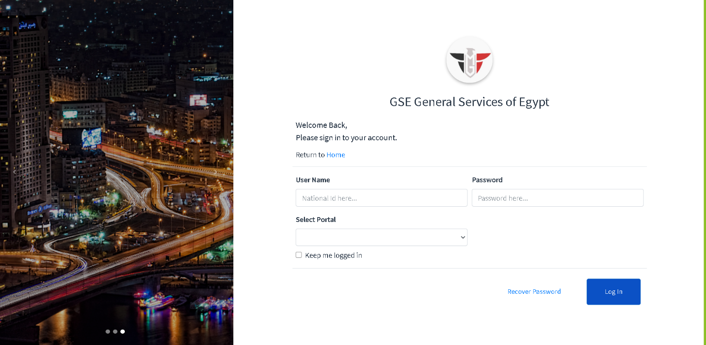

If the user entered Invalid national id/ username or password and choose his portal then clicks on “`login button” the system will display a message “*Please enter username or password correctly”



Else the system will open 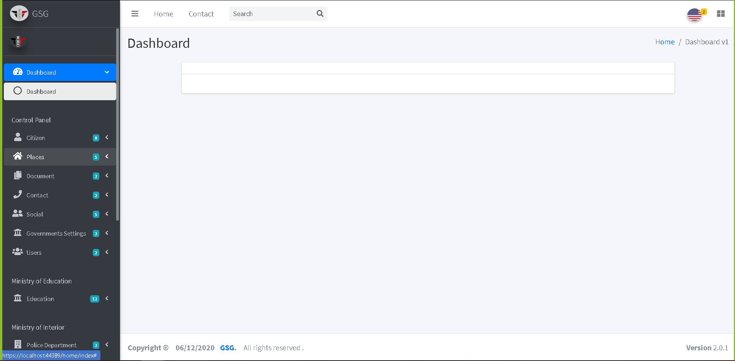

**Add new citizen**

To add new citizen the user should go through 4 steps.

Step1 is the basic information of the citizen, user must fill all fields to go to next step.

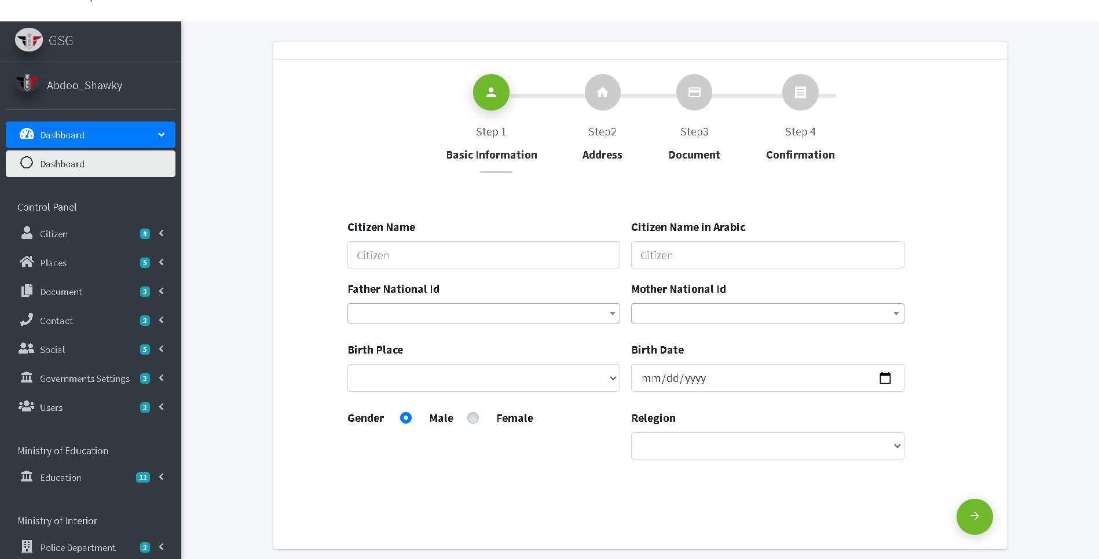

If the user does not fill all field and click on the “next button” the system will display message down each fields “this field is required”

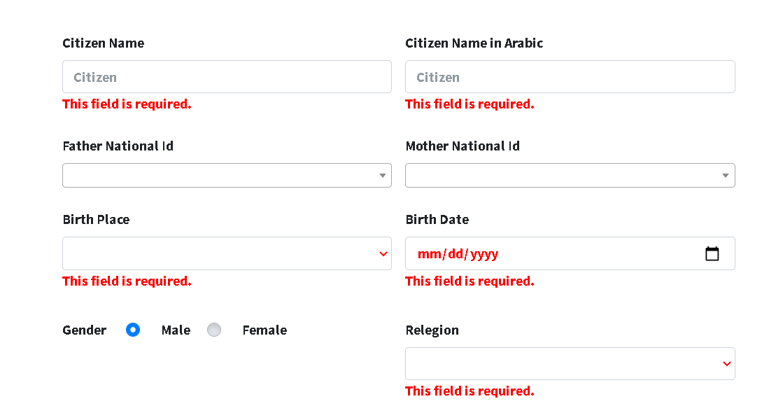

Else the system will go to step 2

Step 2 is the address of the citizen, the user should select the address of citizen and fill the required fields.

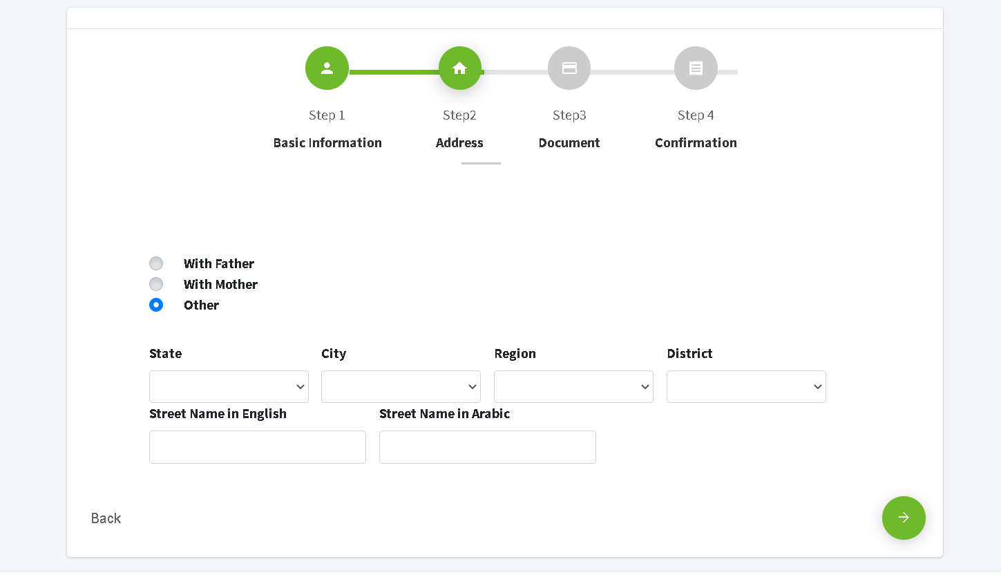

If the user does not fill all field and click on the “next button” the system will display message down each fields “this field is required”

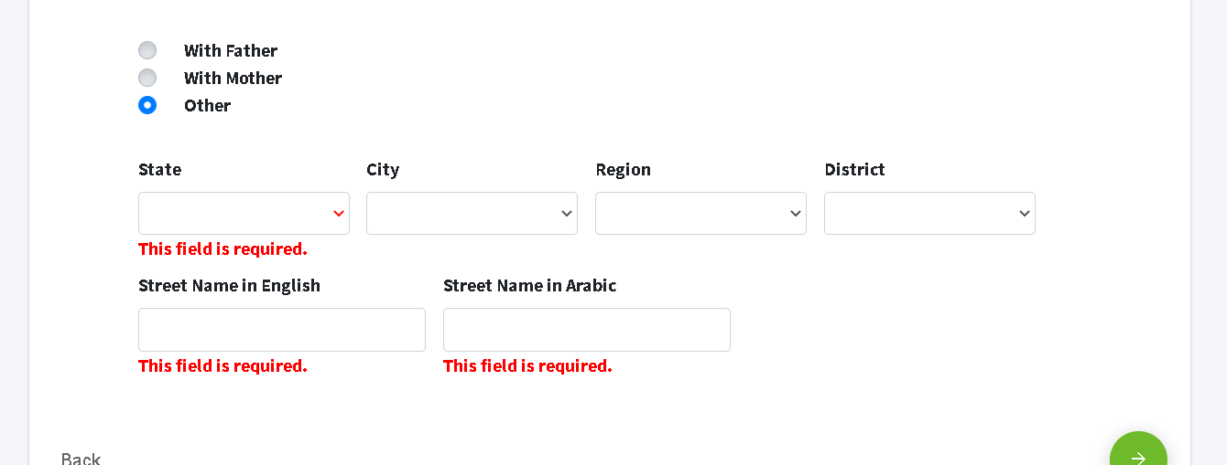

Else the system go to step3.

Step 3 is the document of the citizen, user select type of the document that will upload it down.

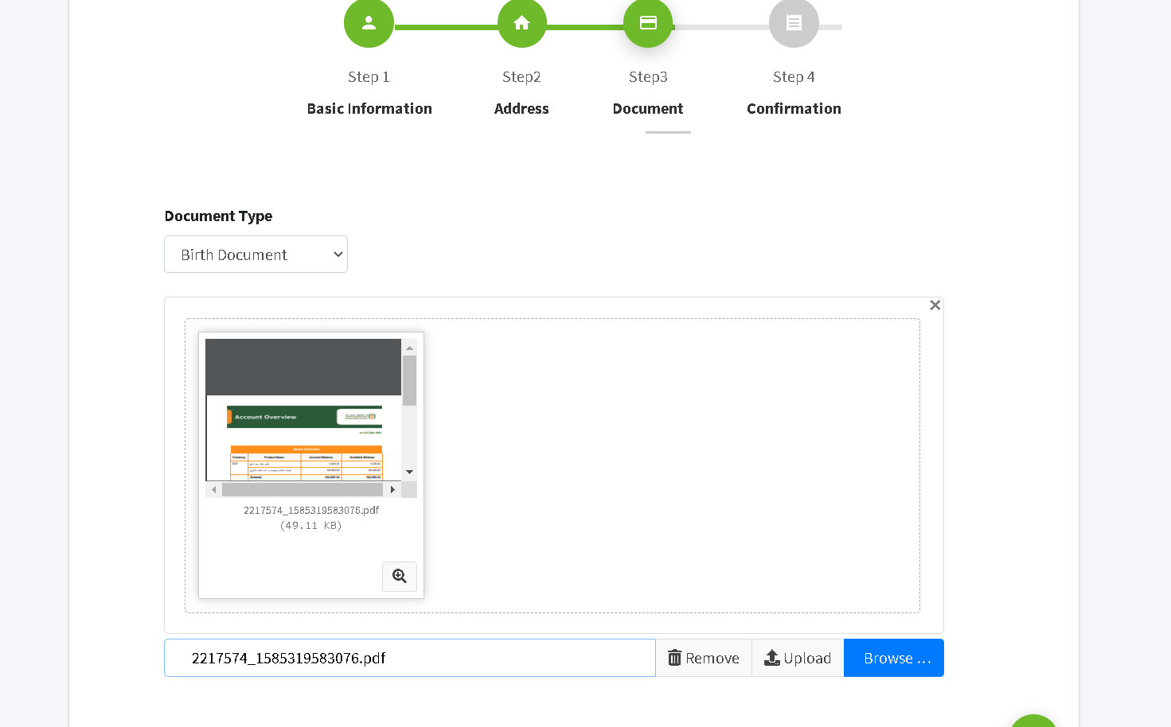

If the user does not fill all field and click on the “next button” the system will display message down each fields “this field is required”

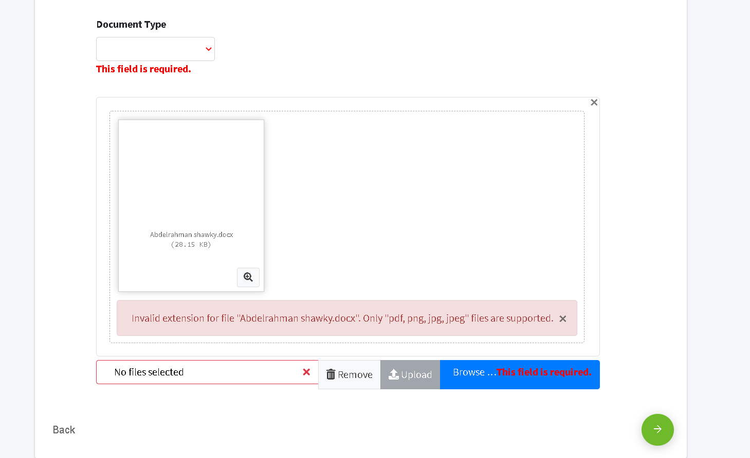

Else the system go to step 4.

Step 4 is the confirmation of submitting citizen, the system will display the data he entered in the previous steps to ensure the information is correct.

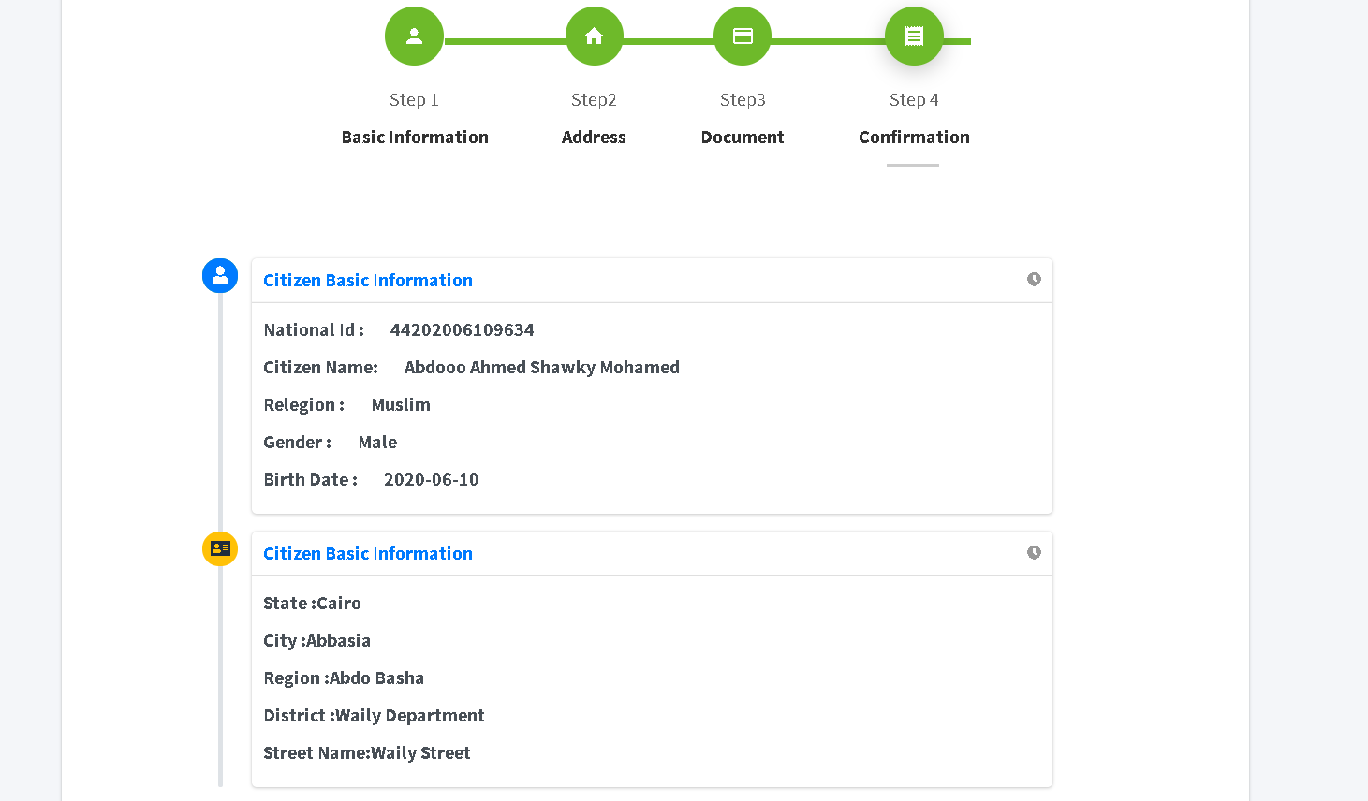

**Add National ID card**

The user should select a national id of the citizens then upload to him/her a photo, aye icon to preview ID card after selecting and uploading photo to the citizen

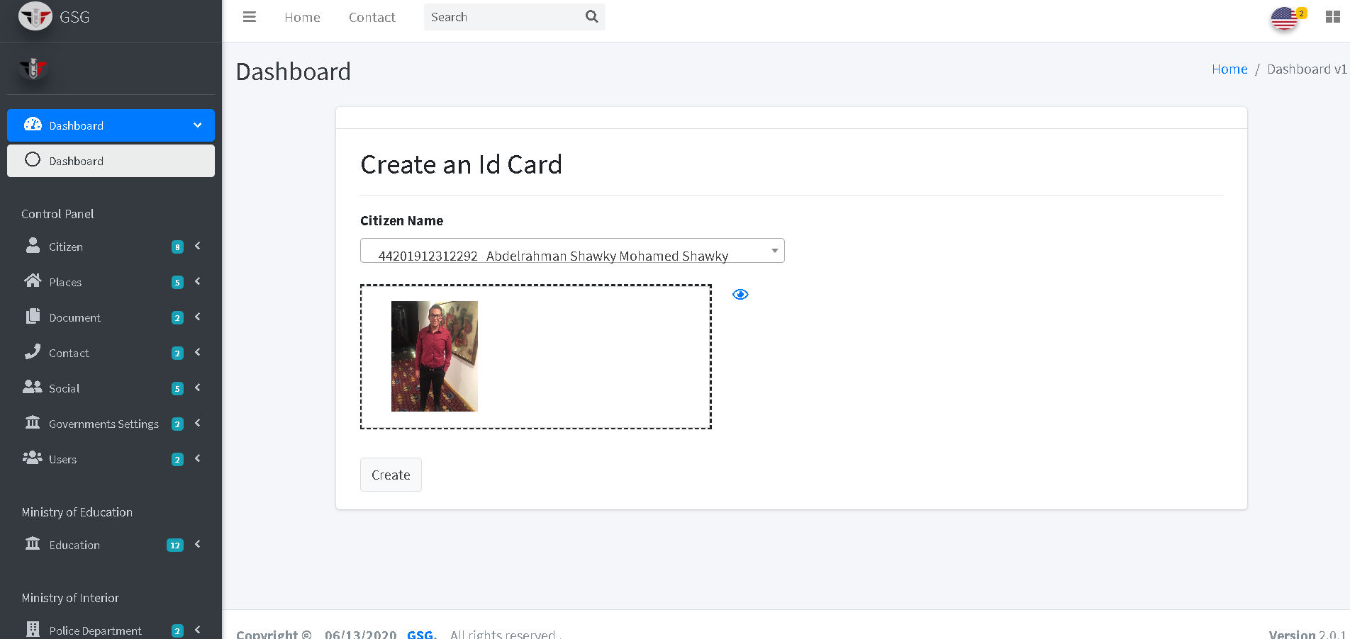

If user upload more than one photo, upload any extension other than png, jpeg and jpg the system will display popup dialog with details of the error message

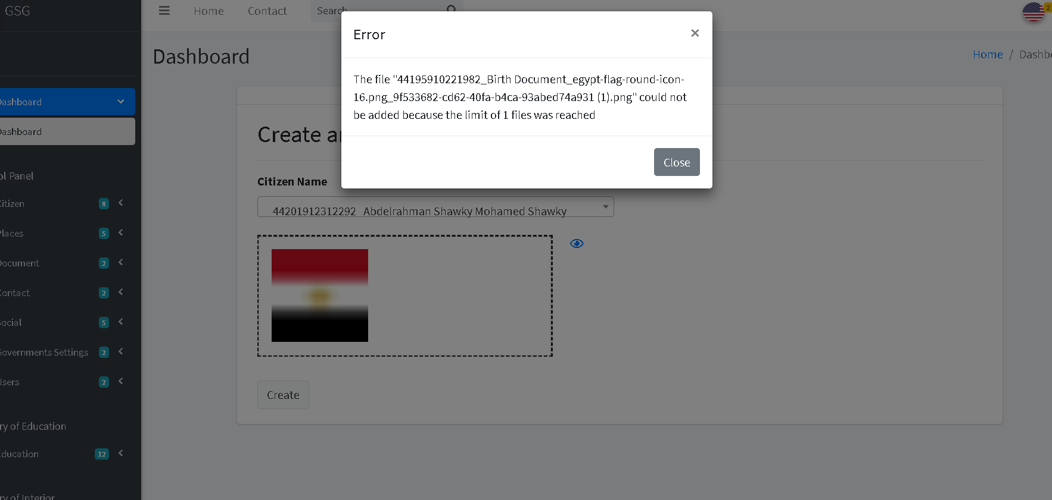

Else the system will go the Index page to export the Card of any citizen

**Exporting National ID card**

The user must select and search by writing the national id of citizen from a dropdown list then information of the citizen will displayed in the card.

User can print it front and the back of card by clicking on “print button”.

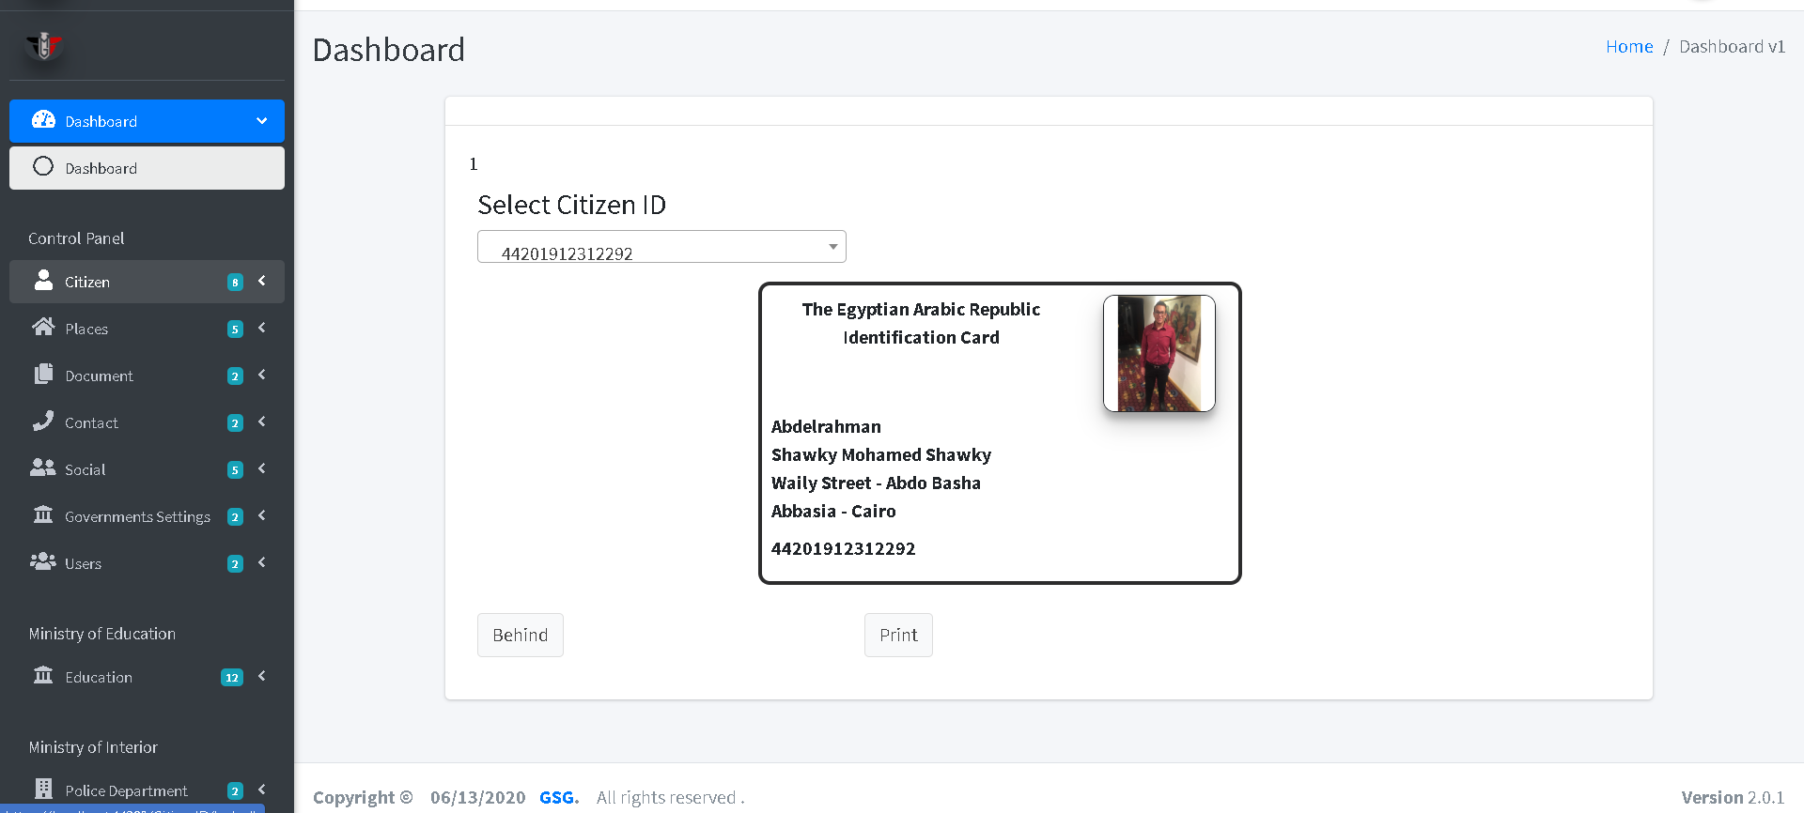

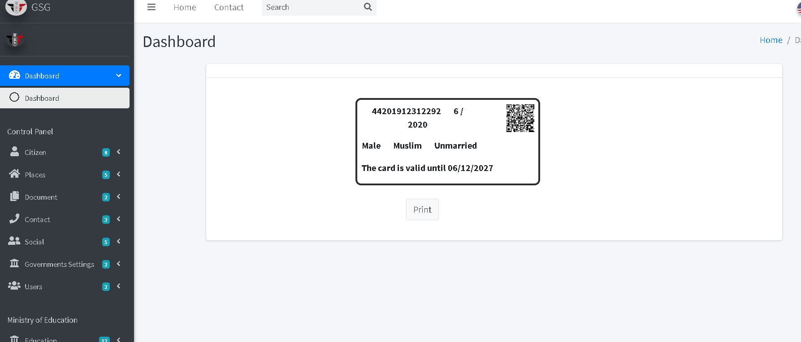

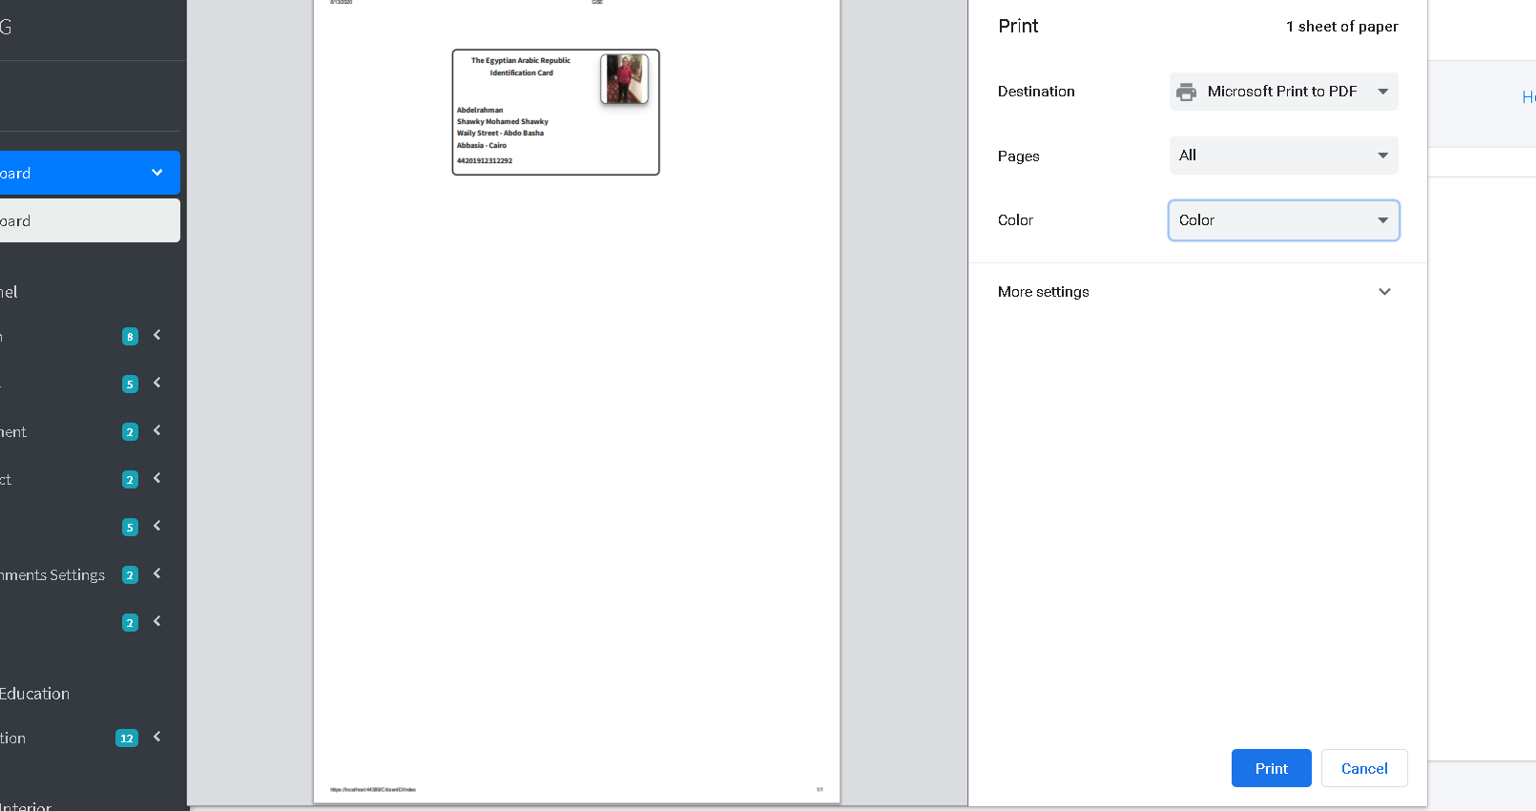

**Exporting Birth Document**

The user must select and search by writing the national id of citizen from a dropdown list then information of the citizen will displayed in the birth document area.

If the user click on “Export button” the system will print the birth document area

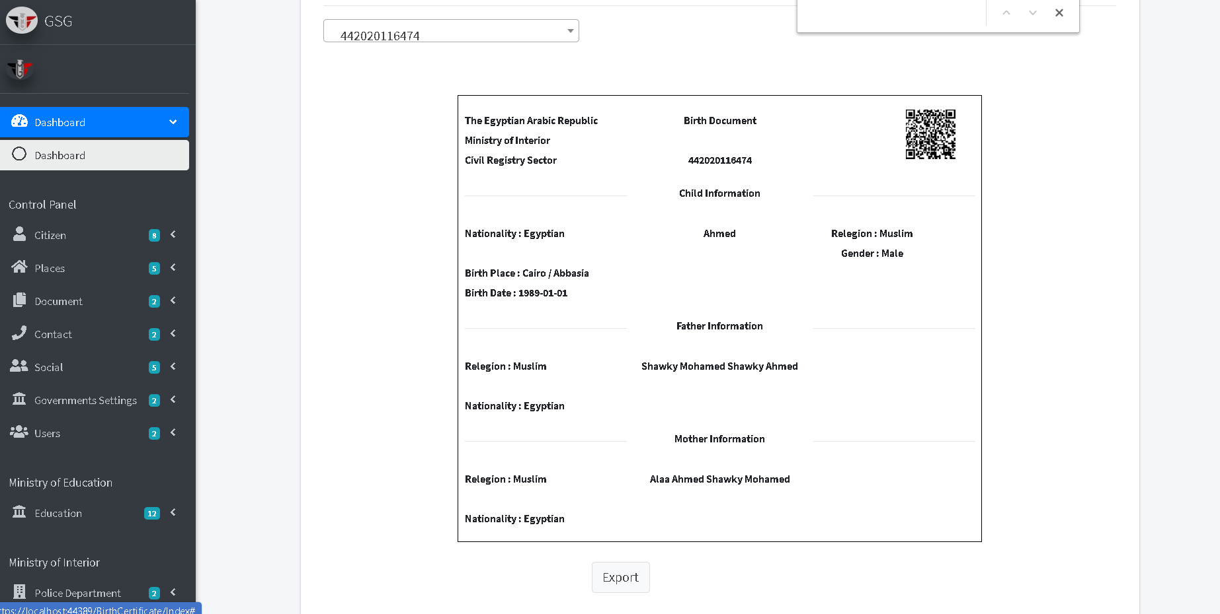

**Exporting Death Document**

The user must select and search by writing the national id of citizen from a dropdown list then information of the citizen will displayed in the death document area.

If the user click on “Export button” the system will print the death document area

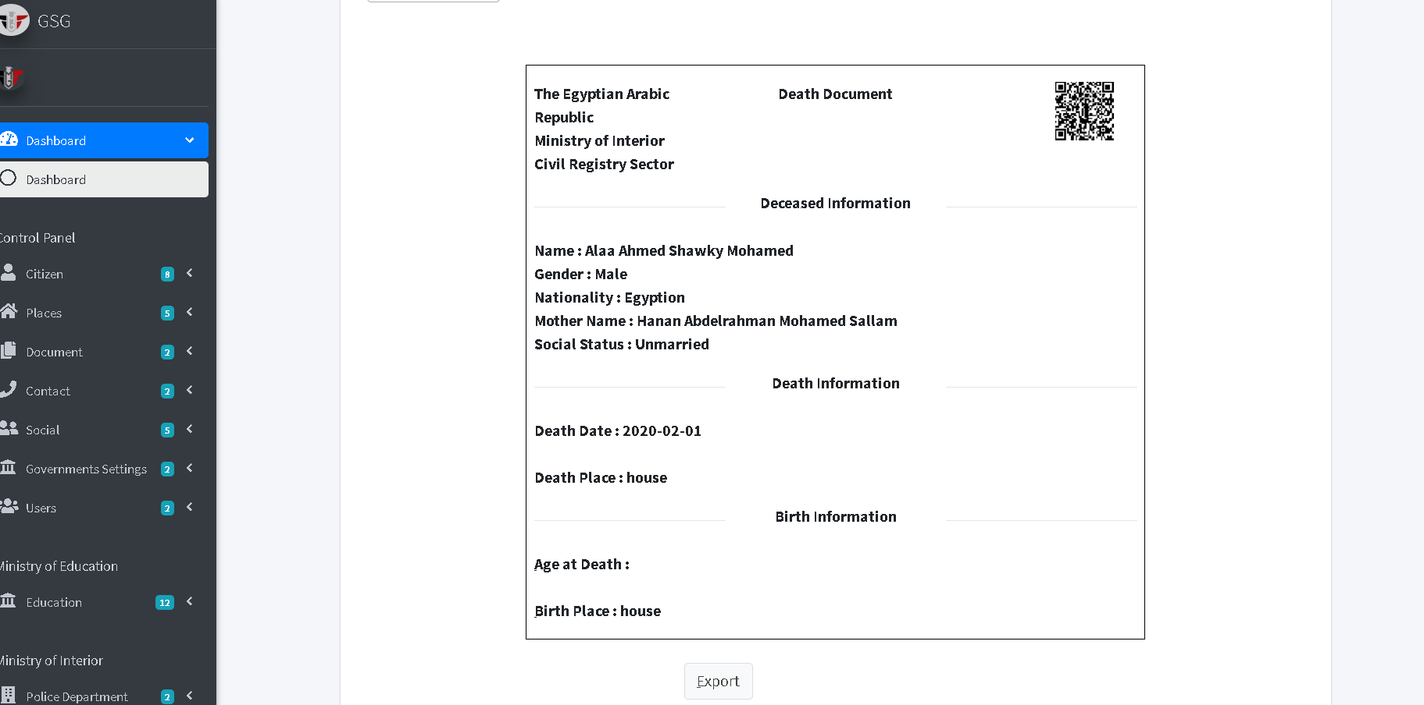

**Exporting Marriage / Divorce Document**

The user should choose the male by selecting or searching national id in dropdown list of males then user must choose type of social status (marriage/ divorce) then females that have a relationship with selected male will appear in dropdown list of females, so after selecting the female the information of marriage/ divorce will displayed is document area.

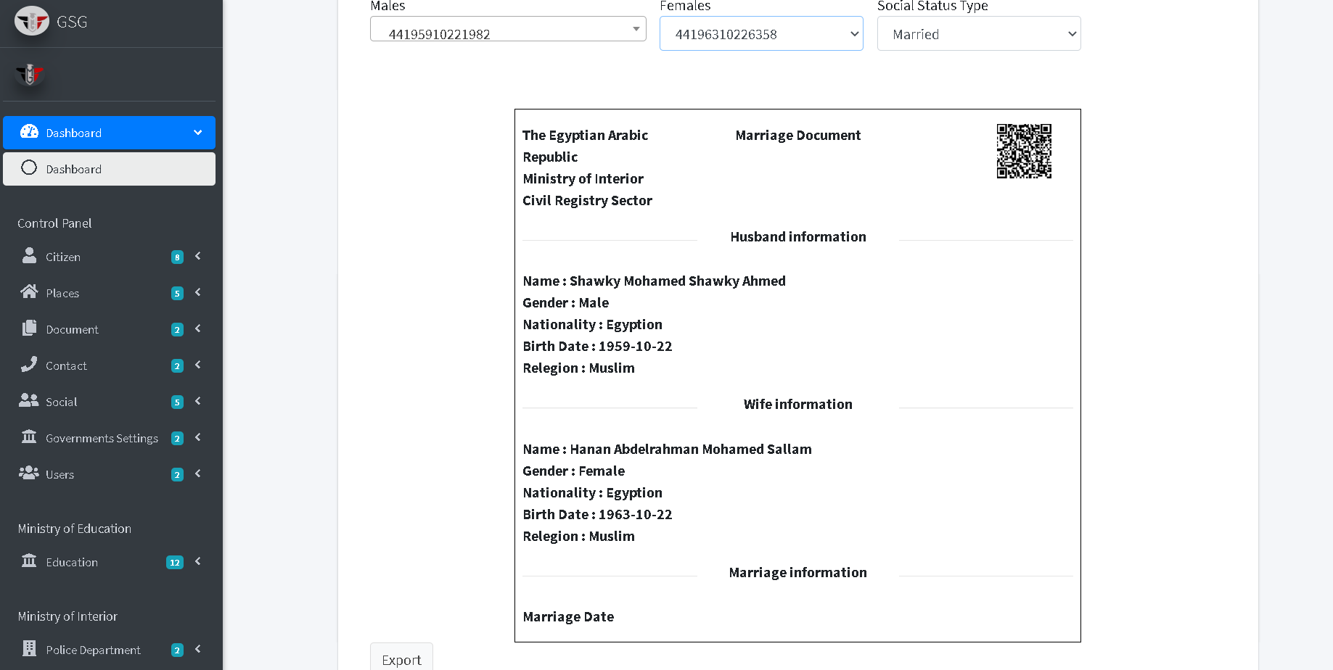

**Doctor reservation in health care**

The user must specify the health care type and the specialization he want then choose the health care by selecting its address (state, city, region and district).

The doctors will appear in the dropdown list after choosing health care, the user can select a doctor then the appointment of the doctor in this health care will displayed in appointment dropdown.

After filling the fields the user could click on “create button”

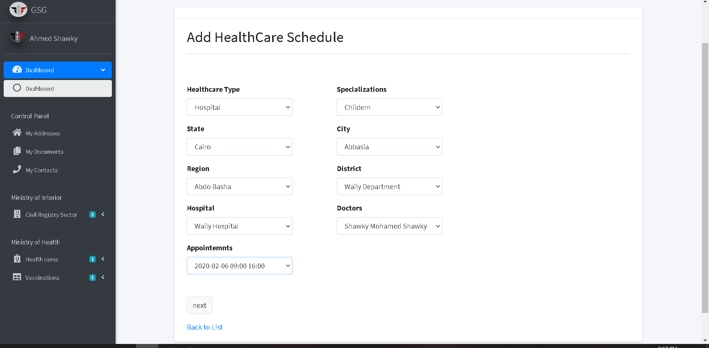

The system will redirect to the index page and display the citizen reservation that he make

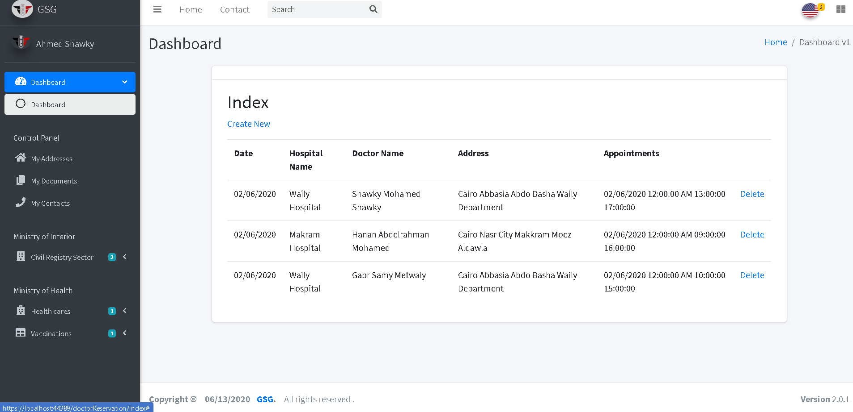

**Create the vaccination reservation**

If the user has children he could make a reservation, the system will display first the children of the user and user must select the child then system will display the vaccination type that should the selected child take it and then choose the health care type and its address (state, city, region and district).

After that user can choose the appointment he want in this health care then click on “submit button”

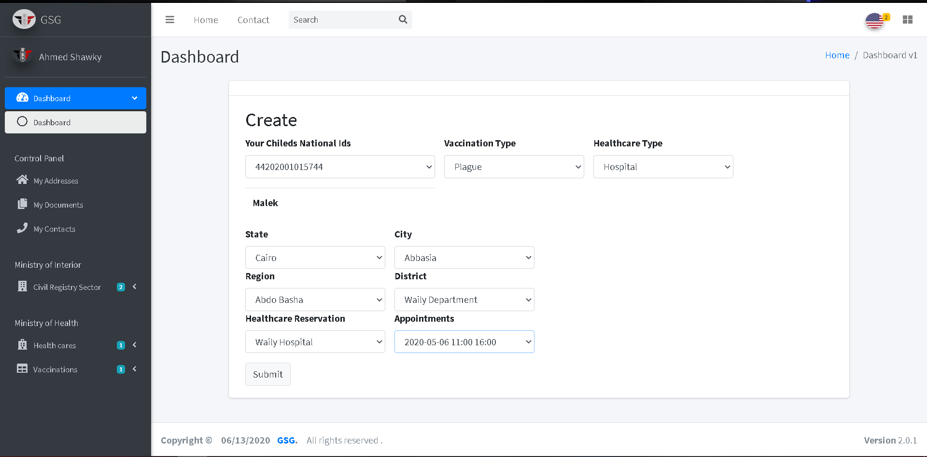

The system will display popup dialog with successful message

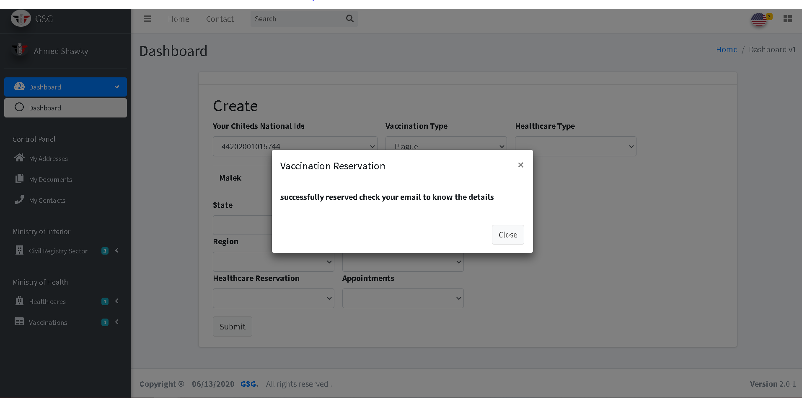

**Export School Certificate**

The user should specify the phase of school then the system will display the student in this phase to make user select them.

After selecting the student the information of selected student and his education displayed in the certificate area and can print it.

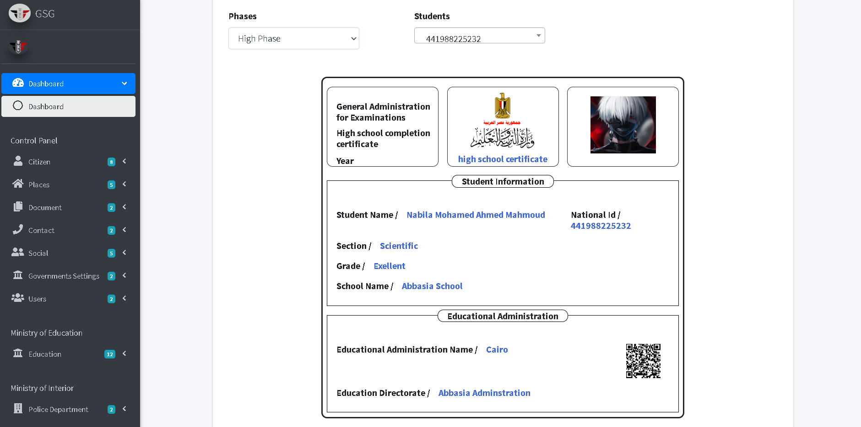

**Create reservation for civil registry**

The user must specify the government body and the service he want then choose the office by selecting its address (state, city, region and district) ,then click on the “reserve button”.

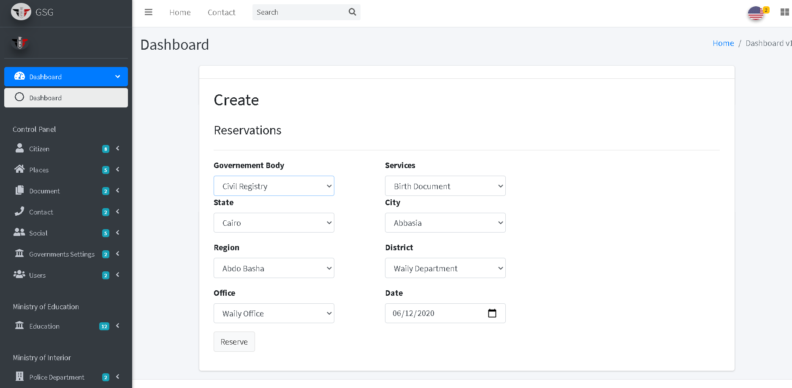

The system will redirect to the index page and display all reservations of the citizen

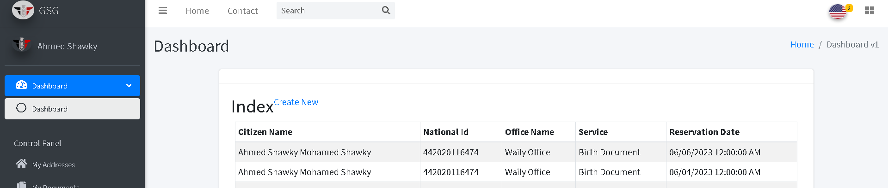

**Create Social Status**

The user should specify the husband and wife then fills the required field then click on “create button”

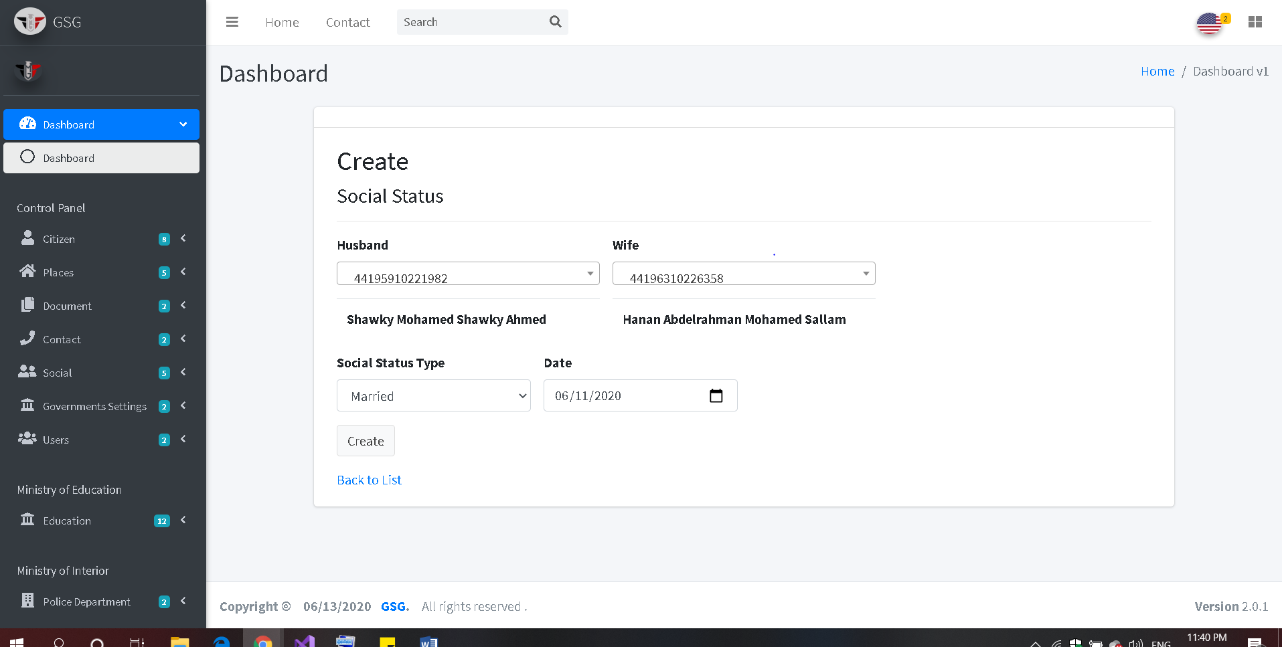

The system will redirect to the index page and the user should choose husband and wife then the system display the social status information

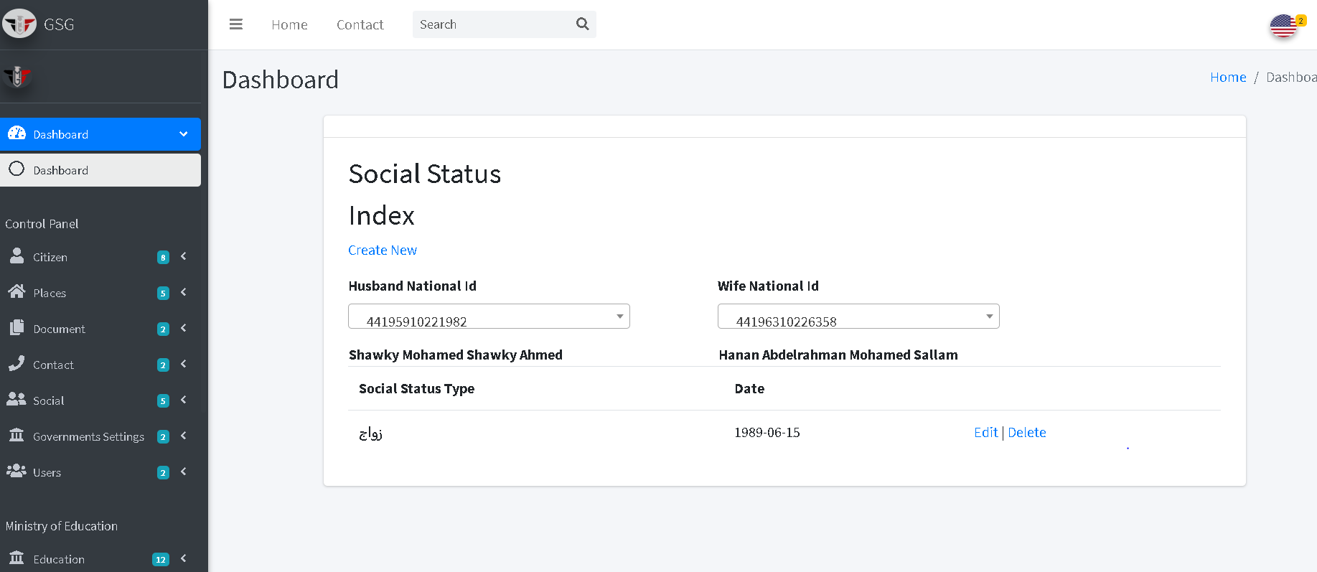

Then the user can edit or delete by click on “edit icon” or “trash icon”, the system will go to edit page and user can edit on the fields then click on “save button”

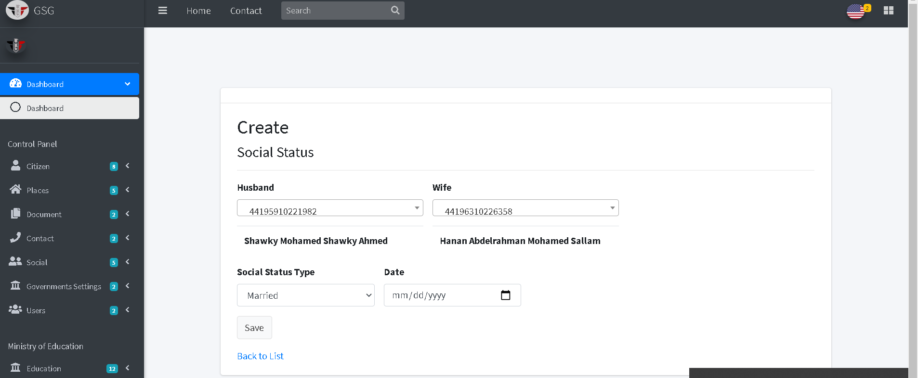

Or will go to delete page and user can confirm deletion by clicking on “delete button” then the system will redirect to index page.

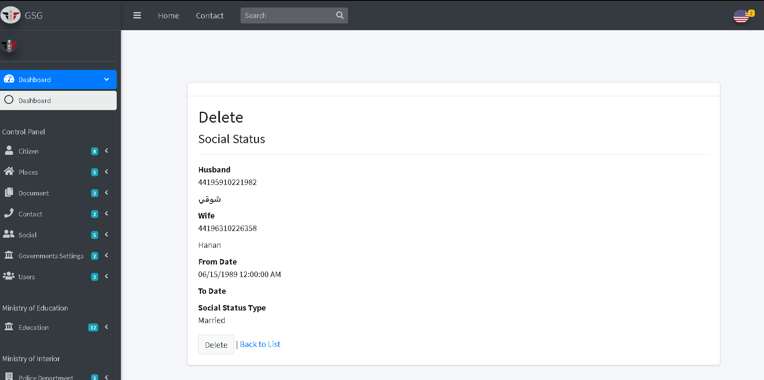

**Create State**

The user must fill the required fields of the states then click on “create button”.

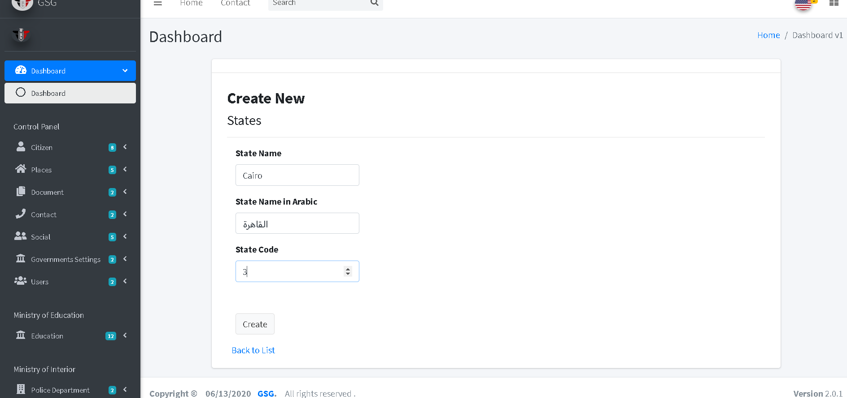

After clicking the submit button the system will redirect to the index page

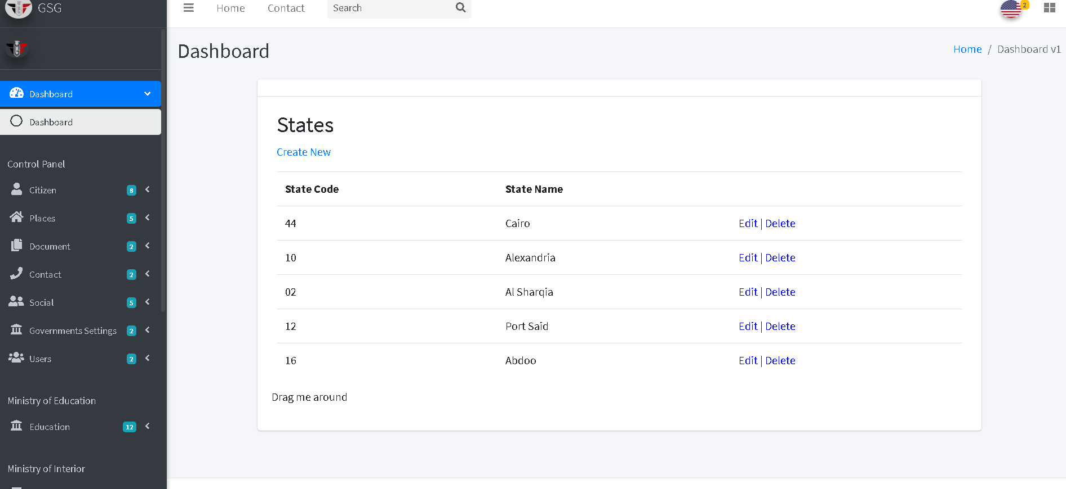

Then the user can edit or delete by click on “edit icon” or “trash icon”, the system will go to edit page and user can edit on the fields then click on “save button”

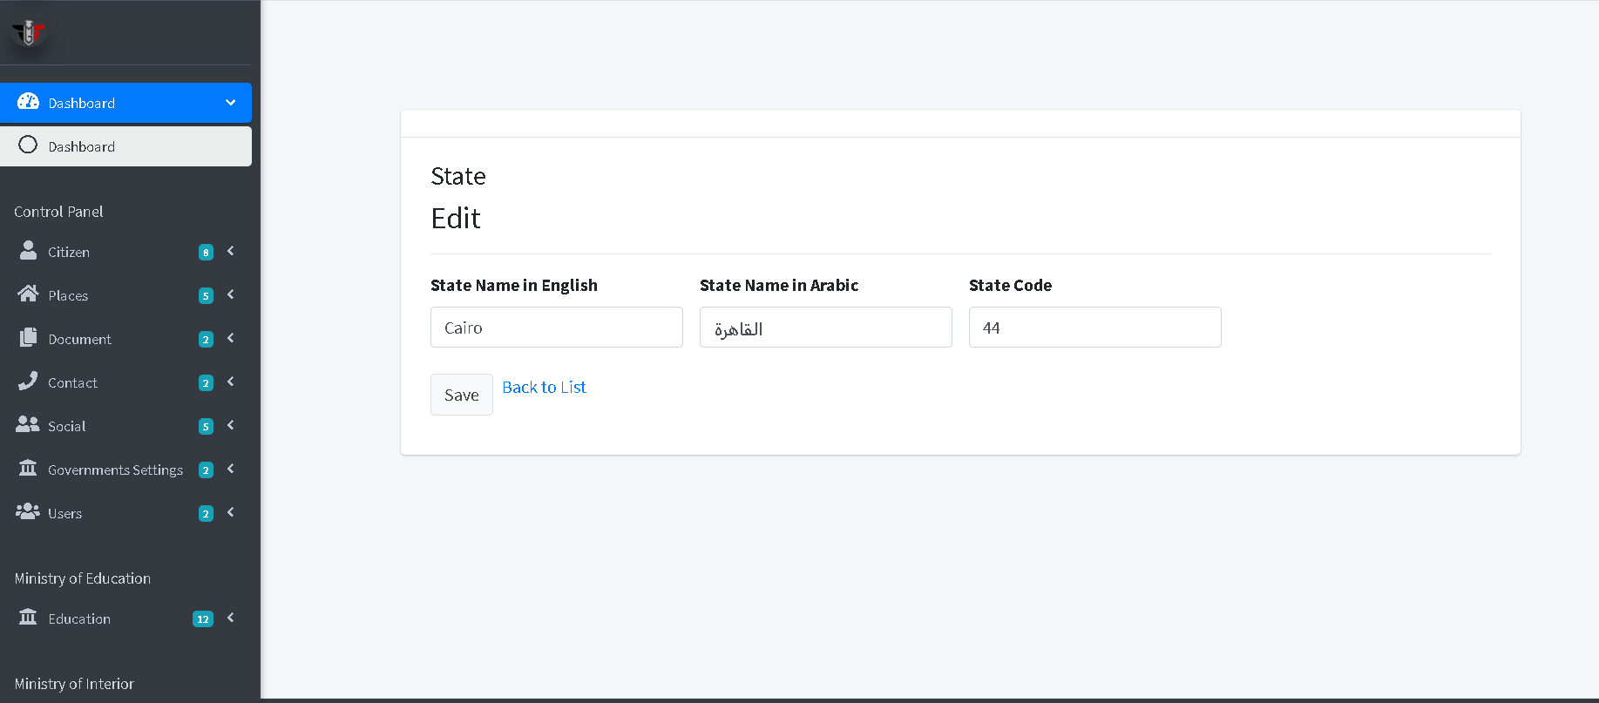

Or will go to delete page and user can confirm deletion by clicking on “delete button” then the system will redirect to index page.

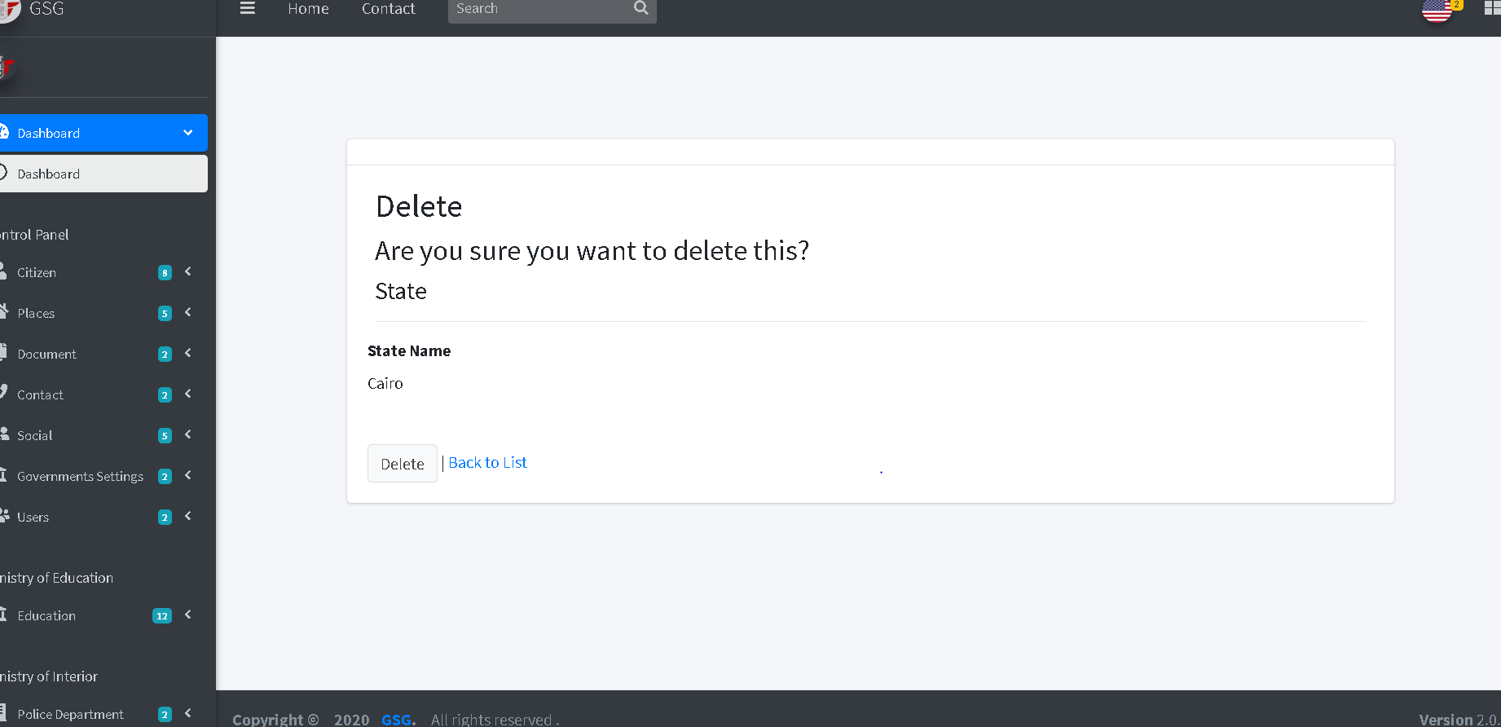

**Create City**

The user must choose the state and write the city name that belongs to selected state then click on “create button”.

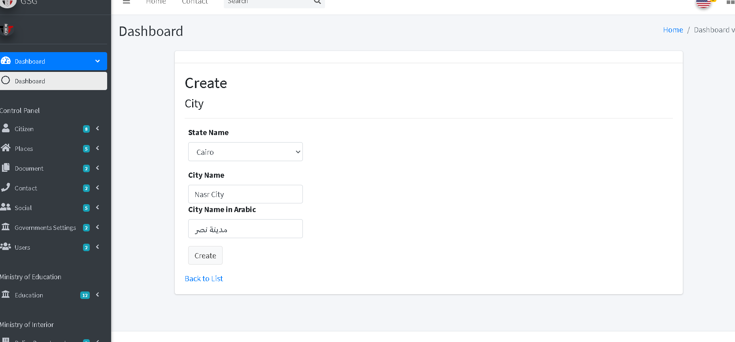

After clicking the submit button the system will redirect to the index page and user should choose state from the dropdown to display its cities.

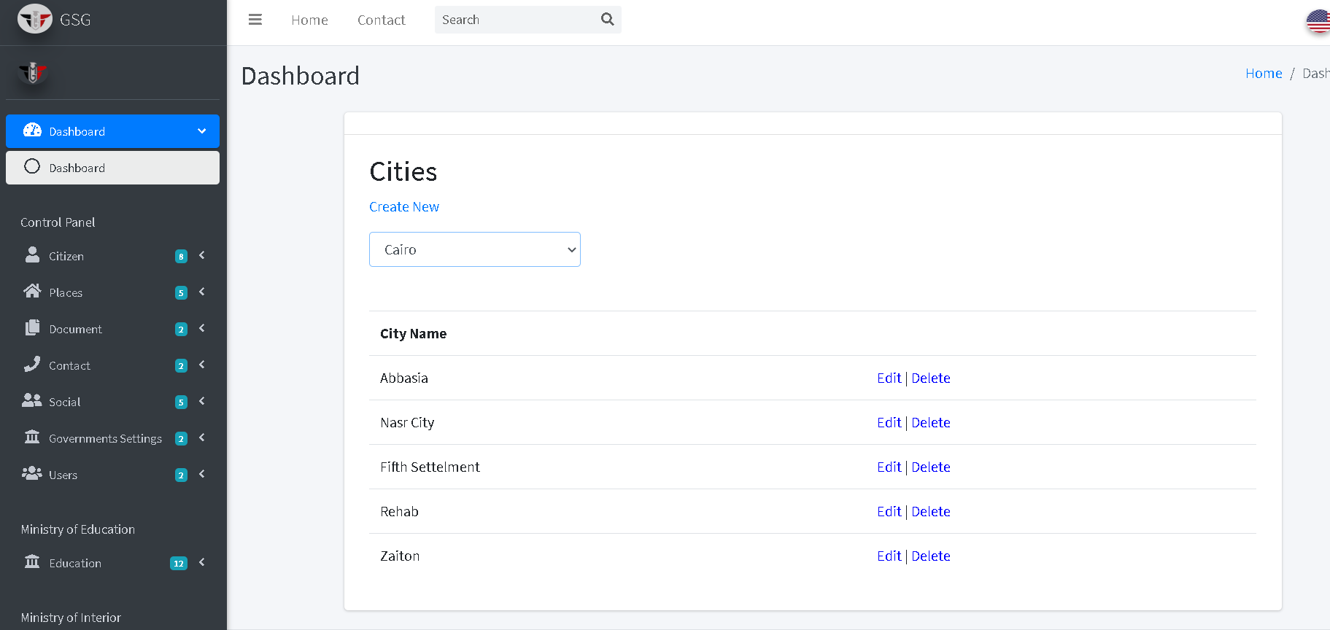

Then the user can edit or delete by click on “edit icon” or “trash icon”, the system will go to edit page and user can edit on the fields then click on “save button”

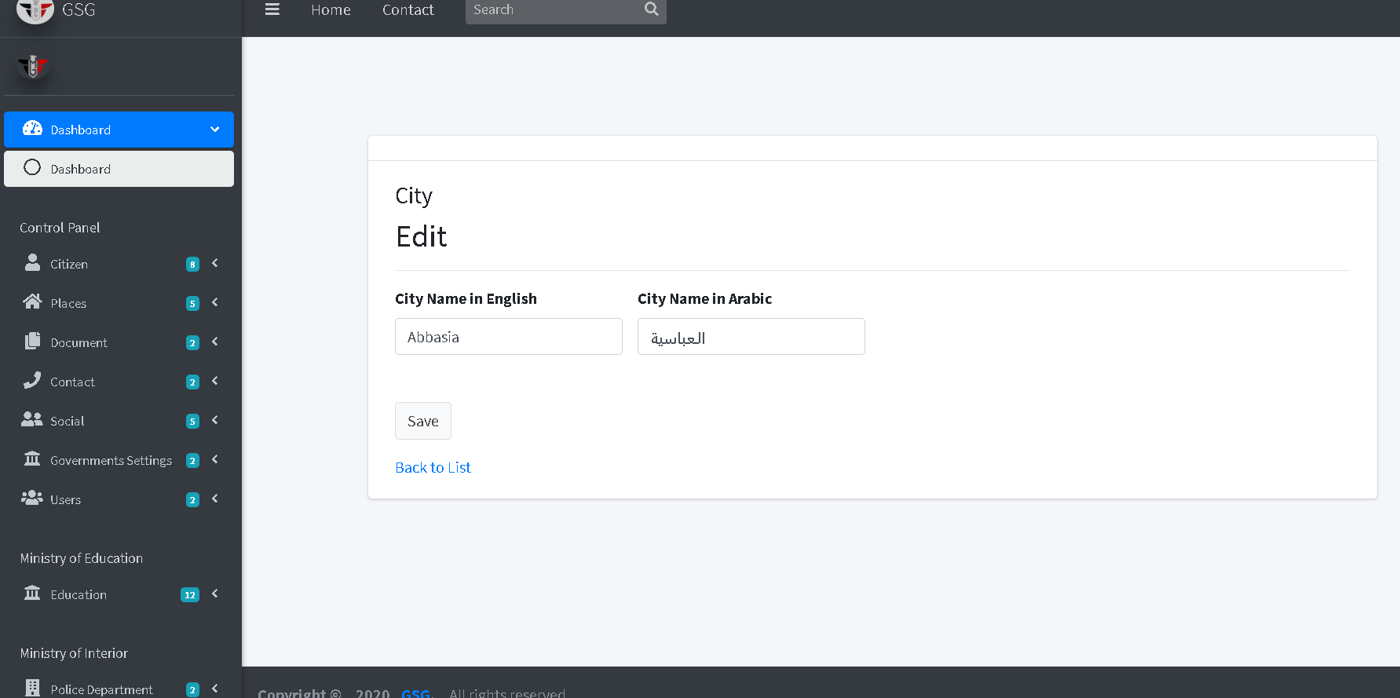

Or will go to delete page and user can confirm deletion by clicking on “delete button” then the system will redirect to index page.

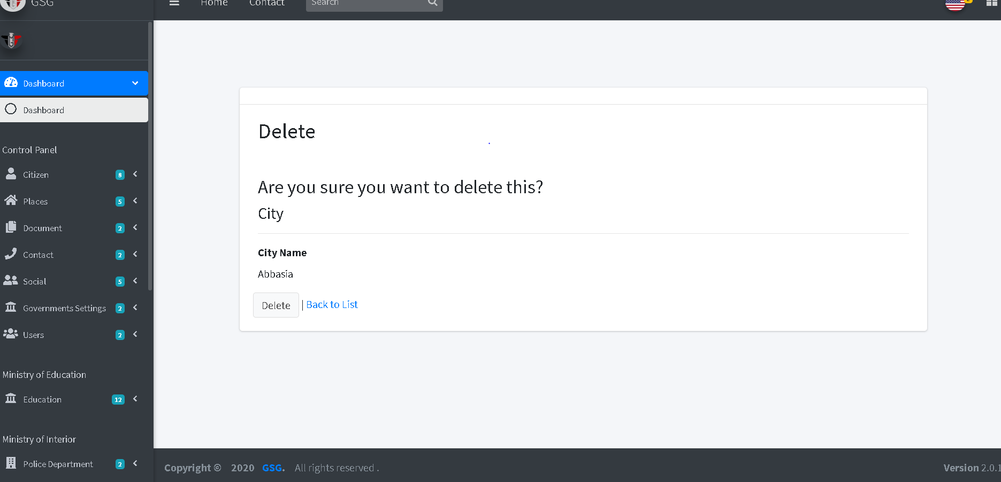

**Create Region**

The user must choose the state and city then write the region name that belongs to selected city then click on “create button”.

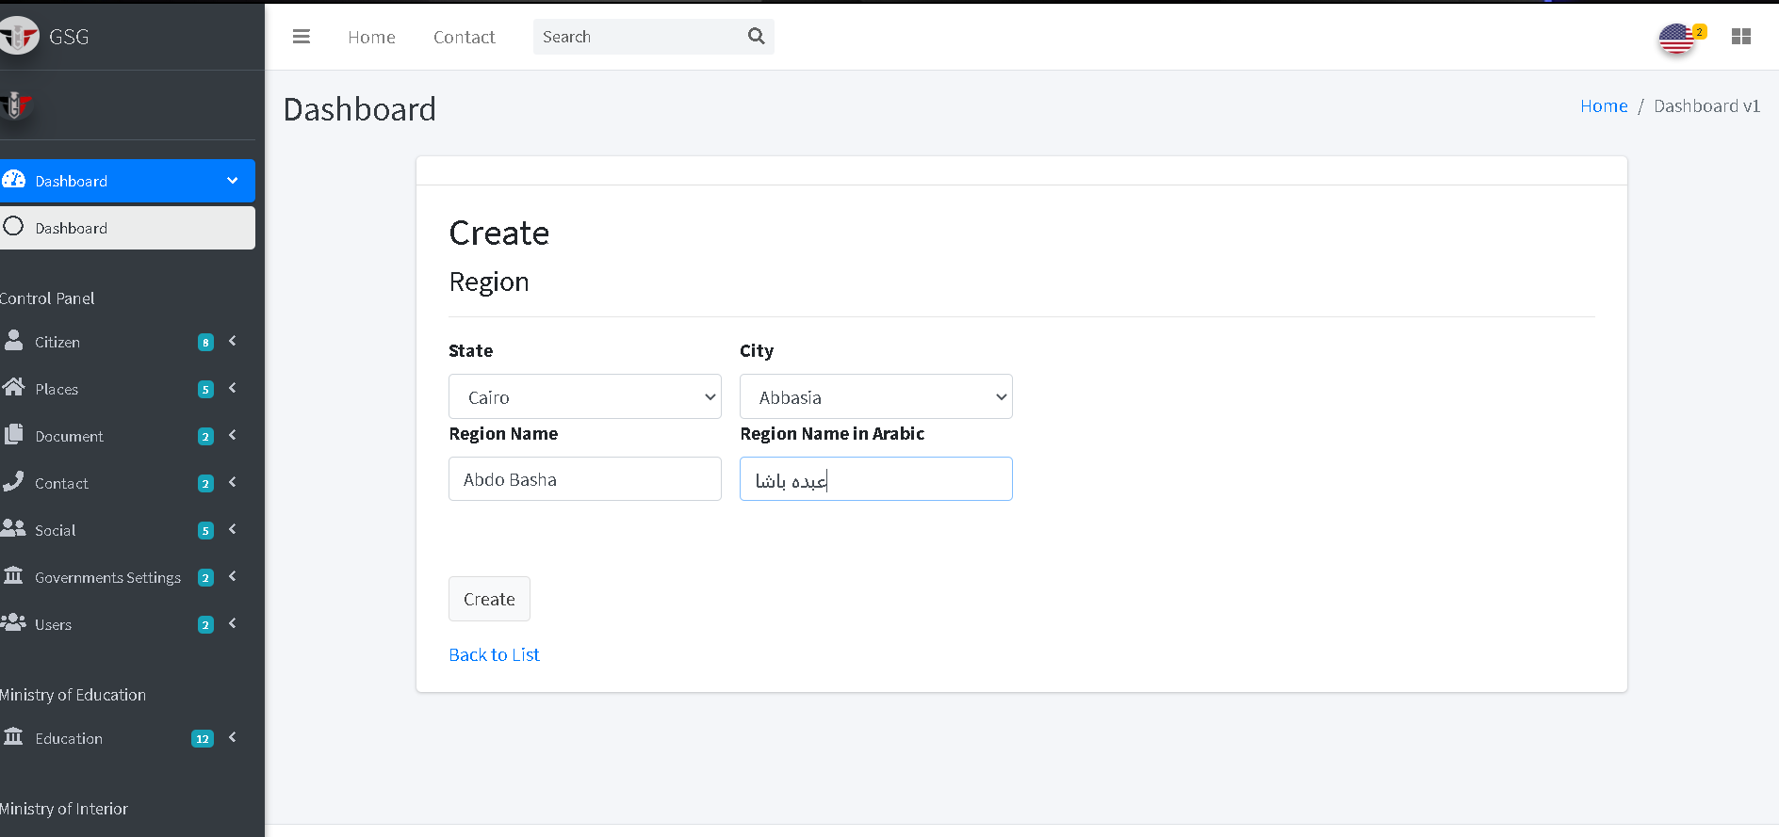

After clicking the submit button the system will redirect to the index page and user should choose state and city from the dropdown to display its regions.

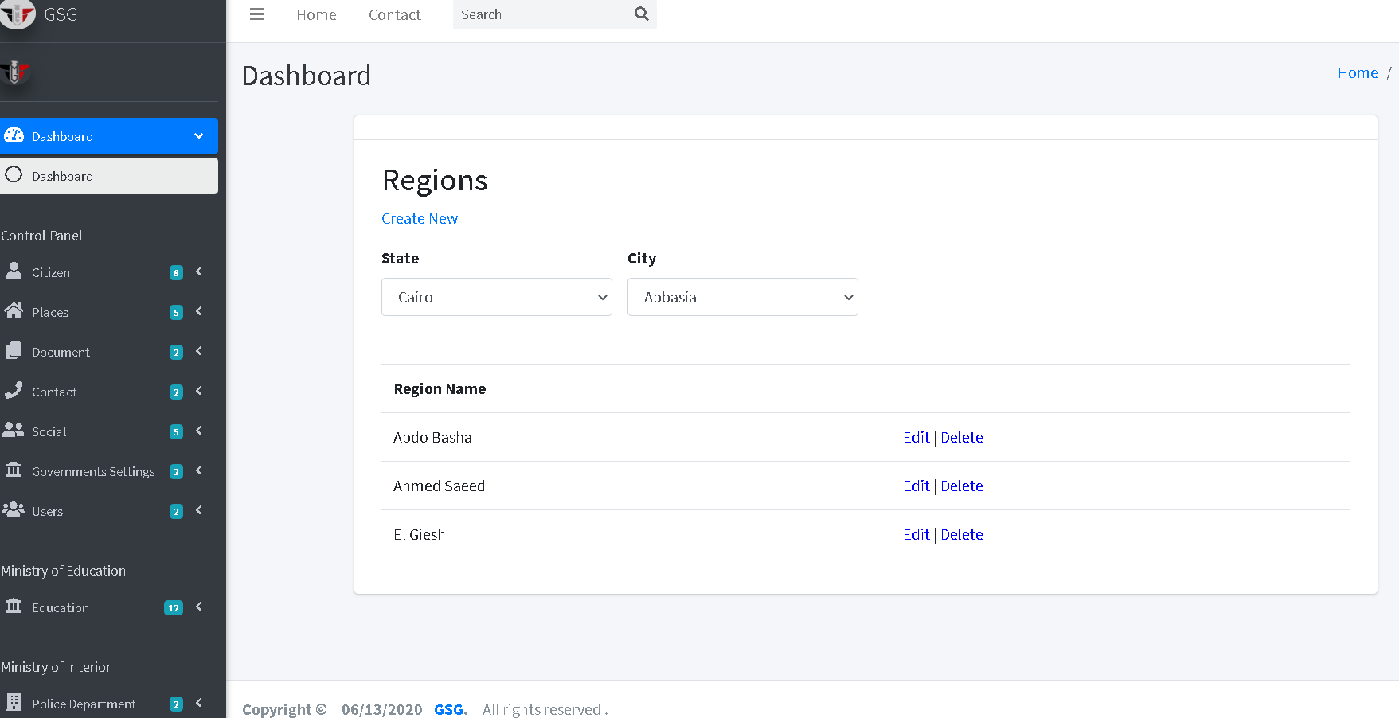

Then the user can edit or delete by click on “edit icon” or “trash icon”, the system will go to edit page and user can edit on the fields then click on “save button”

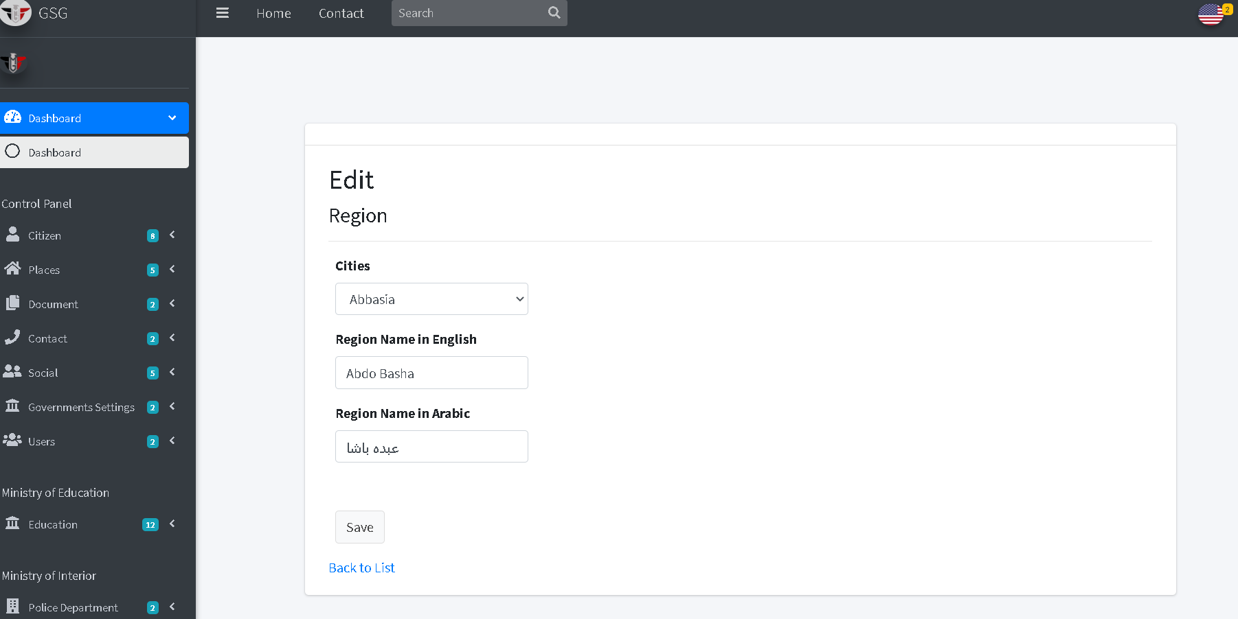

Or will go to delete page and user can confirm deletion by clicking on “delete button” then the system will redirect to index page.

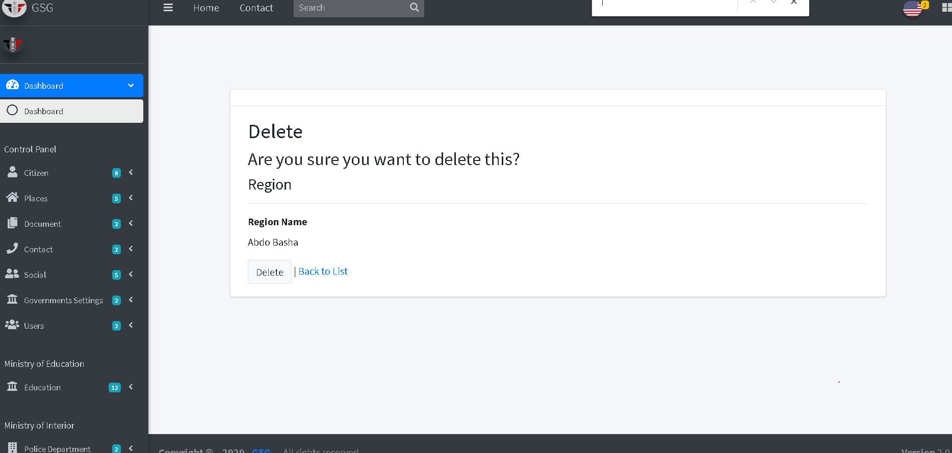

**Create District**

The user must choose the state, city and region then write the district name that belongs to selected region then click on “create button”.

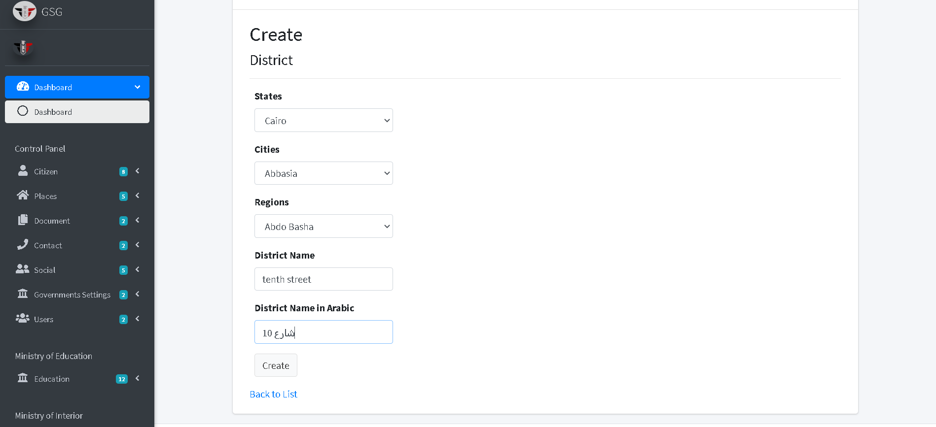

After clicking the submit button the system will redirect to the index page and user should choose state, city and region from the dropdowns to display its districts

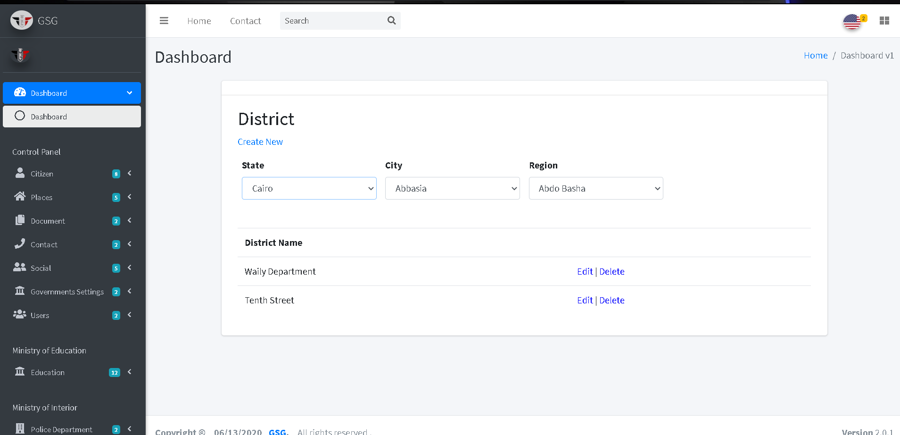.

Then the user can edit or delete by click on “edit icon” or “trash icon”, the system will go to edit page and user can edit on the fields then click on “save button”

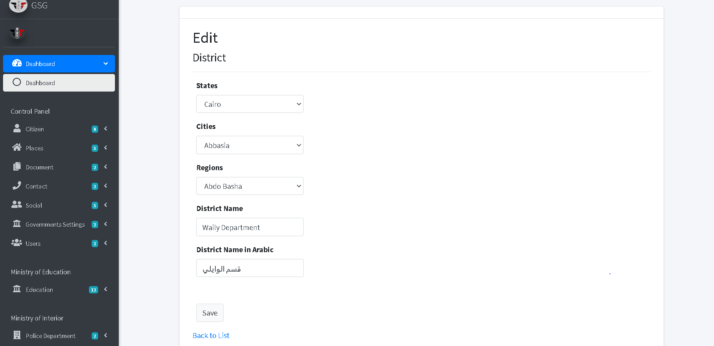

Or will go to delete page and user can confirm deletion by clicking on “delete button” then the system will redirect to index page.

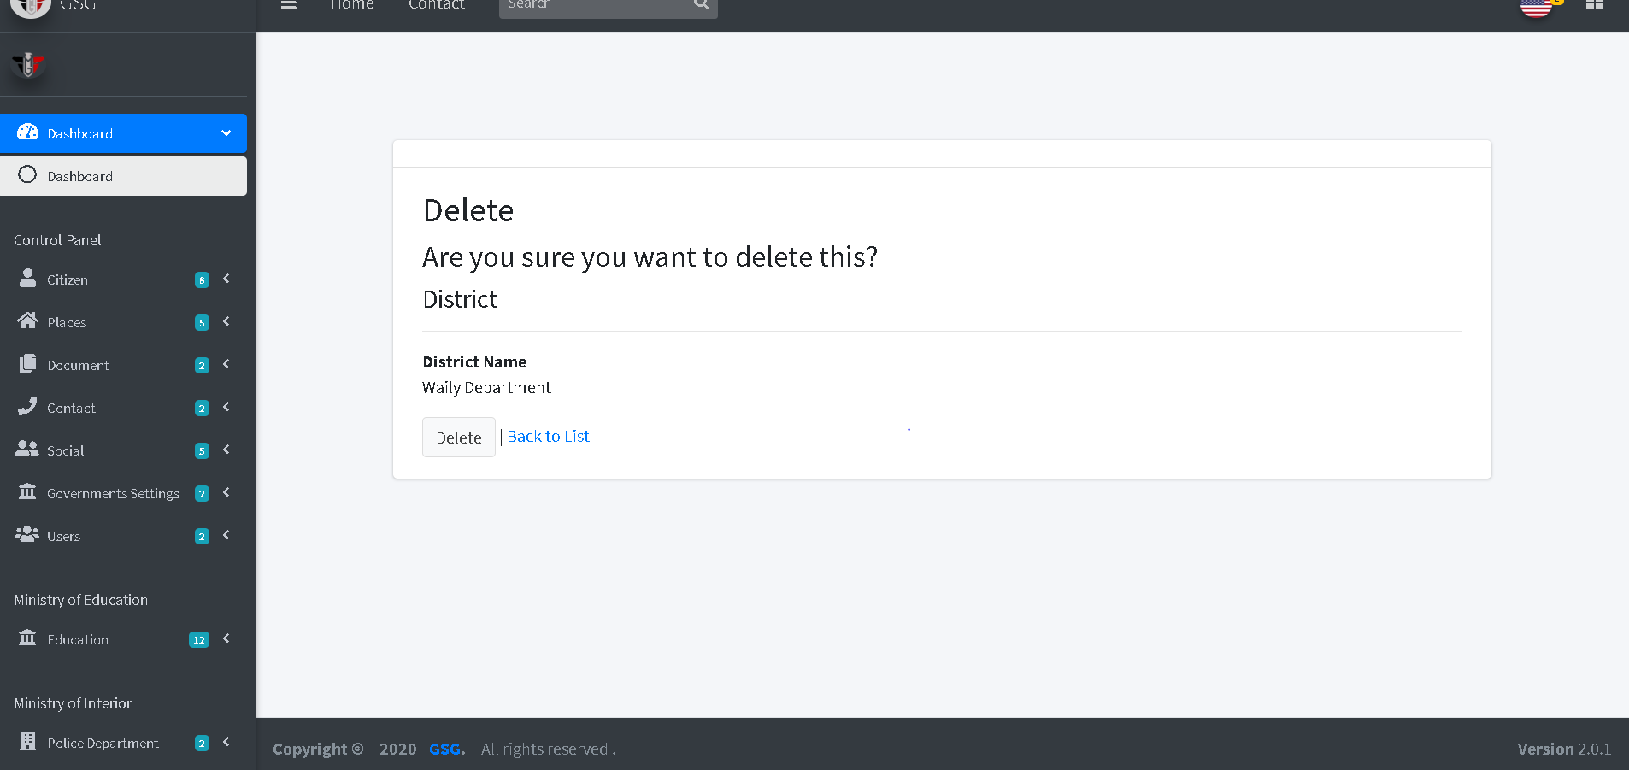

**Create Office**

The user must choose the government body, state, city, region and district then write the office name that belongs to selected district then click on “create button”.

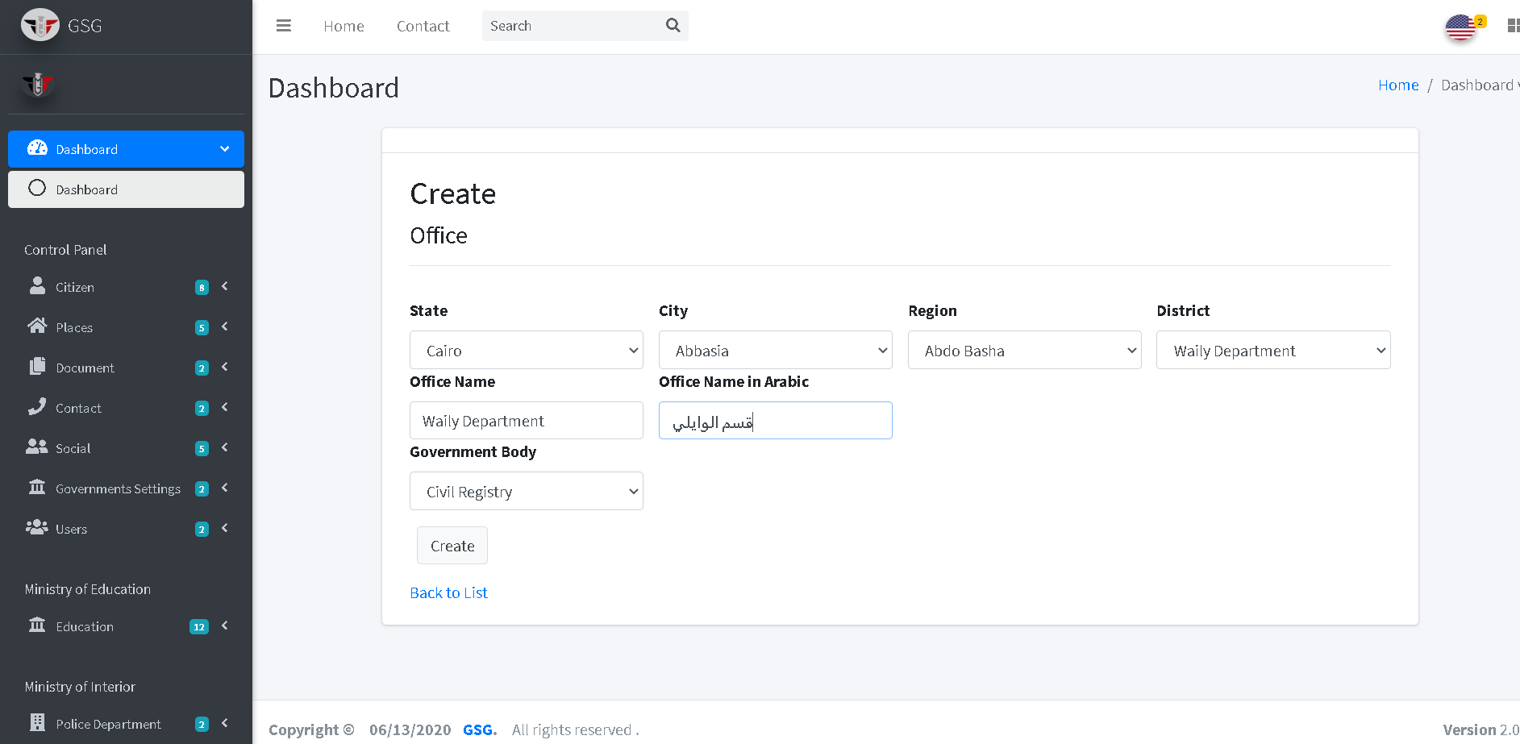

After clicking the submit button the system will redirect to the index page

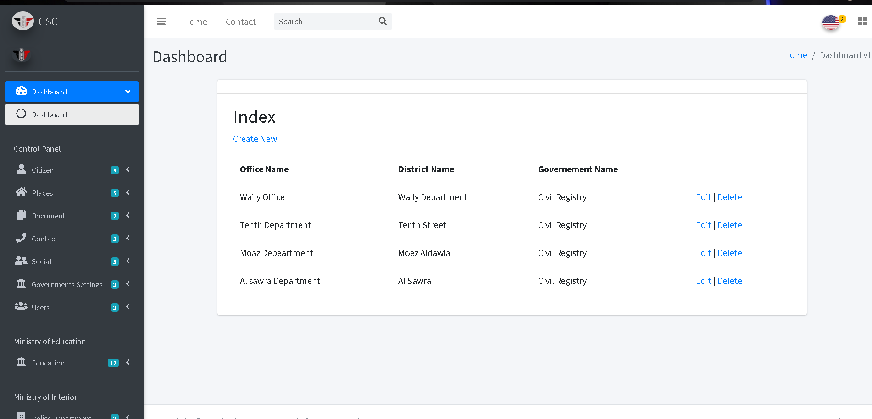

Then the user can edit or delete by click on “edit icon” or “trash icon”, the system will go to edit page and user can edit on the fields then click on “save button”

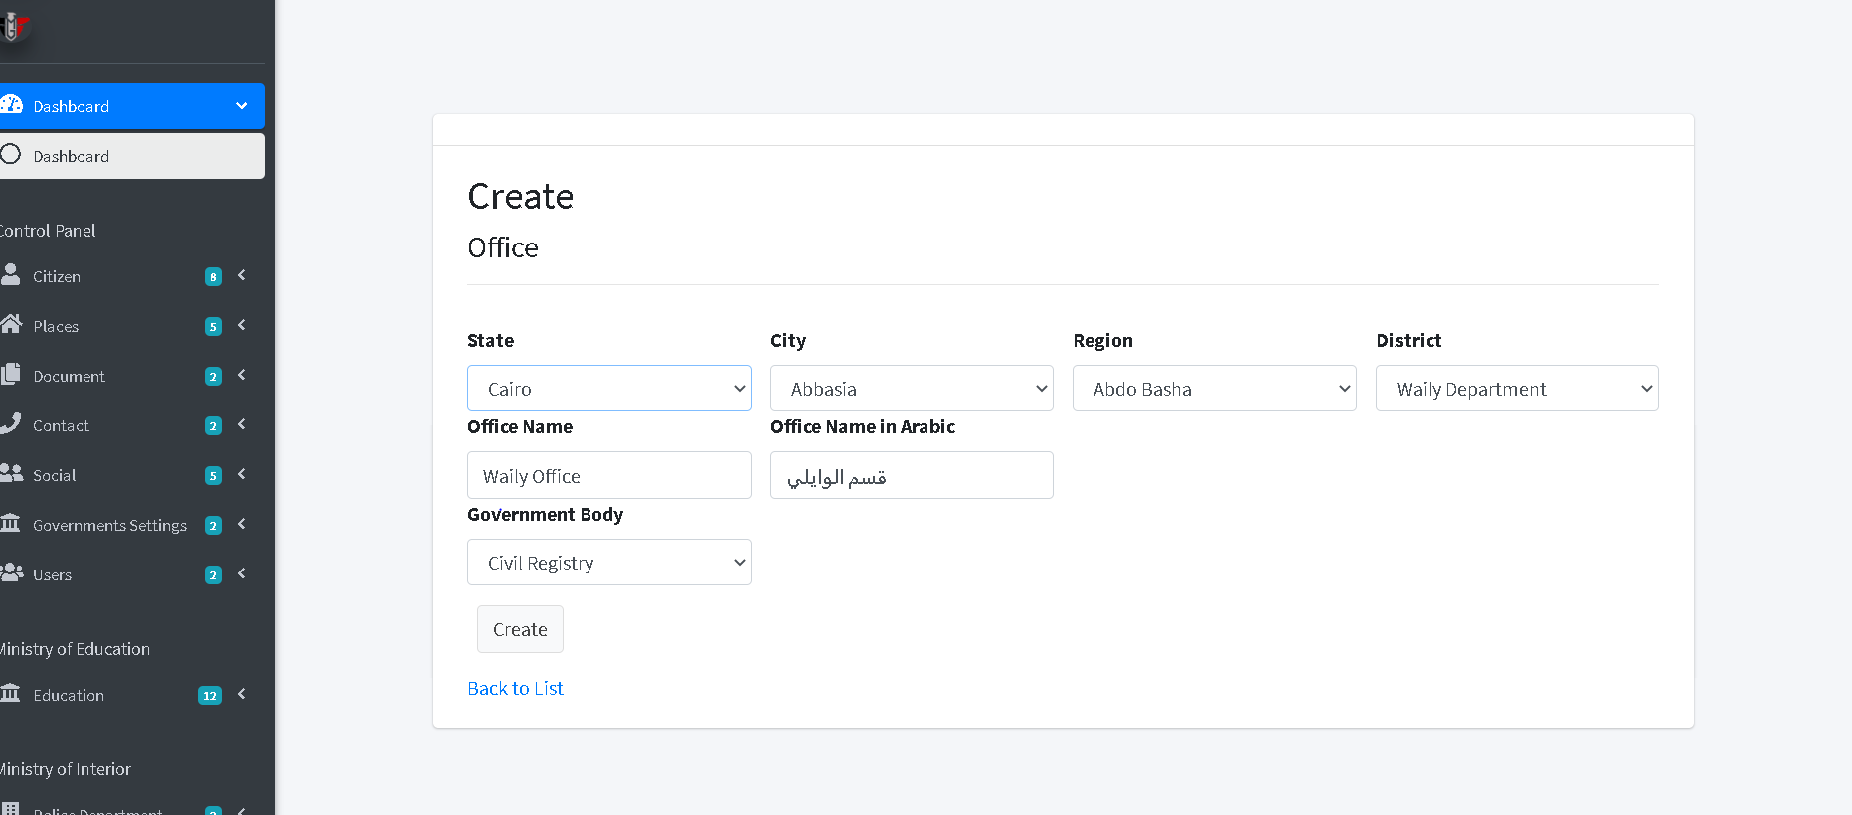

Or will go to delete page and user can confirm deletion by clicking on “delete button” then the system will redirect to index page.

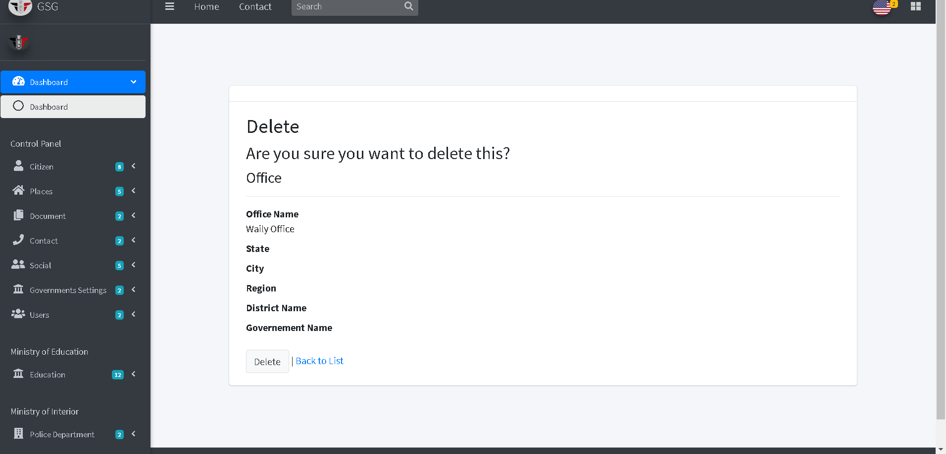

**Upload Citizen Document**

The user must choose the national id of specific citizen from the dropdown list and the document type that he want to upload then clicks on “upload button”

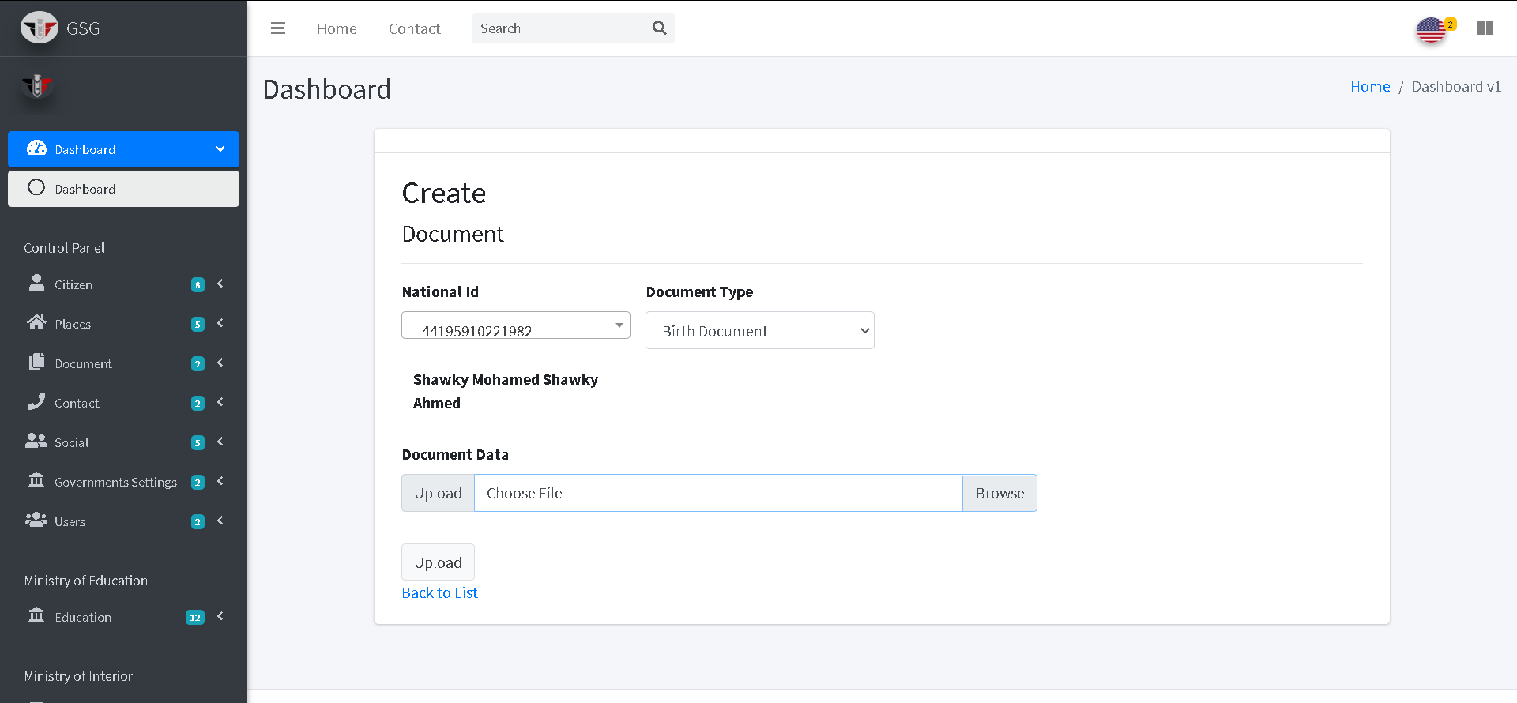

The system will redirect to the index page and the user should select the national id of the citizen to display the information of his document

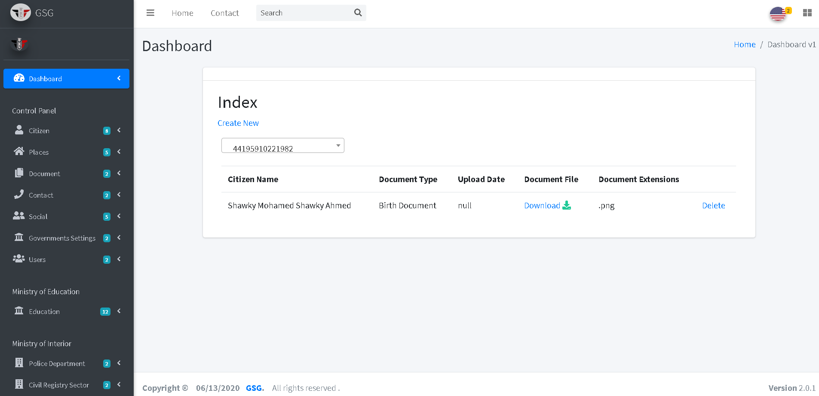

Then user can delete the system will go to delete page and user can confirm deletion by clicking on “delete button” then the system will redirect to index page.

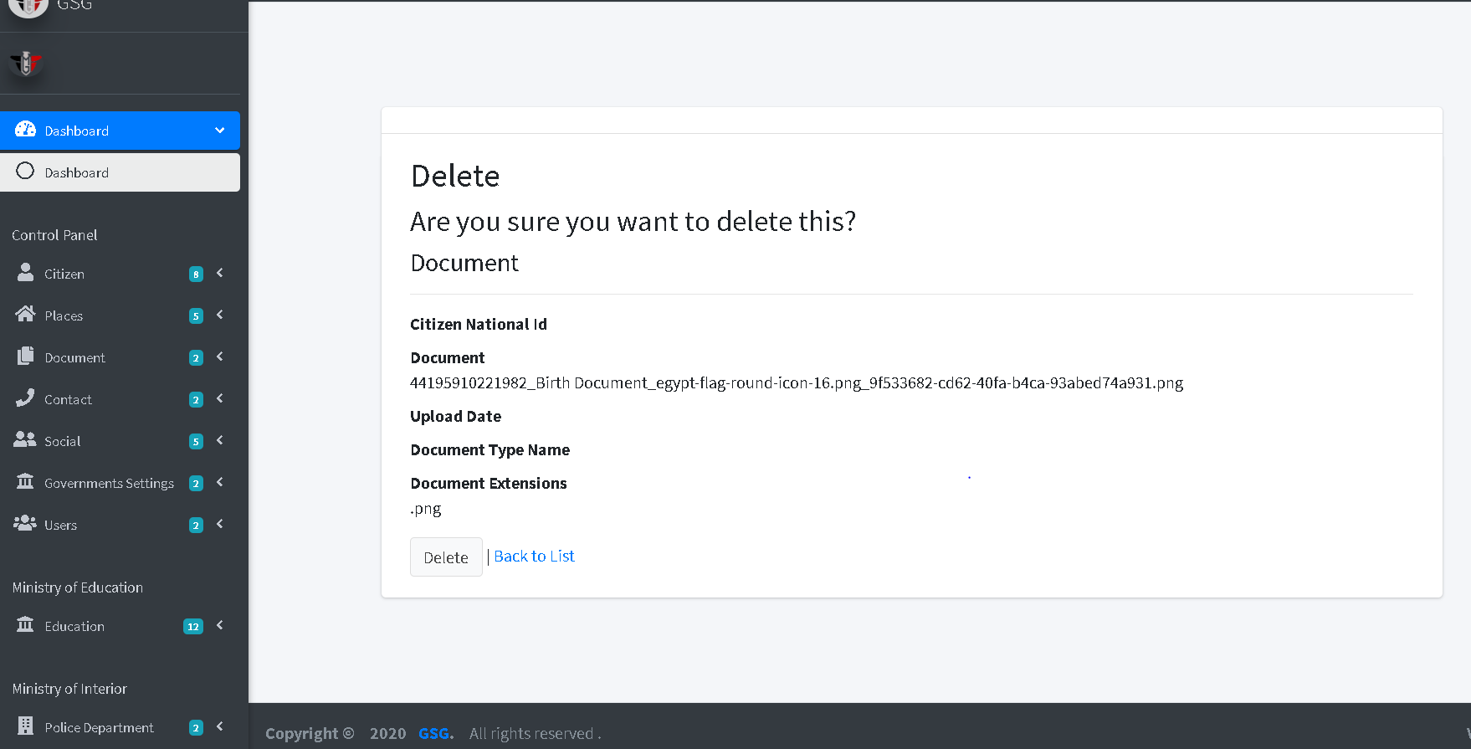

**Create Document Type**

The user must fill the required fields of the states then click on “create button”.

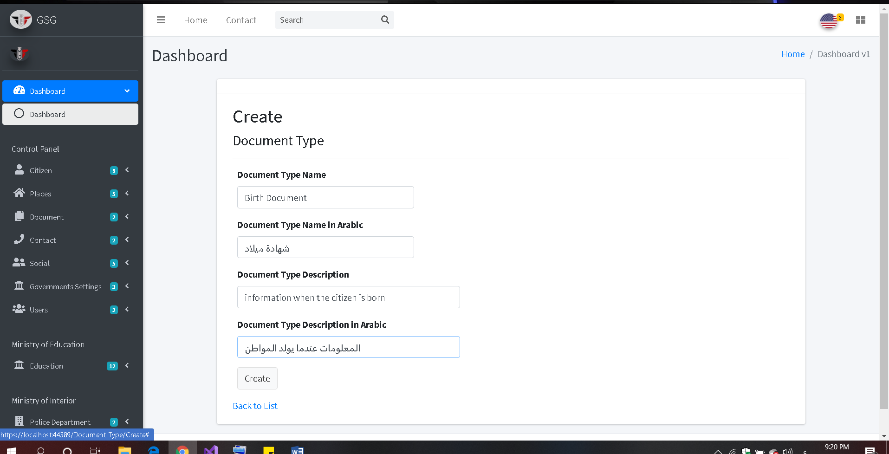

After clicking the submit button the system will redirect to the index page

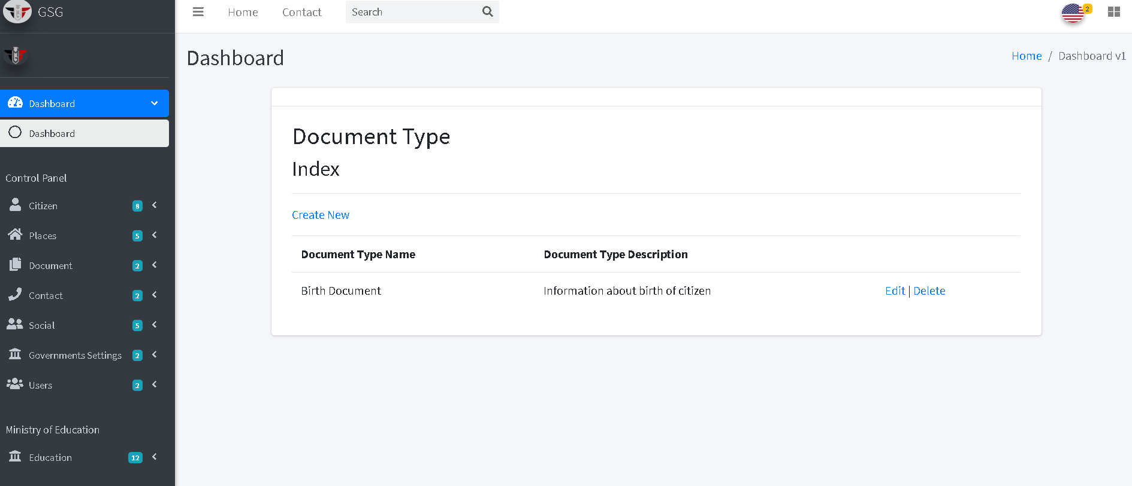

**Change the application languages**

The user could click on the icon on top right of the navigation bar then choose the language he want .

English:

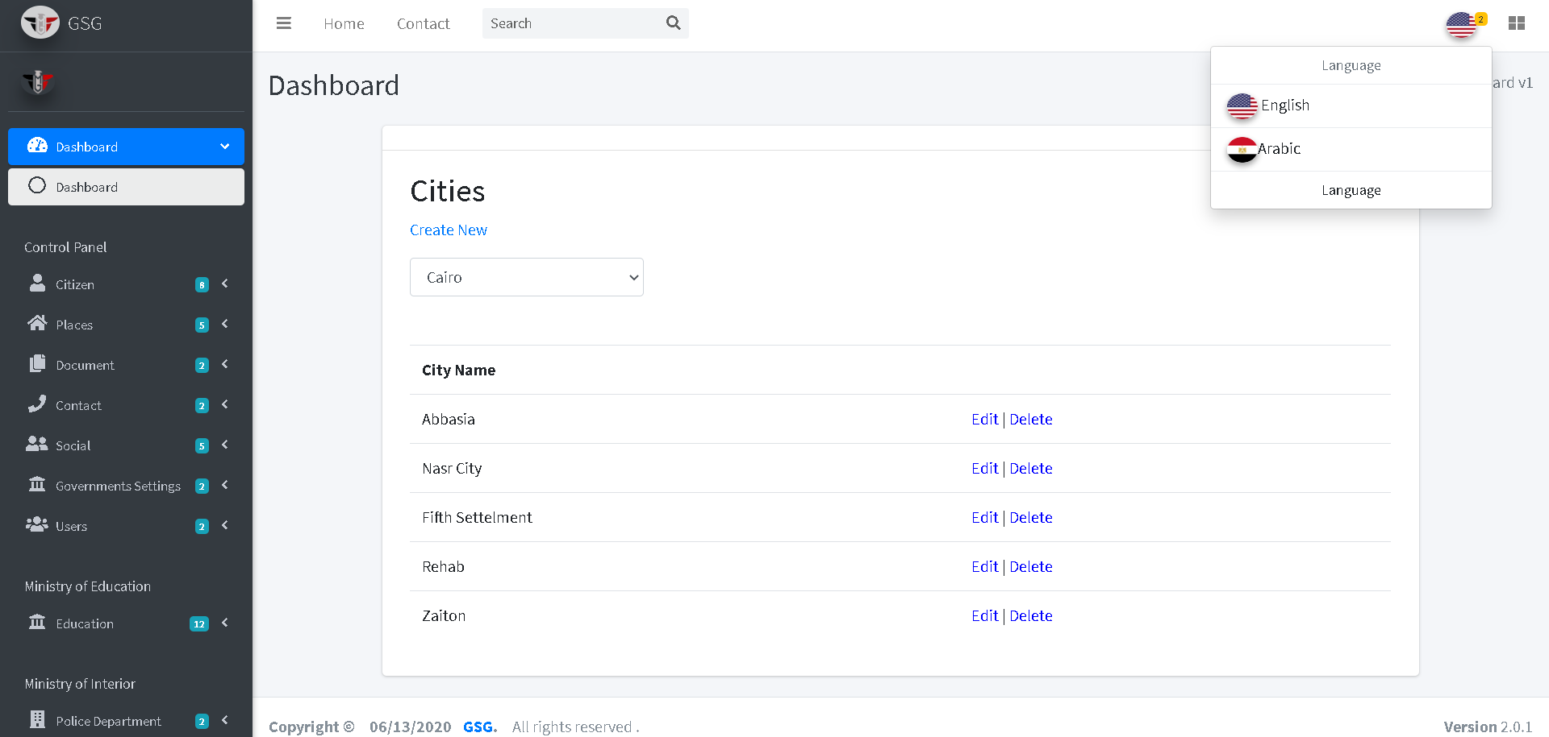

Arabic:

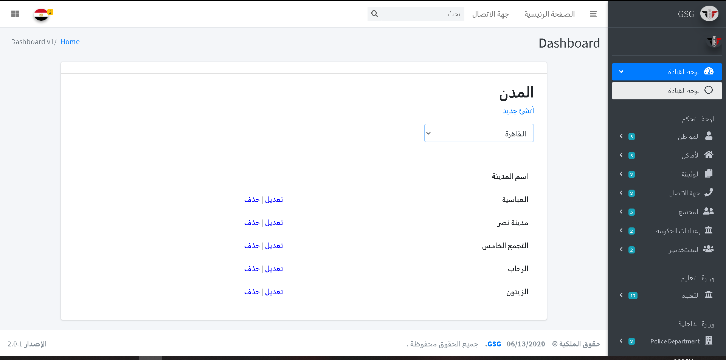

**Create social status type**

The user should fill the required fields the click on “create button”

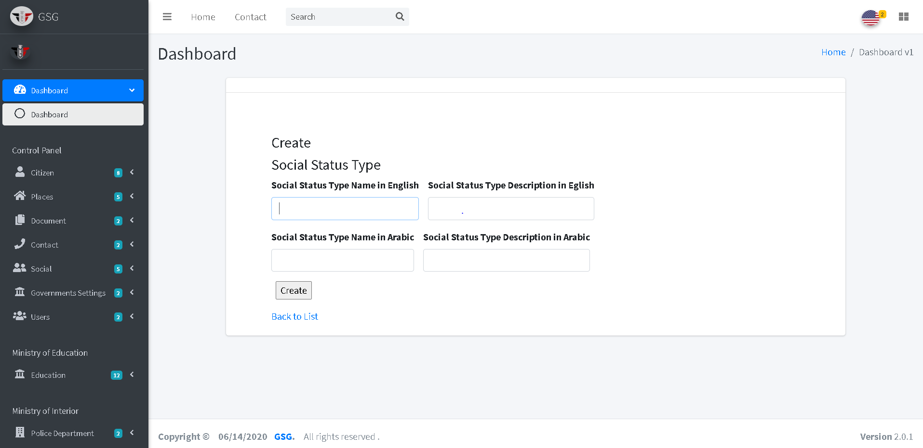

The system will redirect to the index page and display all the social status type.

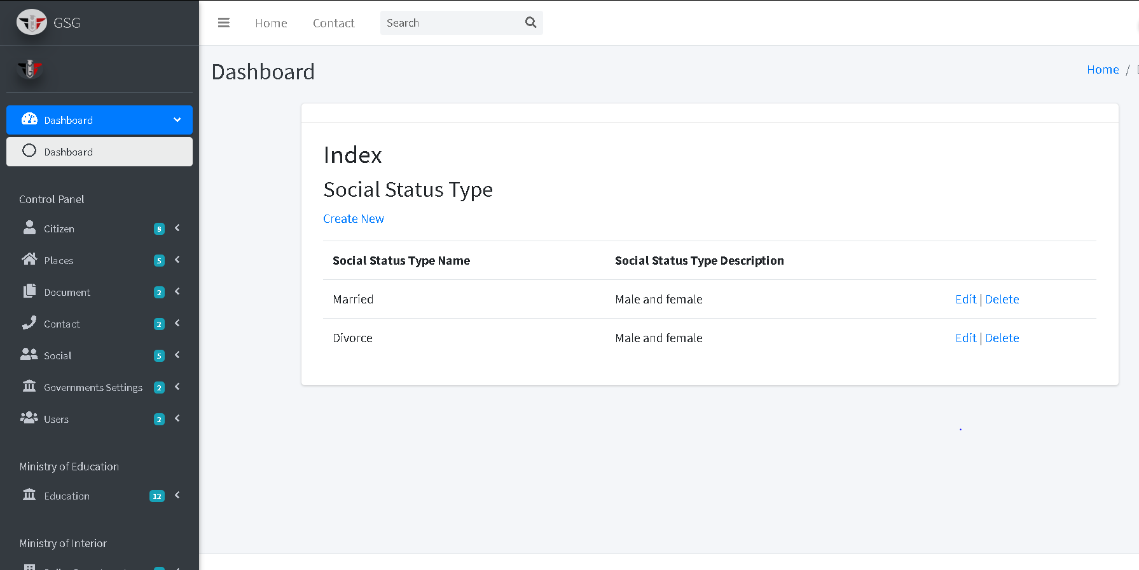

Then the user can edit or delete by click on “edit icon” or “trash icon”, the system will go to edit page and user can edit on the fields then click on “save button”

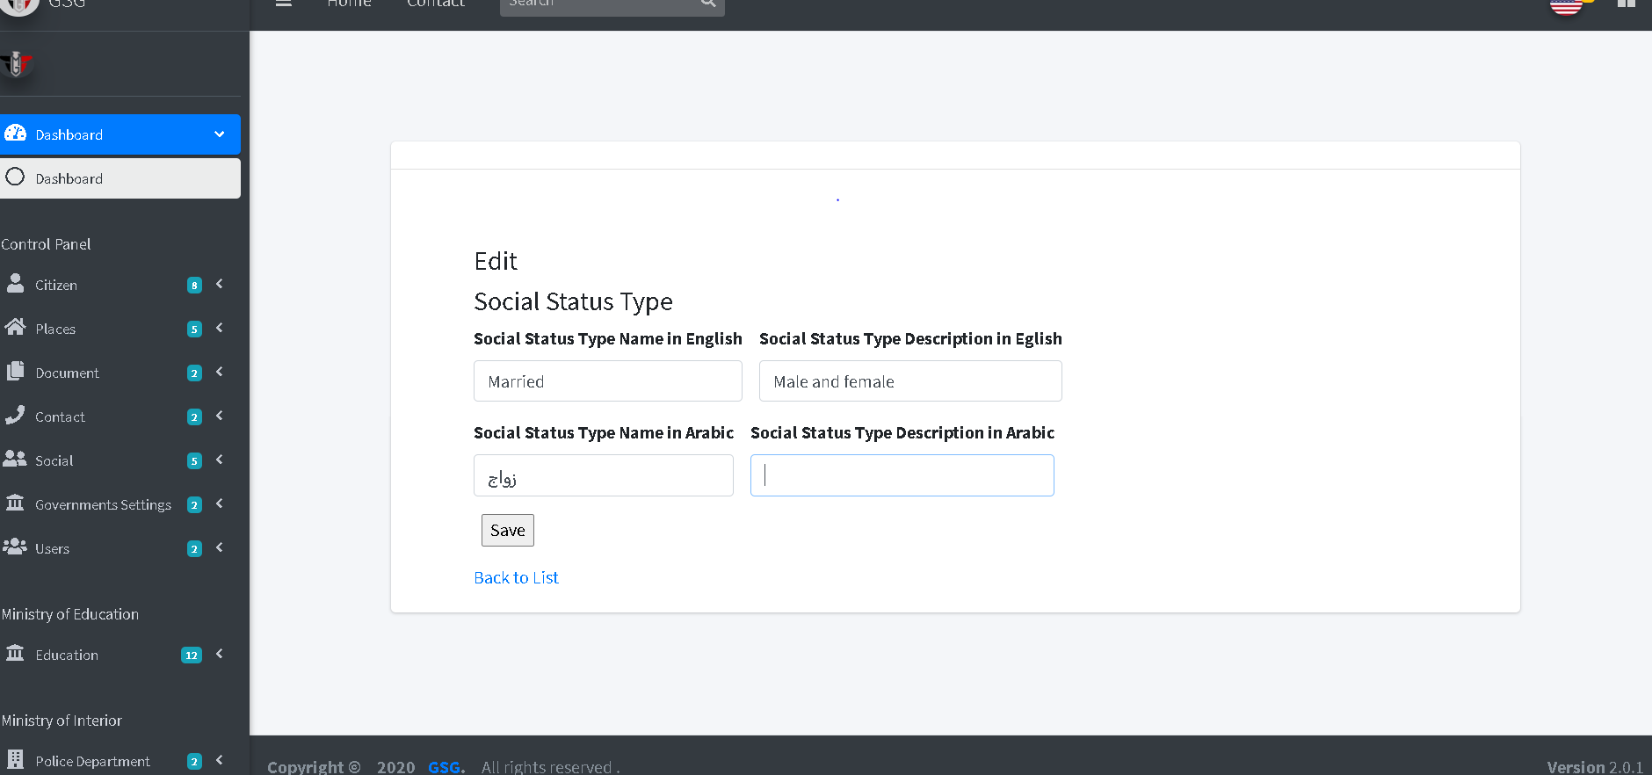

Or will go to delete page and user can confirm deletion by clicking on “delete button” then the system will redirect to index page.

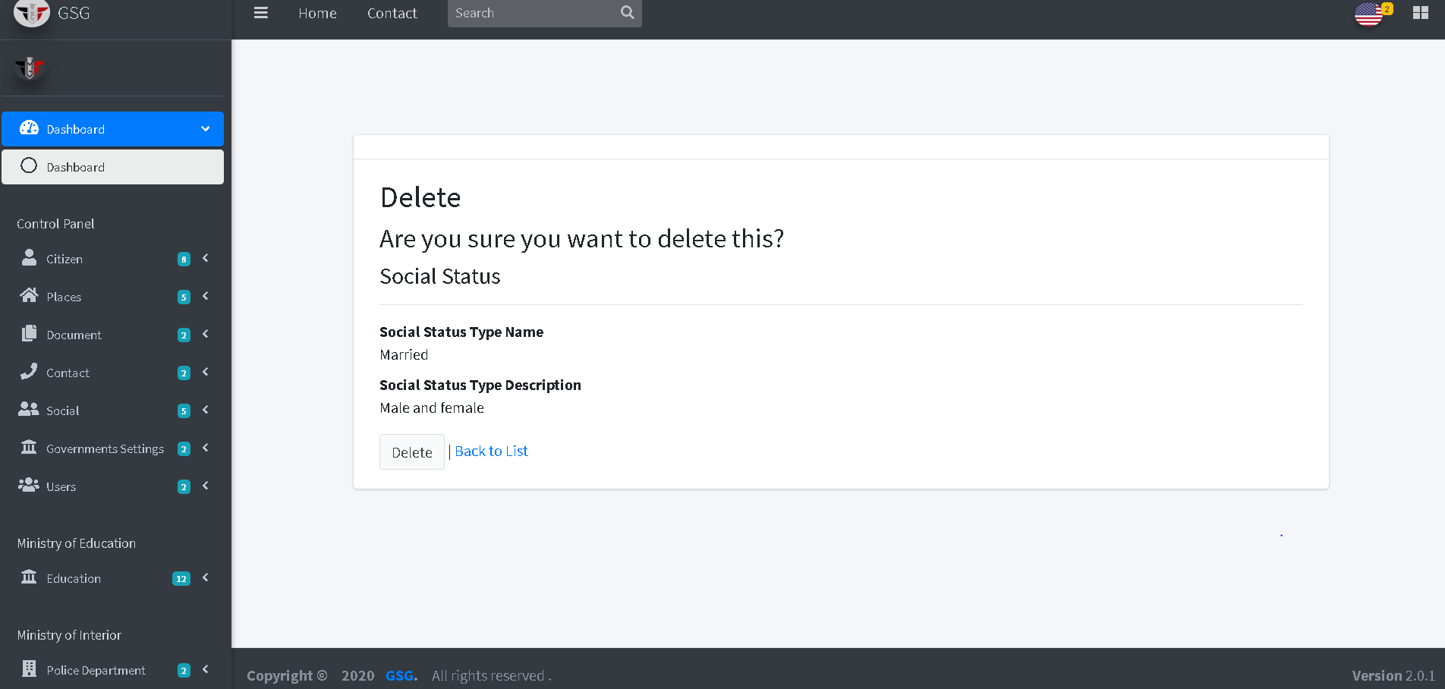

**Create Violation for cars**

The user should search or select car code from dropdown and select the violation type then click on “create button”

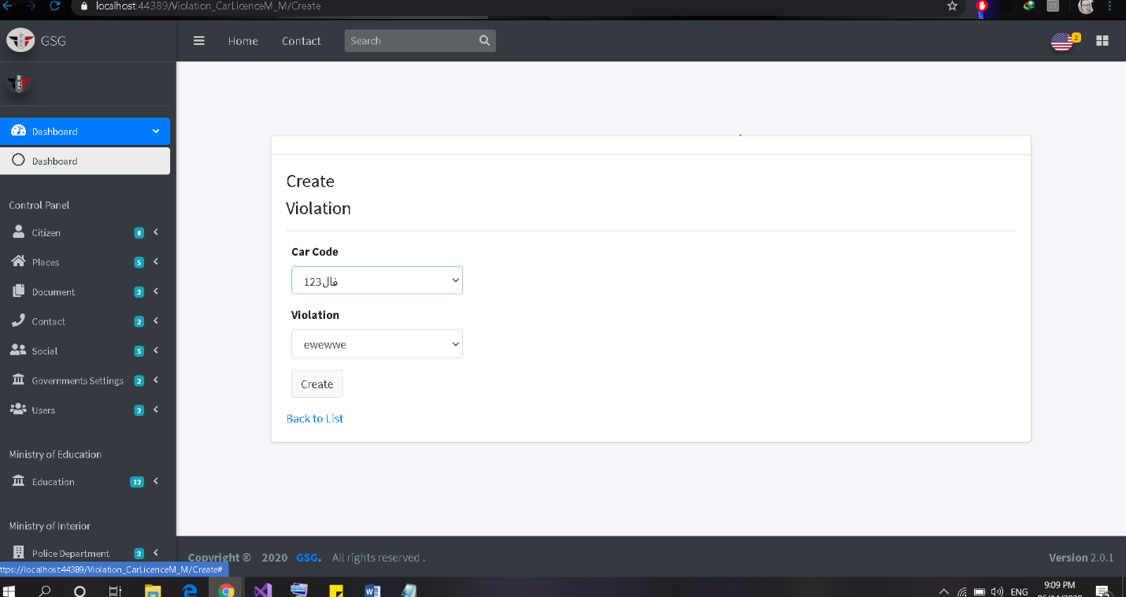

Then the system will redirect to the index page and user should select the car code to display who have it and have its violation.

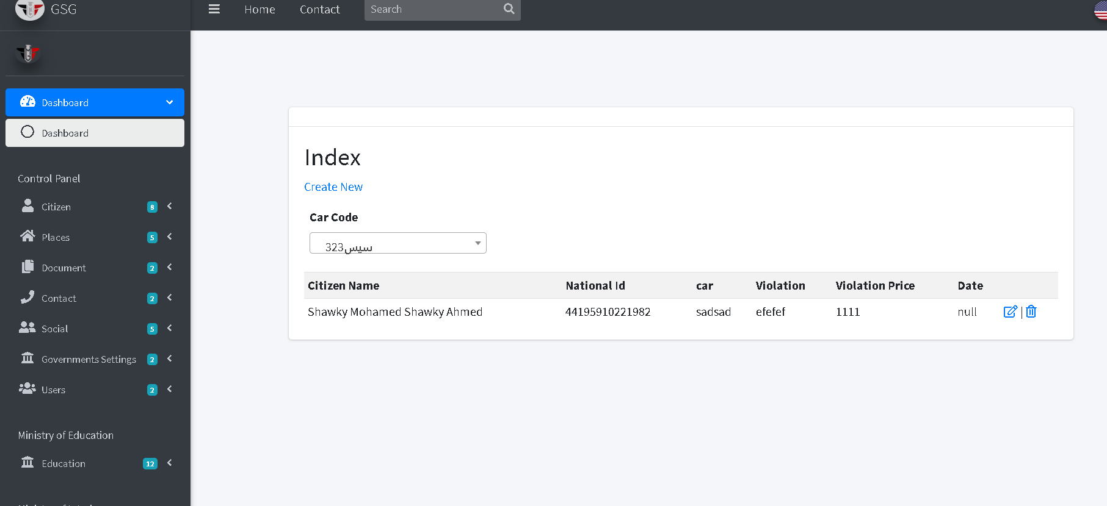

Then the user can edit or delete by click on “edit icon” or “trash icon”, the system will go to edit page and user can edit on the fields then click on “save button”

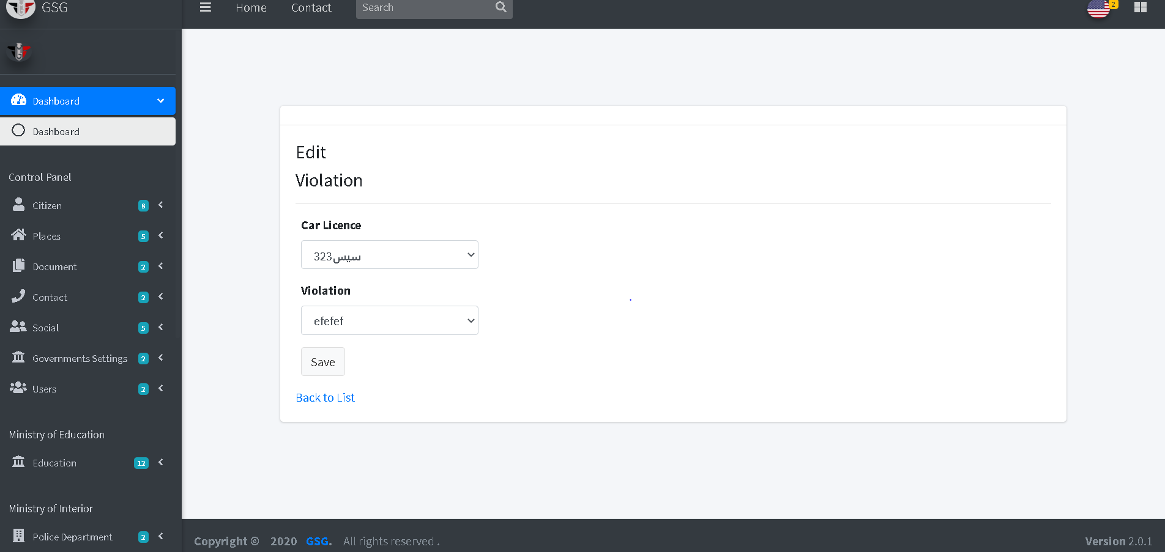

Or will go to delete page and user can confirm deletion by clicking on “delete button” then the system will redirect to index page.

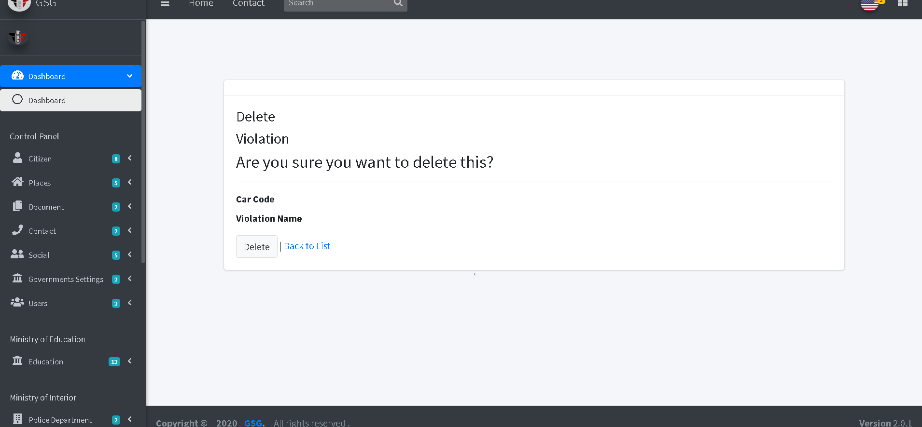

**Create a car license**

User must select national id of citizen and car name from its dropdowns then write the model of car and the code then click on “create button”

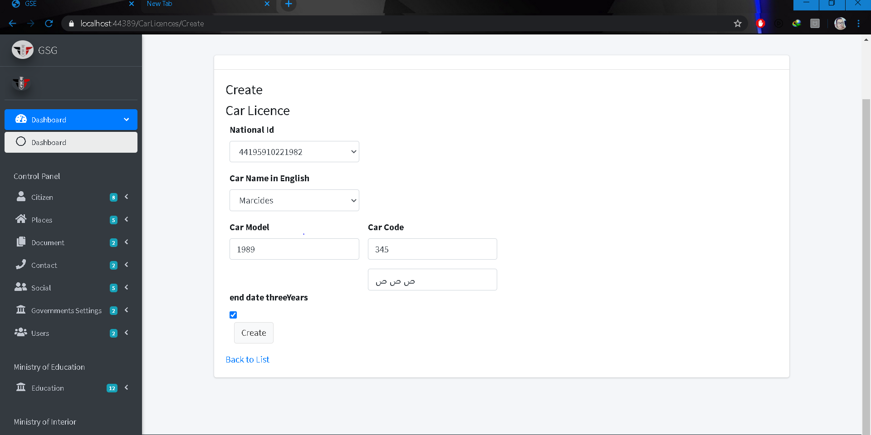

Then the system will redirect to the index page and user should select the national id of the citizen to display information of his/her car/s .

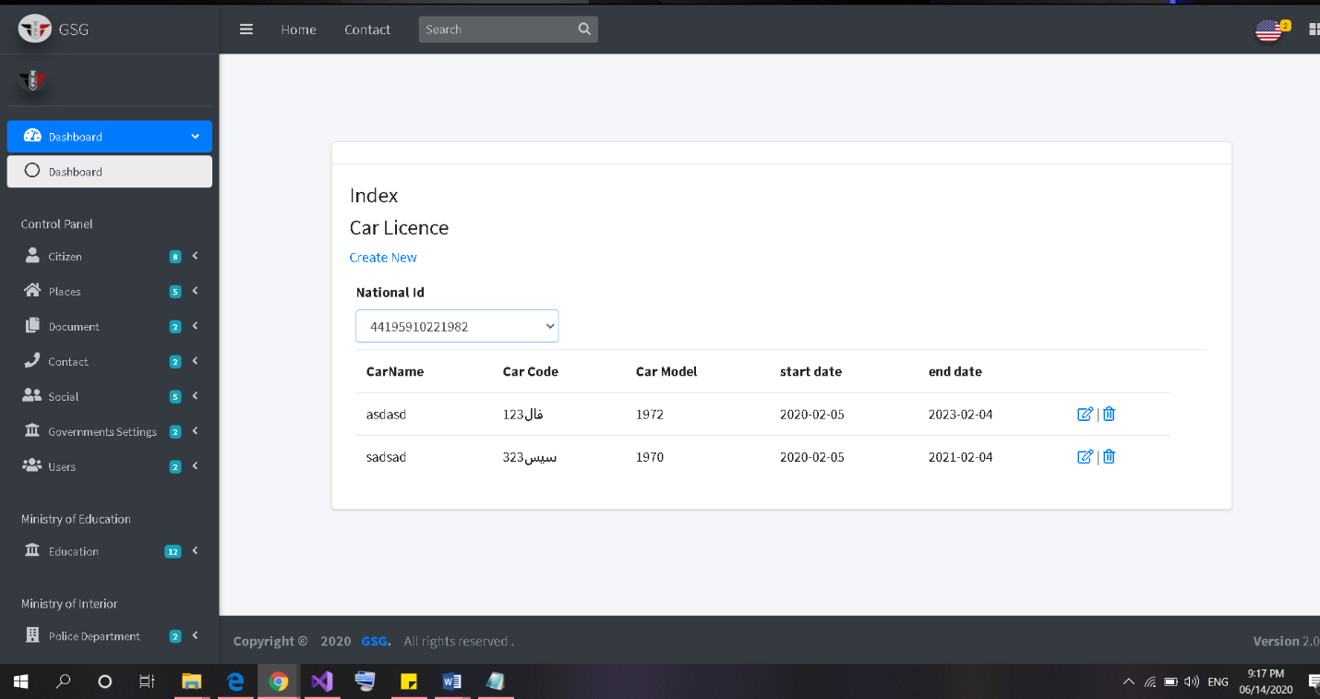

Then the user can edit or delete by click on “edit icon” or “trash icon”, the system will go to edit page and user can edit on the fields then click on “save button”

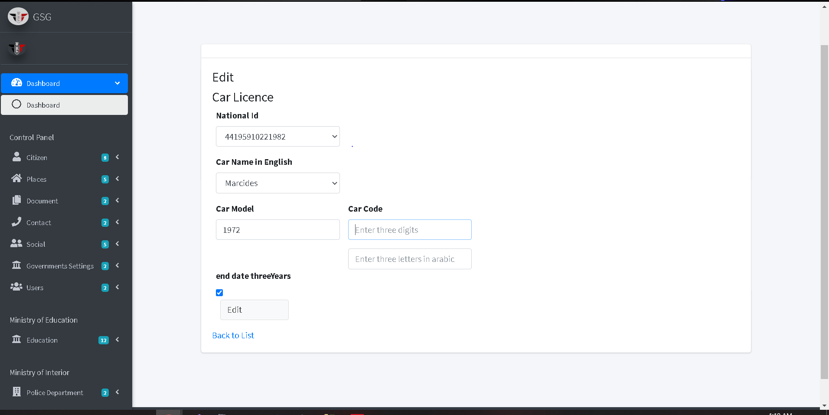

Or will go to delete page and user can confirm deletion by clicking on “delete button” then the system will redirect to index page.

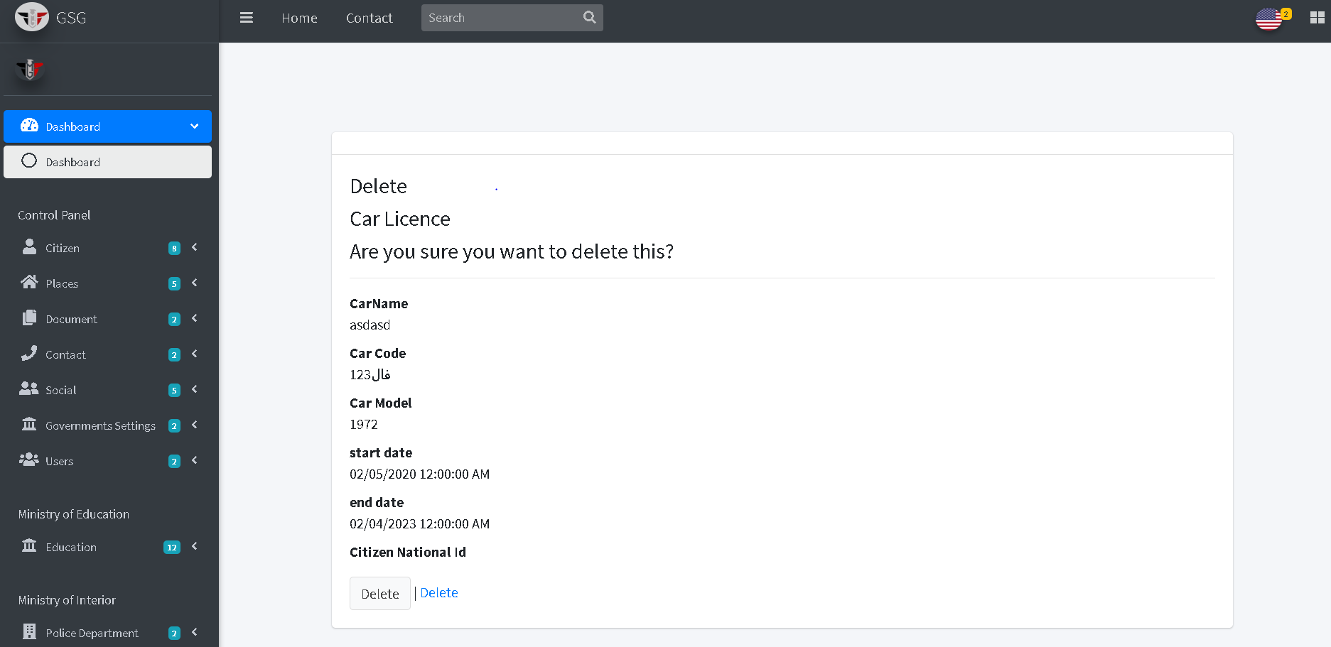

**Create university**

The user should specify the address of the university and write its name then click on “create button”

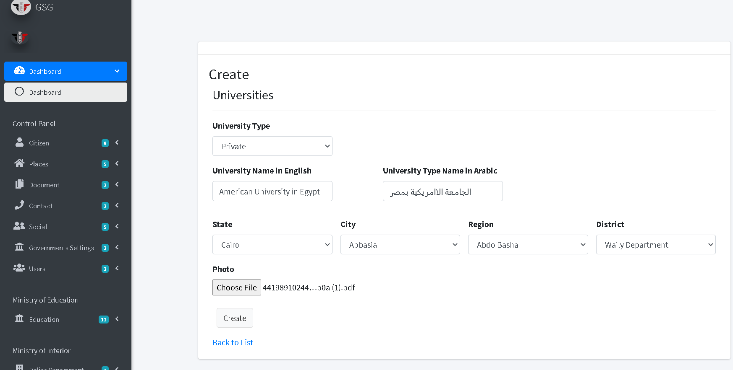

The system will redirect to index page and user should specify the address to display all university of the selected address

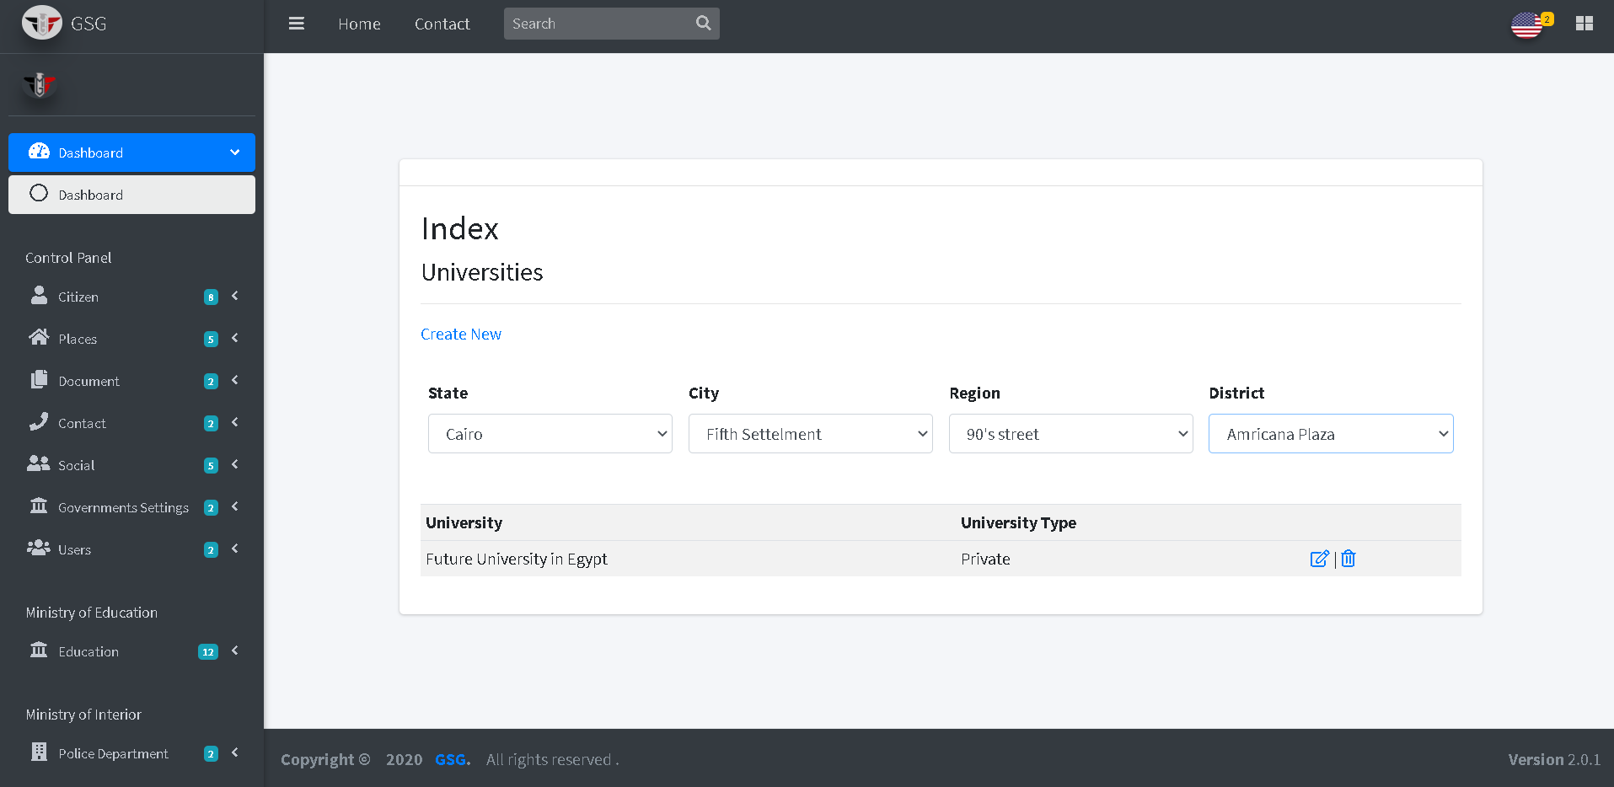

Then the user can edit or delete by click on “edit icon” or “trash icon”, the system will go to edit page and user can edit on the fields then click on “save button”

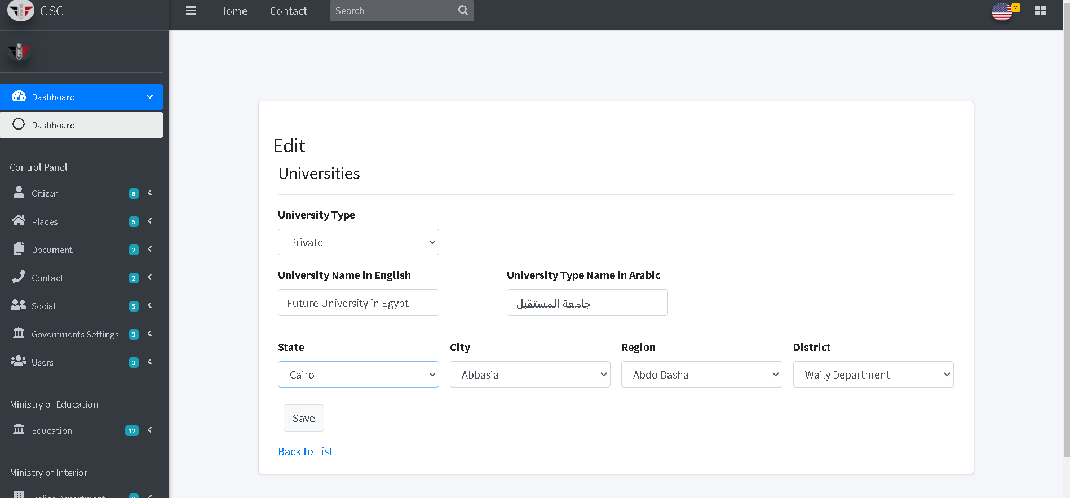

Or will go to delete page and user can confirm deletion by clicking on “delete button” then the system will redirect to index page.

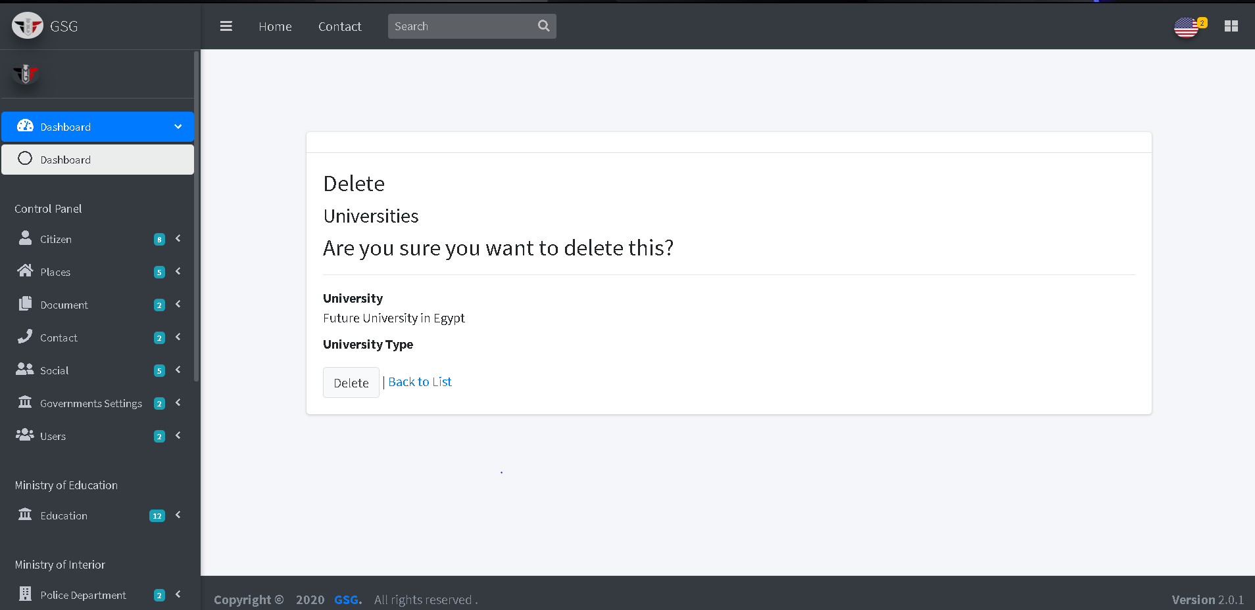

**Create faculty**

User must enter name of the faculty and specify how mush year and the section of school the click on “create button”

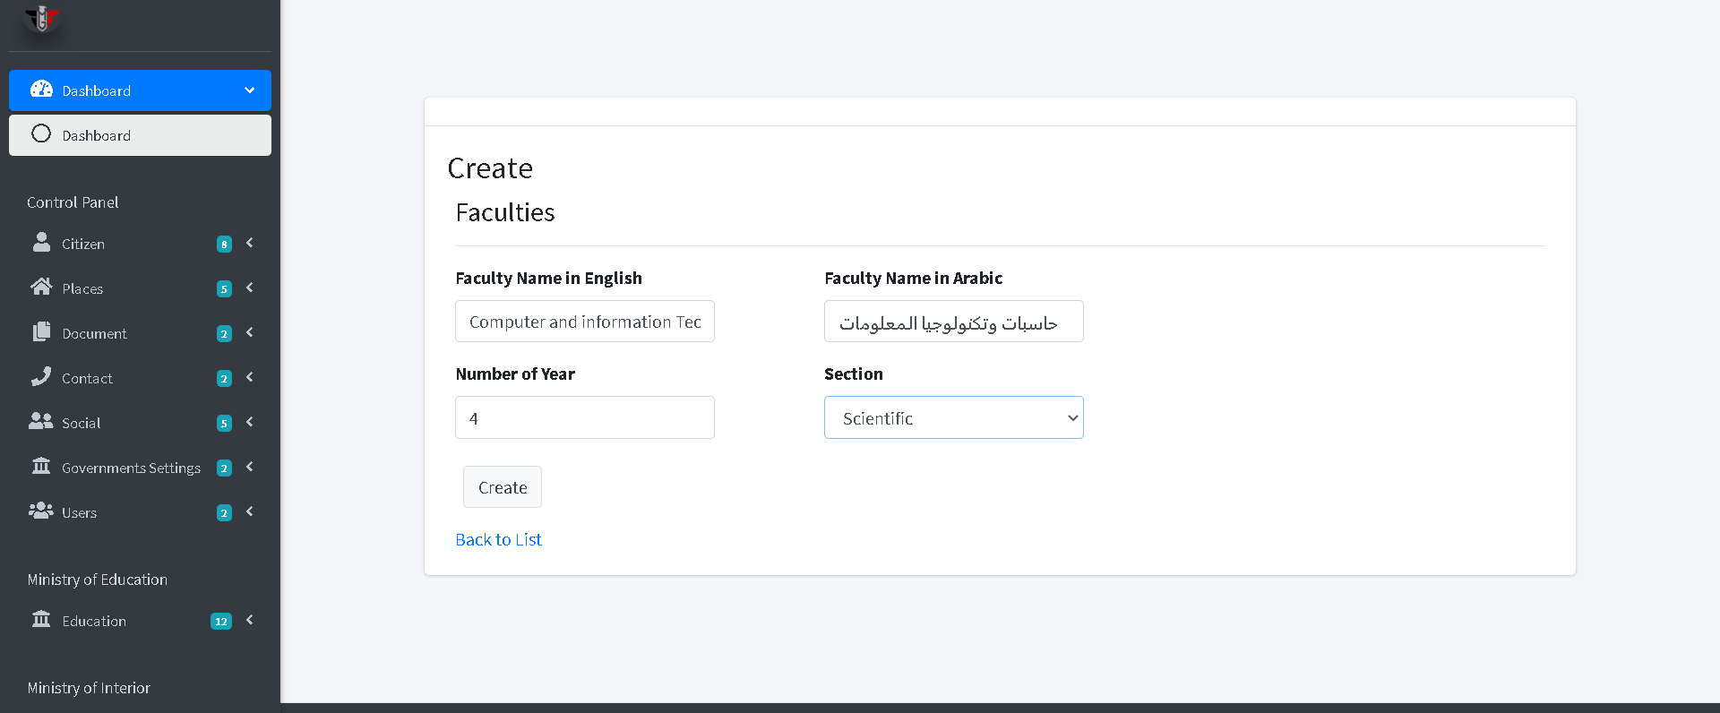

The system will redirect to index page to display all faculties in Egypt

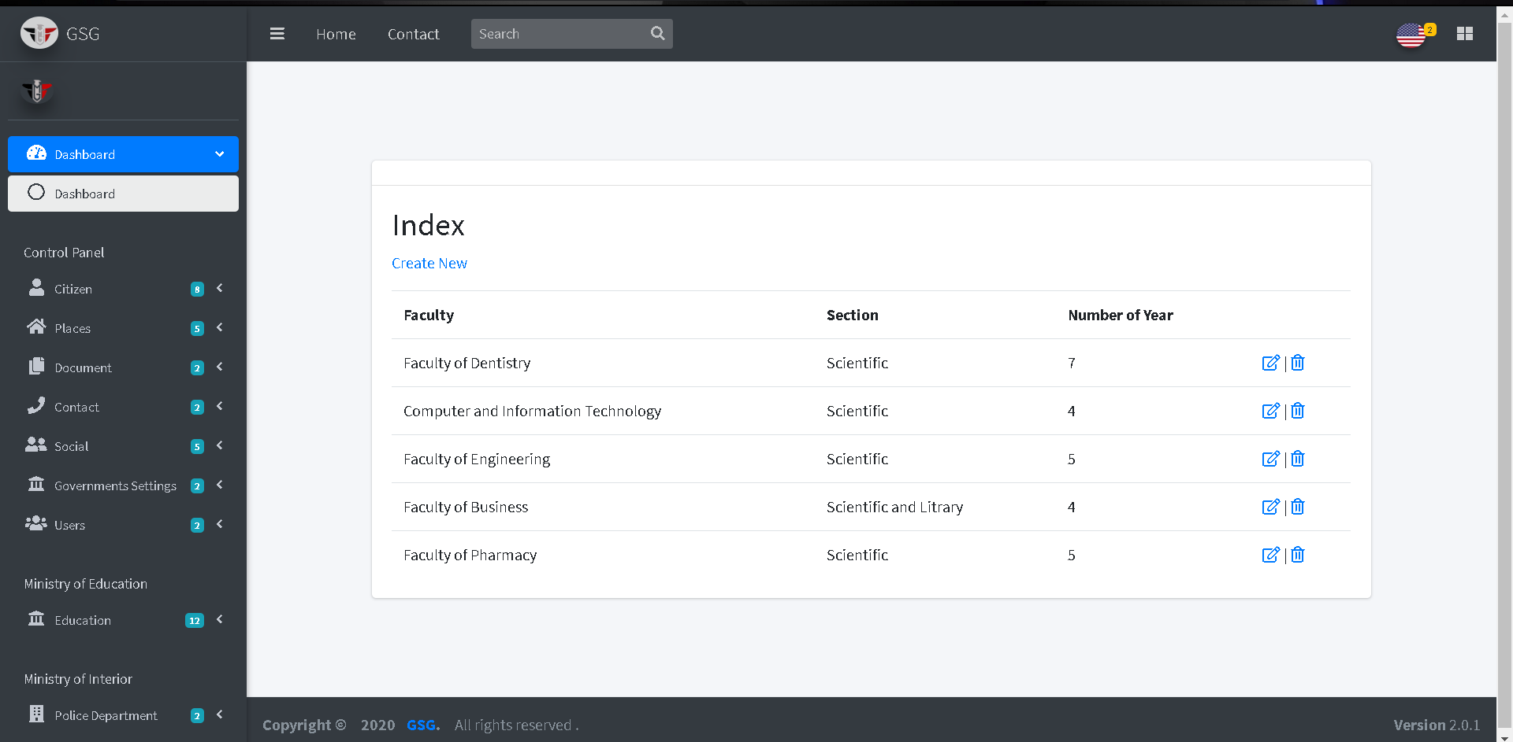

Then the user can edit or delete by click on “edit icon” or “trash icon”, the system will go to edit page and user can edit on the fields then click on “save button”

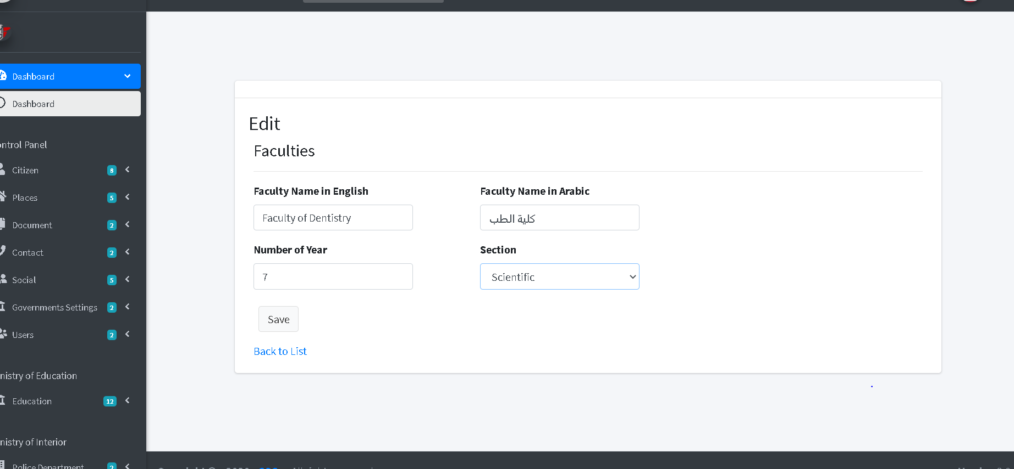

Or will go to delete page and user can confirm deletion by clicking on “delete button” then the system will redirect to index page.

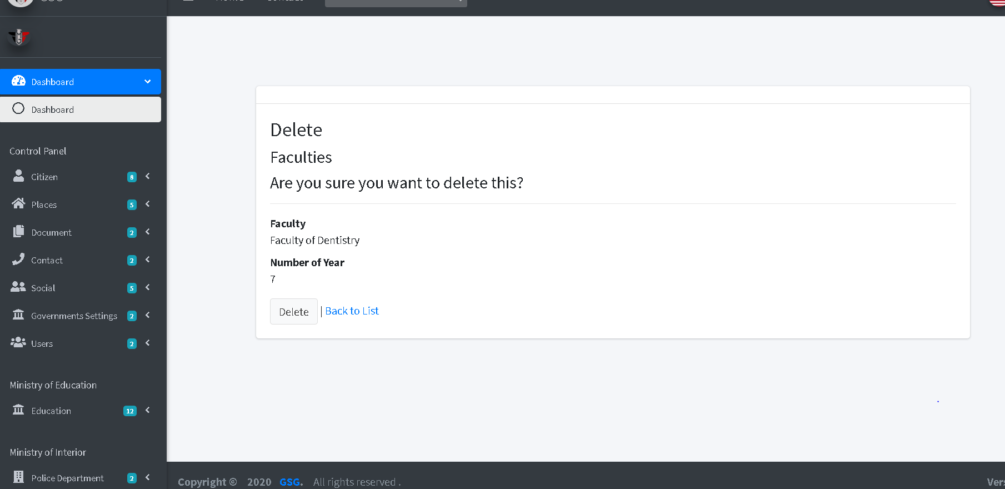

**Create school**

User must specify the address of the school and its type and enter name of it the click on “create button”

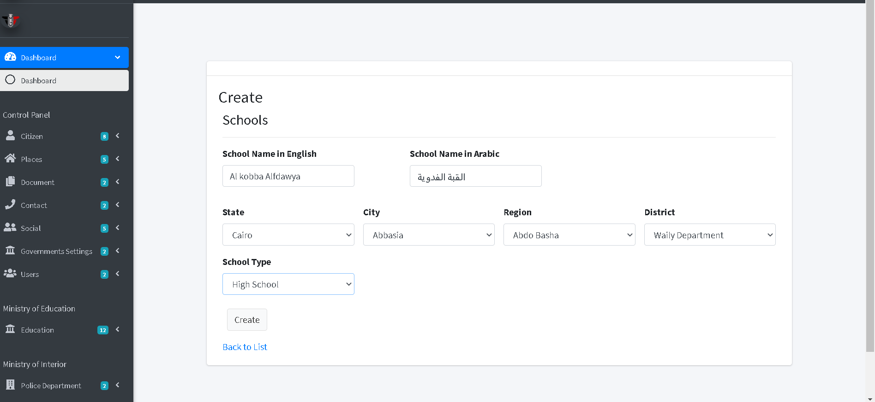

The system will redirect to index page and user should specify the address to display all Schools of the selected address

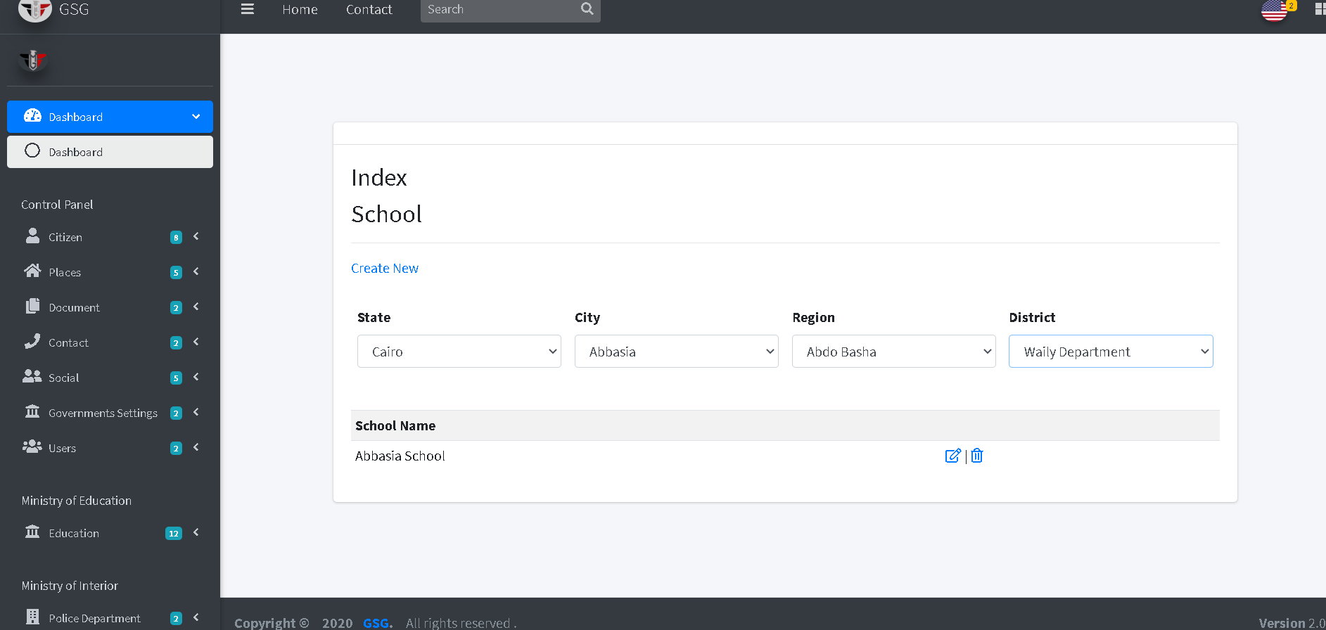

Then the user can edit or delete by click on “edit icon” or “trash icon”, the system will go to edit page and user can edit on the fields then click on “save button”

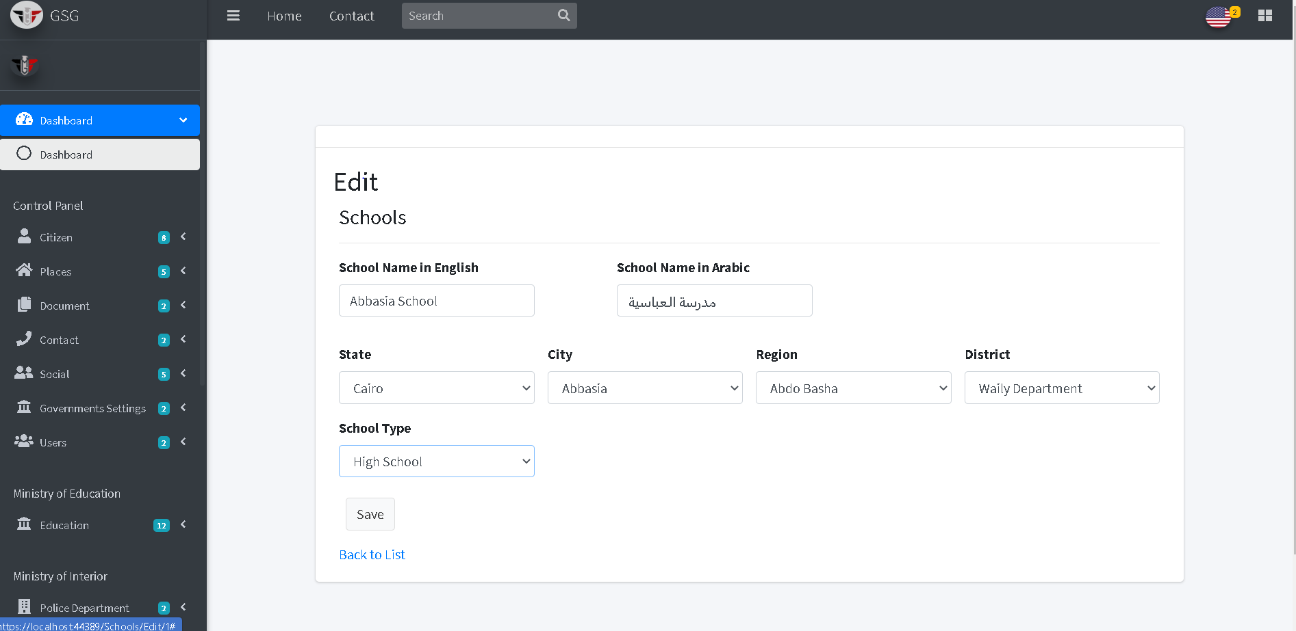

Or will go to delete page and user can confirm deletion by clicking on “delete button” then the system will redirect to index page. 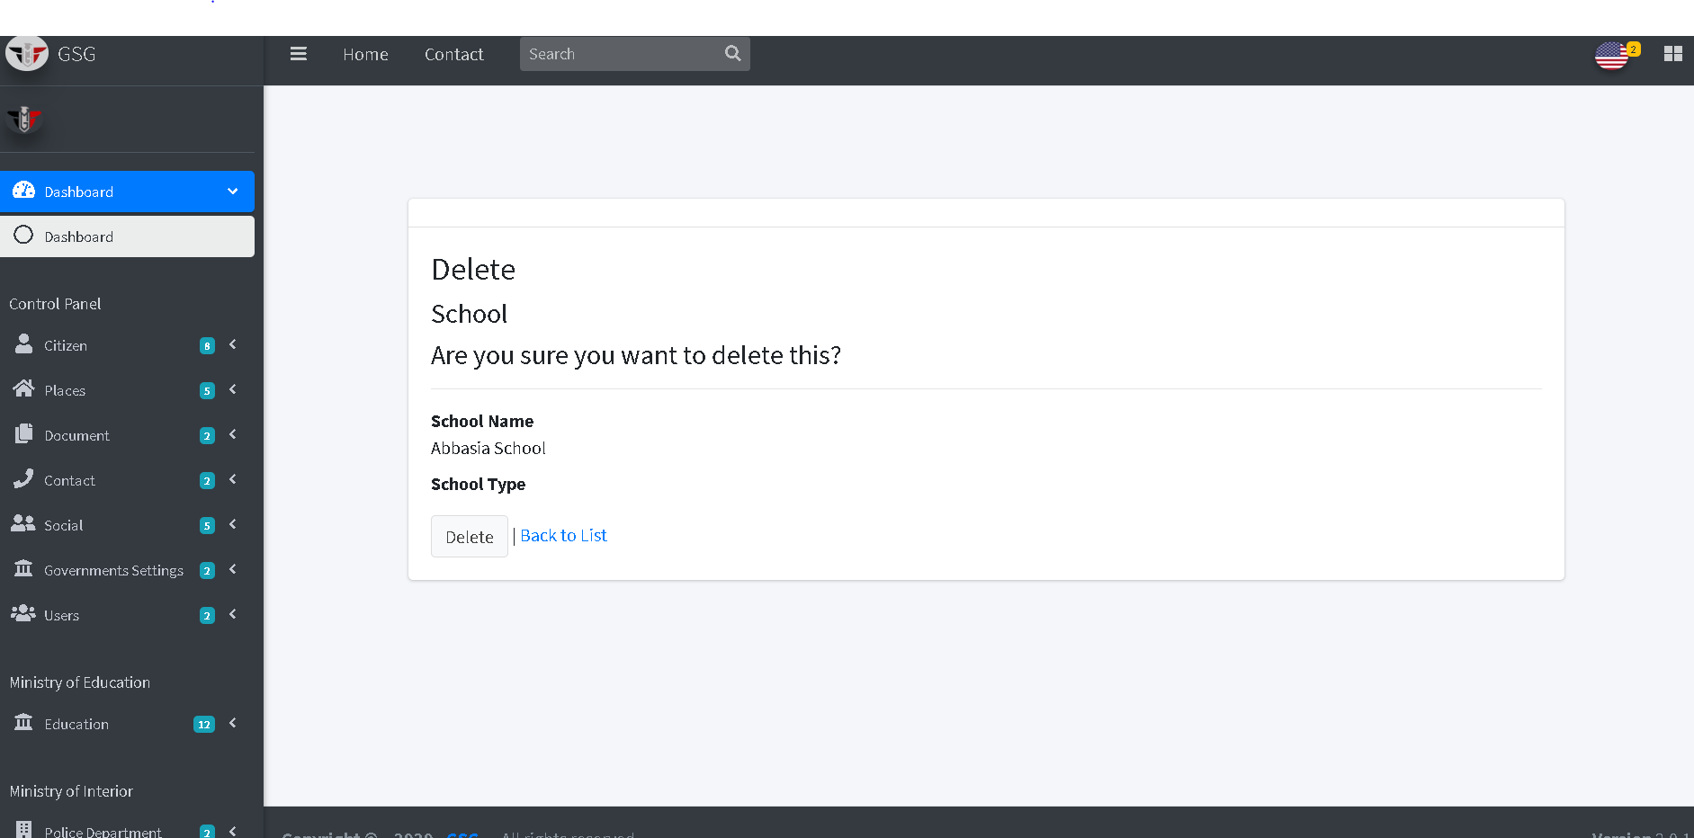

**Create Educational directorate**

The user should enter the directorate name and specify the administration the belongs to then click on “create button”

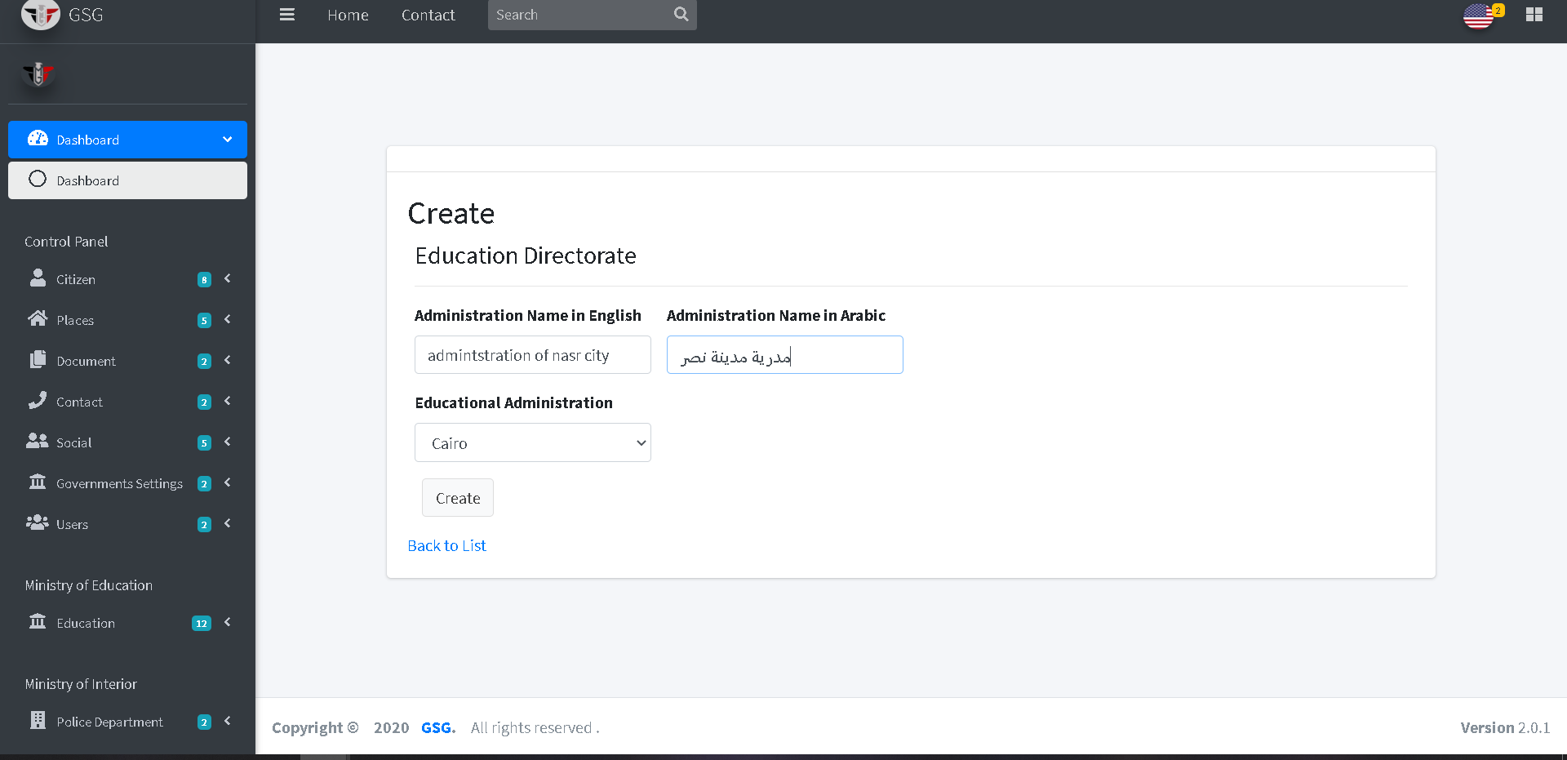

Then the system will redirect the index page to display all directorate by selected administration

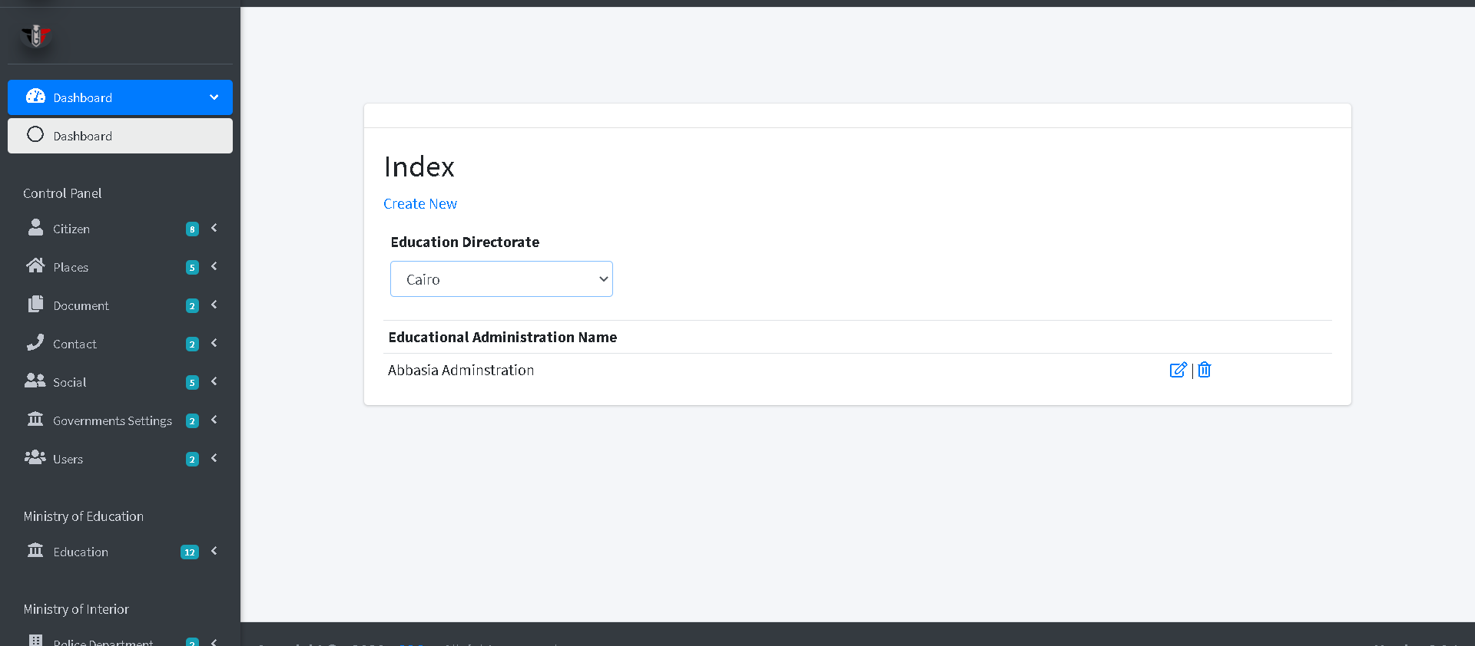

Then the user can edit or delete by click on “edit icon” or “trash icon”, the system will go to edit page and user can edit on the fields then click on “save button”

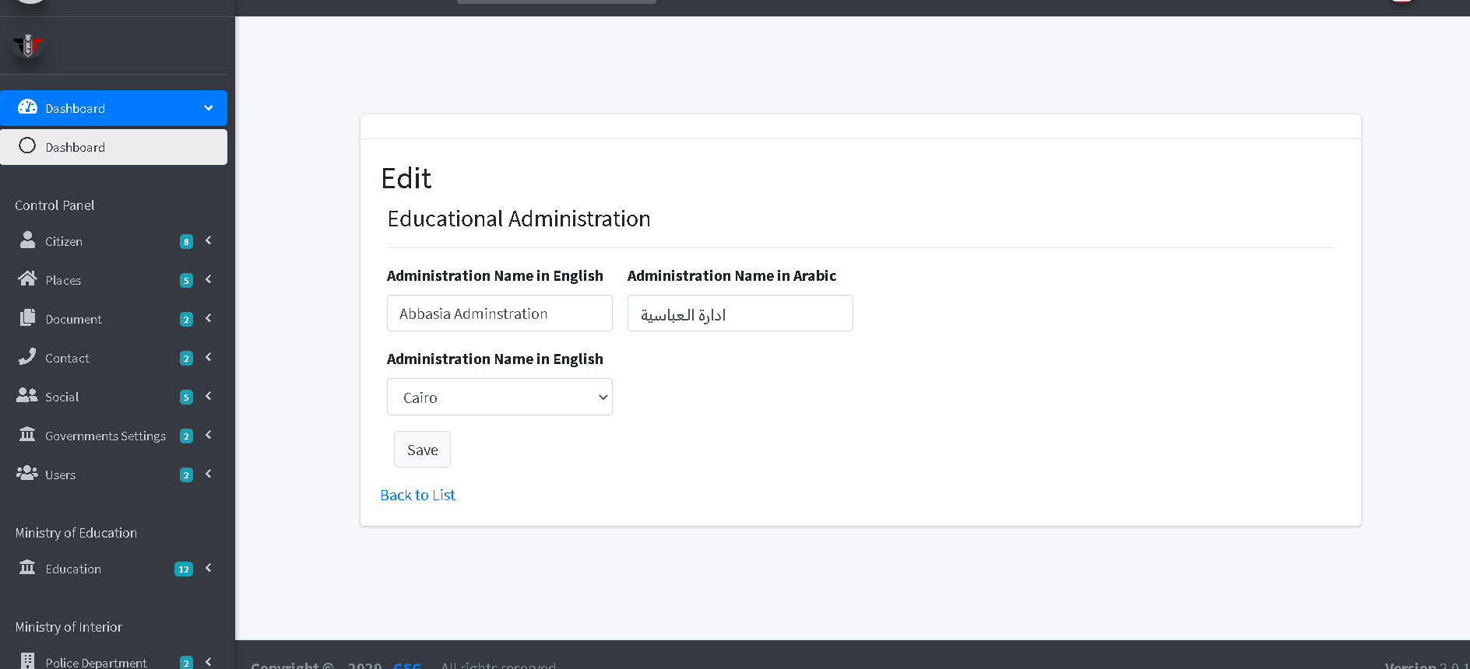

Or will go to delete page and user can confirm deletion by clicking on “delete button” then the system will redirect to index page.

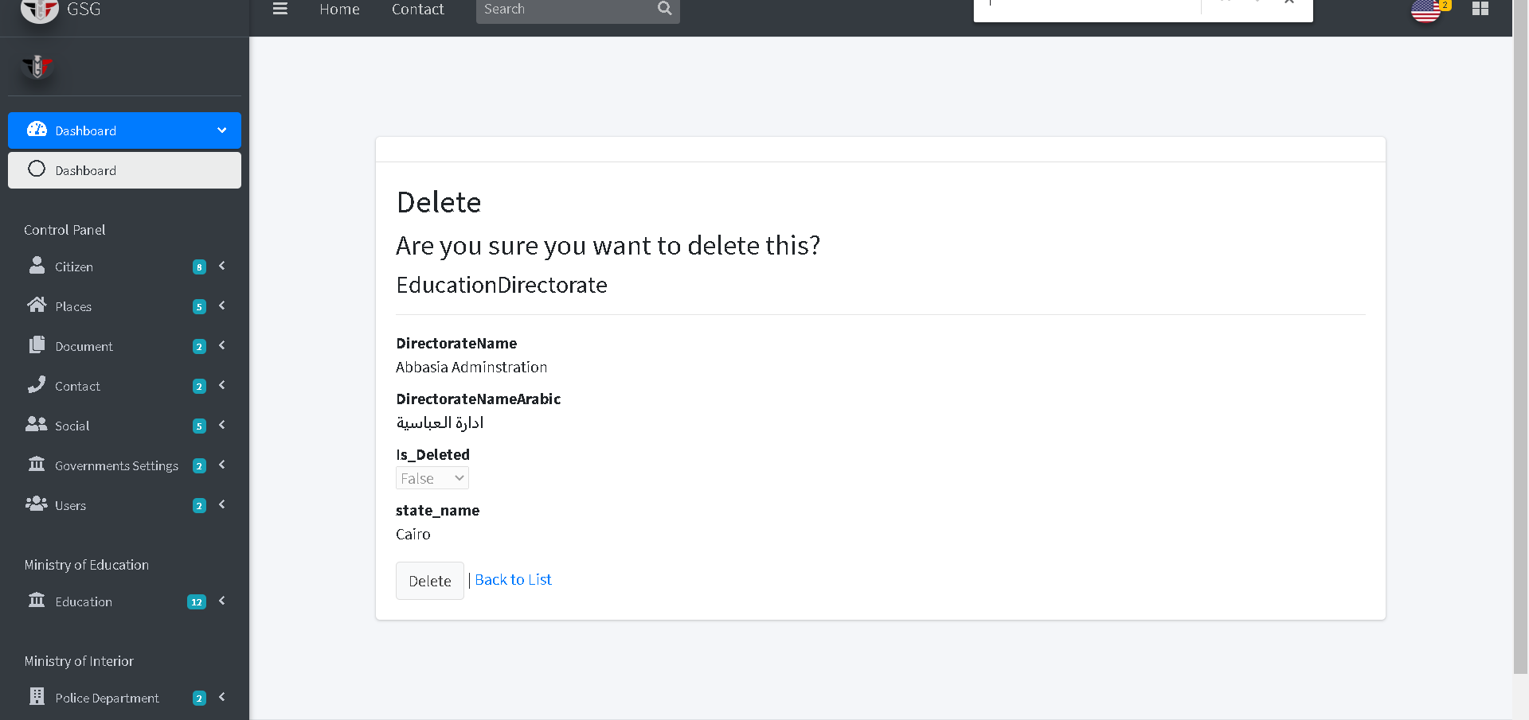

**Create specialization of faculty**

User must write the specialization name and specify its faculty and university the click on “create button”

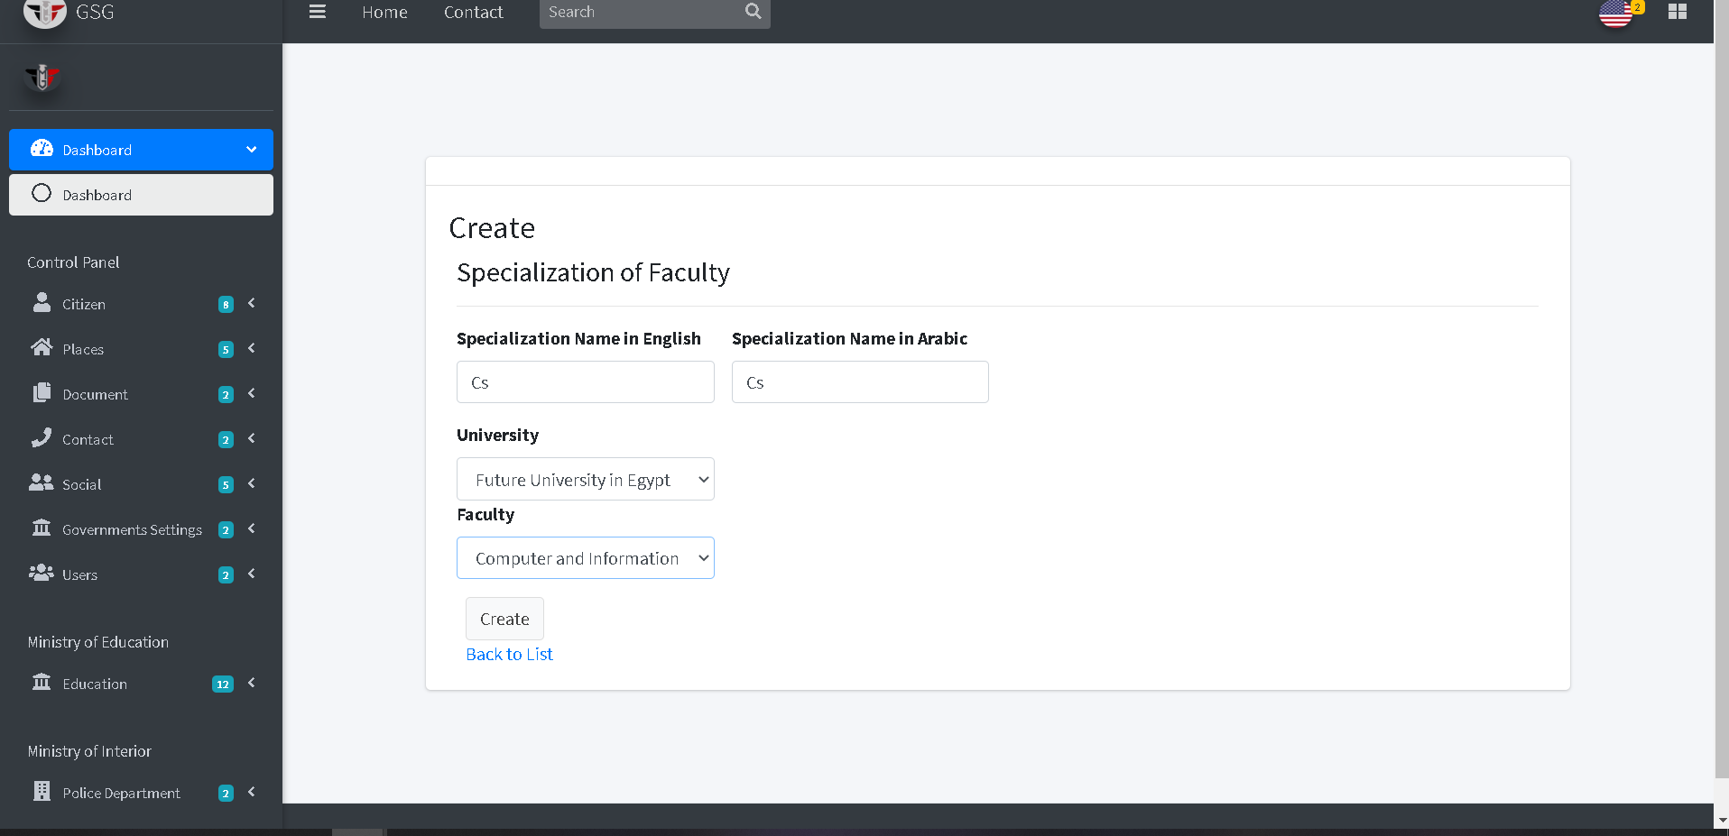

Then the system will redirect to the index page then display all specialization the specific faculty belongs to selected university.

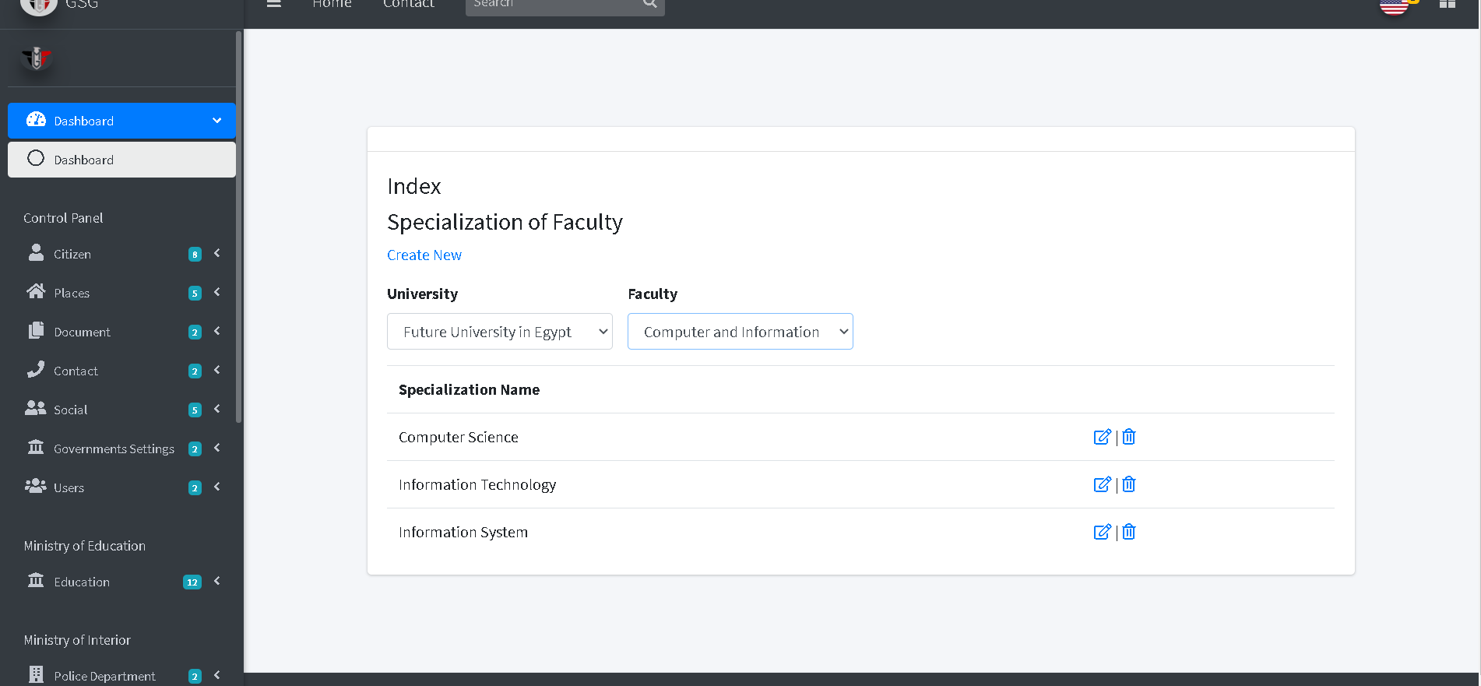

Then the user can edit or delete by click on “edit icon” or “trash icon”, the system will go to edit page and user can edit on the fields then click on “edit button”

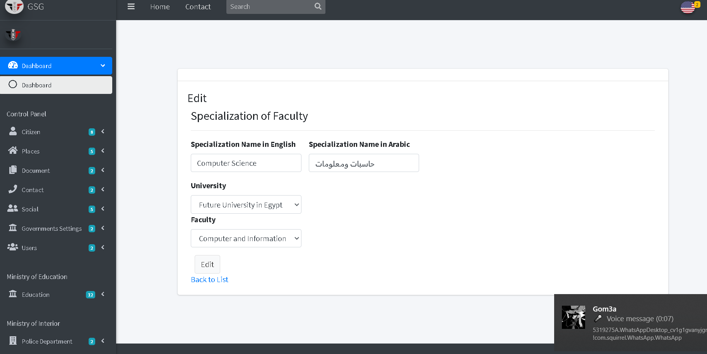

Or will go to delete page and user can confirm deletion by clicking on “delete button” then the system will redirect to index page.

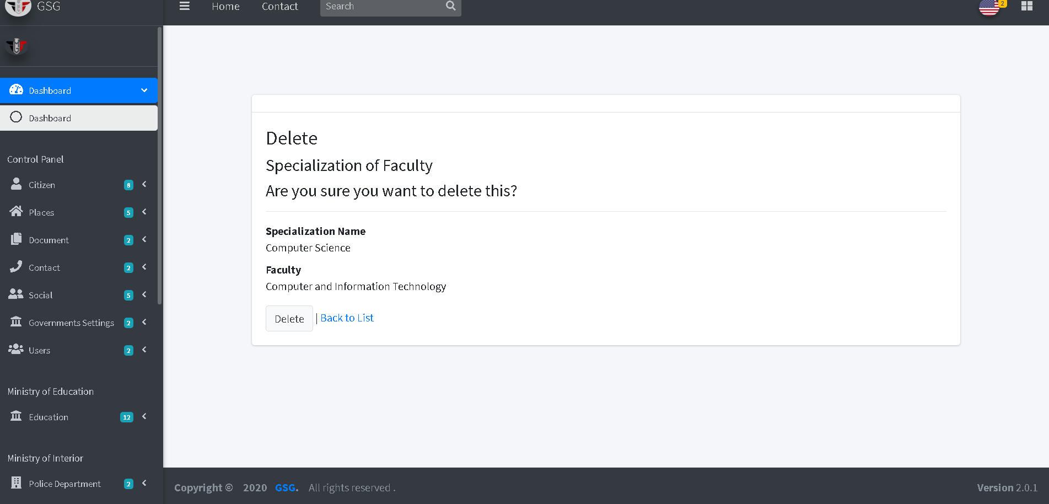

**Add new student**

The system will display to the user two boxes for the student in Egypt and that educated abroad to add

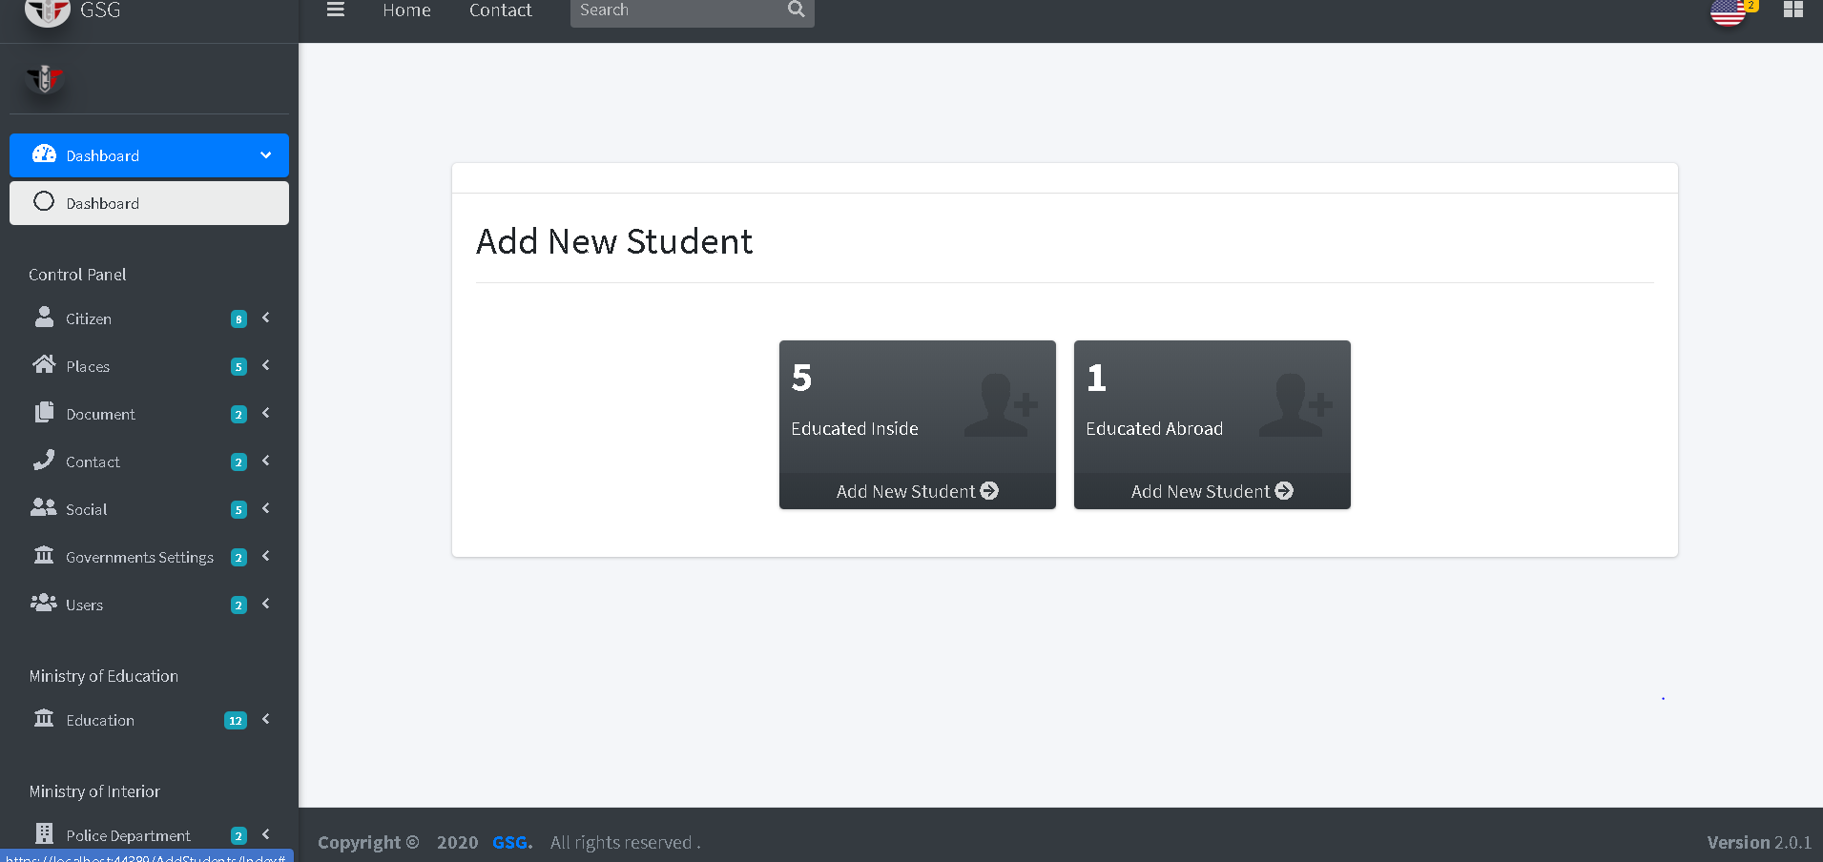

If the user click on “educated inside card” the system will show all phases of the education and how many student in each phase should added in the system

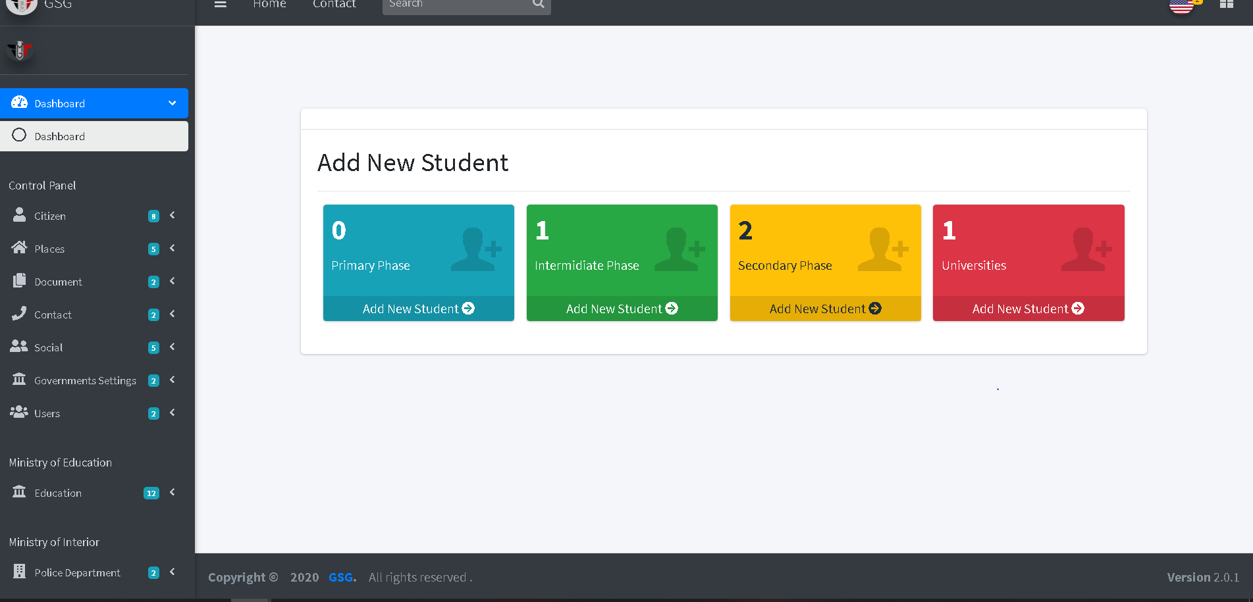

Then the user should click on one of four cards to add students in each phase of education, so the user should fill the fields to add student in specific phase

Intermediate phase: the user should select or search for national id of student and select School by specify the address of it then click on “create button “

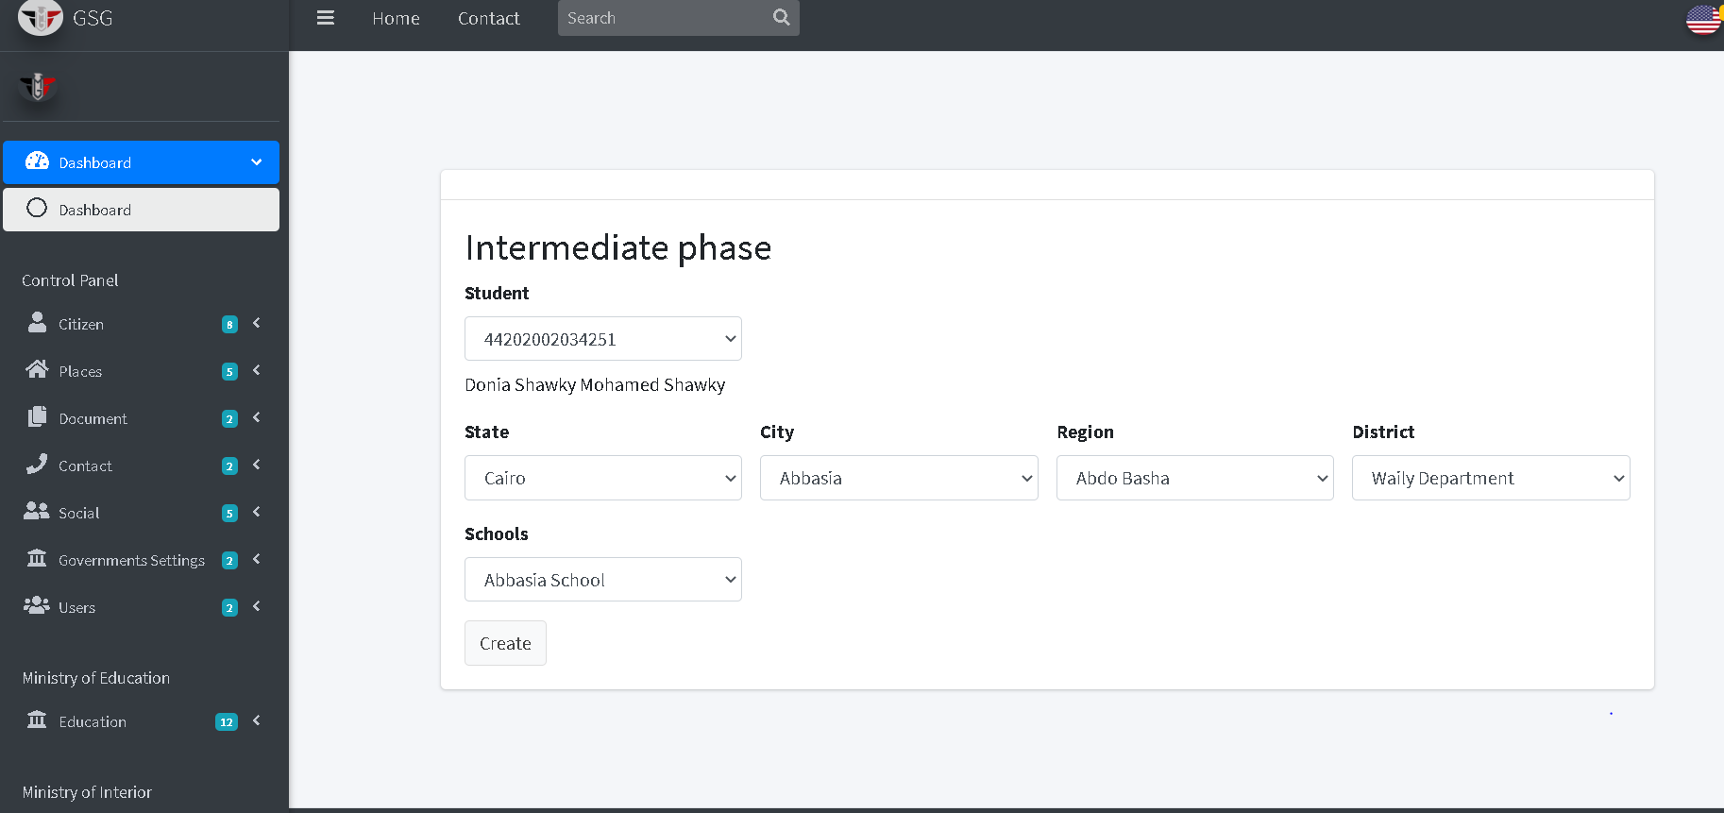

Then the system will go to the index page and display all student by selecting a school and its address, so the user can find student in that school he searched.

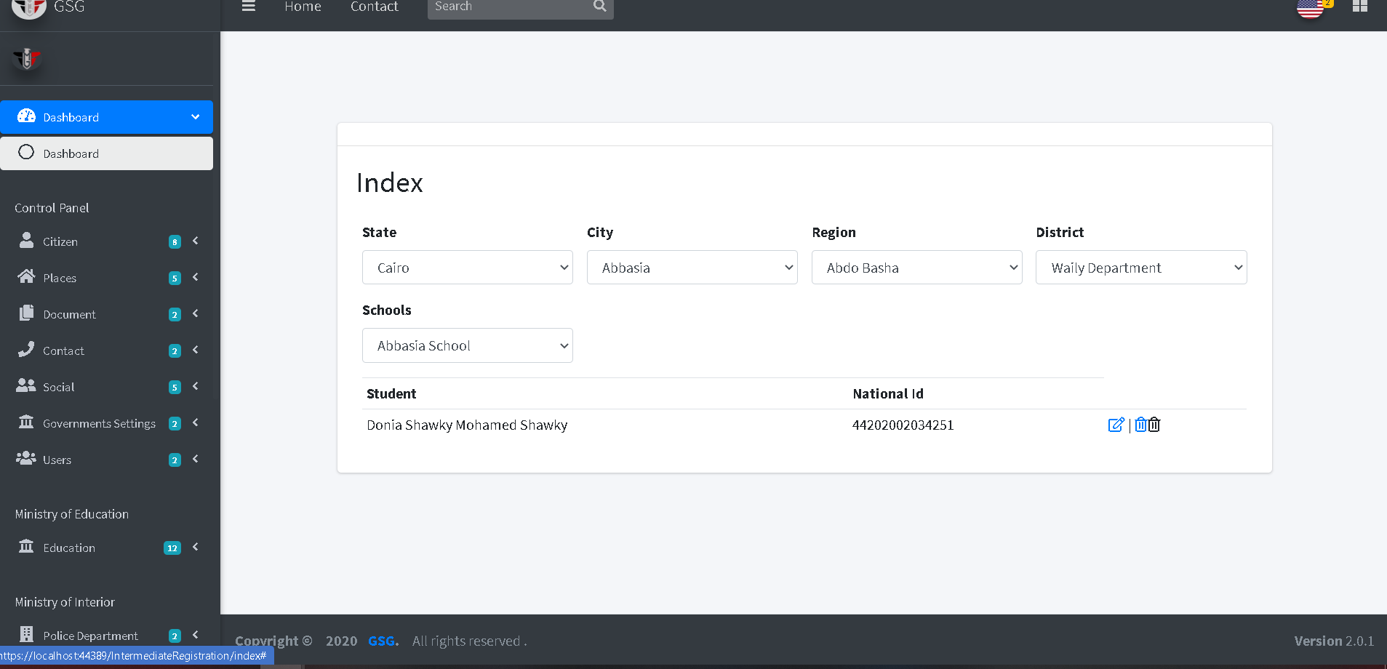

Then the user can edit or delete by click on “edit icon” or “trash icon”, the system will go to edit page and user can edit on the fields then click on “edit button”

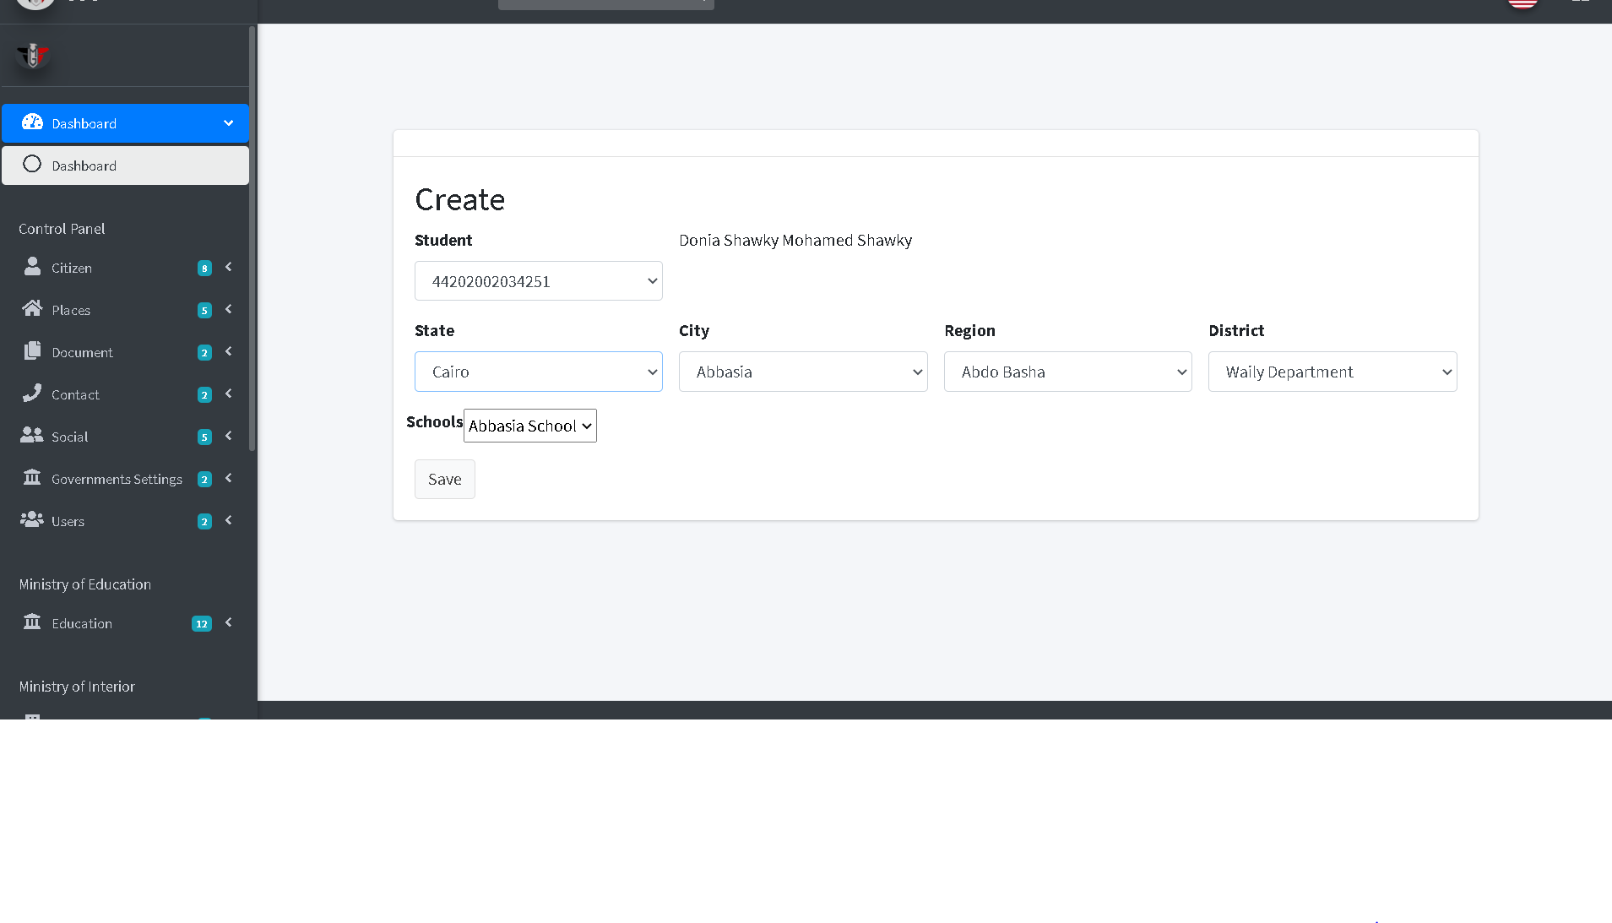

The secondary phase: the user should select or search for national id of student, select School by specify the address of it and the section of this phase then click on “create button “

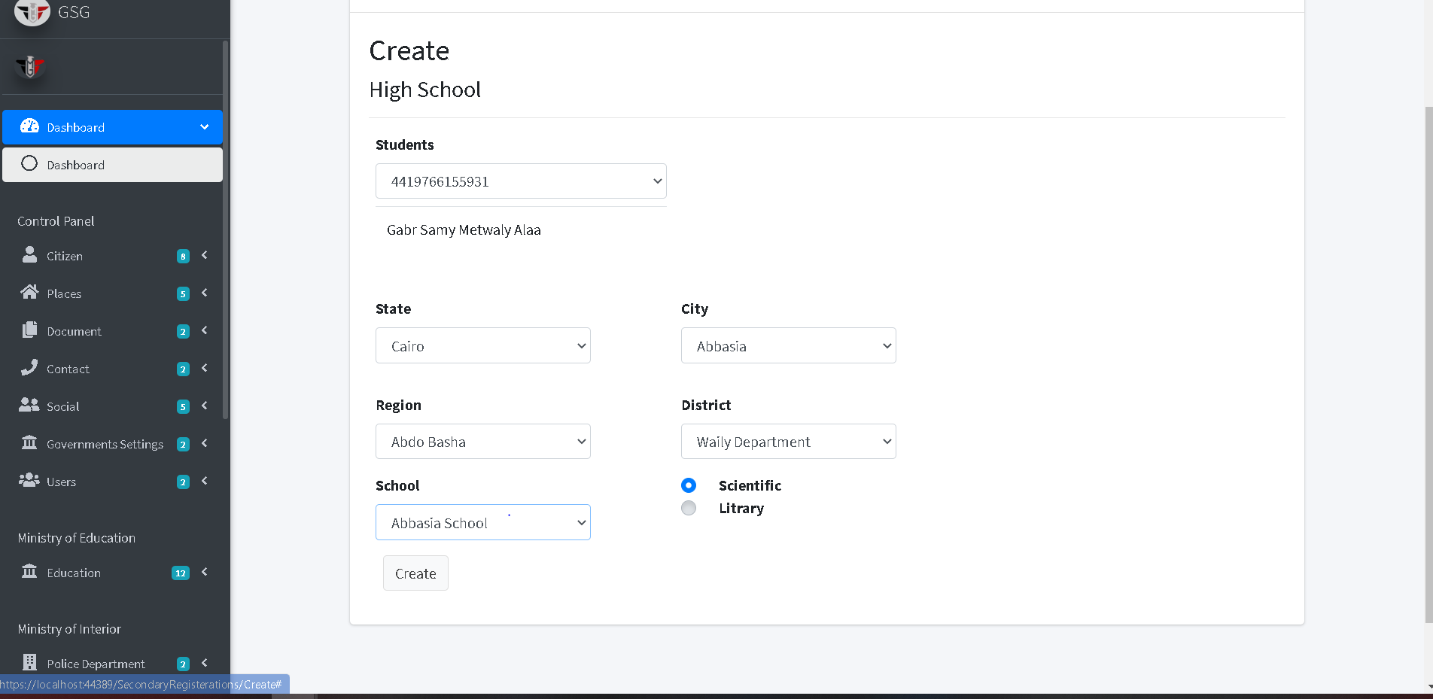

Then the system will go to the index page and display all student by selecting a school and its address, so the user can find student in that school he searched.

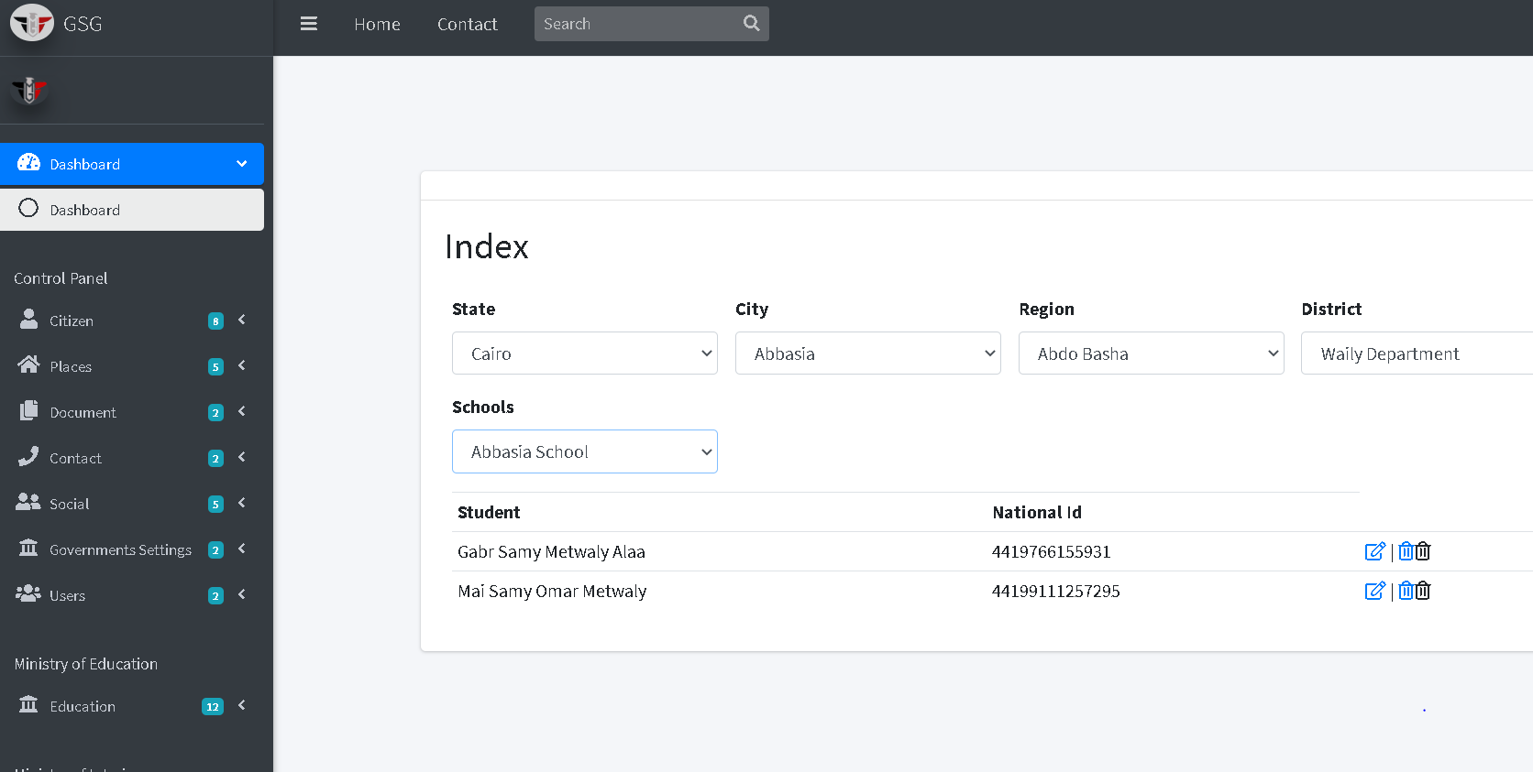

Then the user can edit or delete by click on “edit icon” or “trash icon”, the system will go to edit page and user can edit on the fields then click on “edit button”

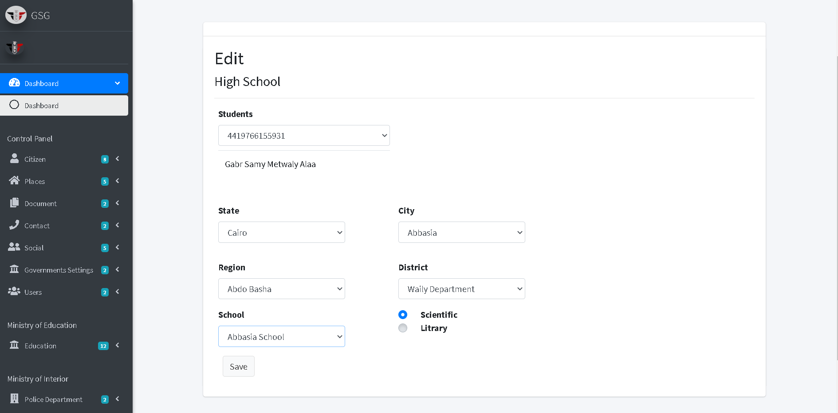

The University phase: the user should select or search for national id of student, select faculty by specify the address of university and select university then click on “create button “

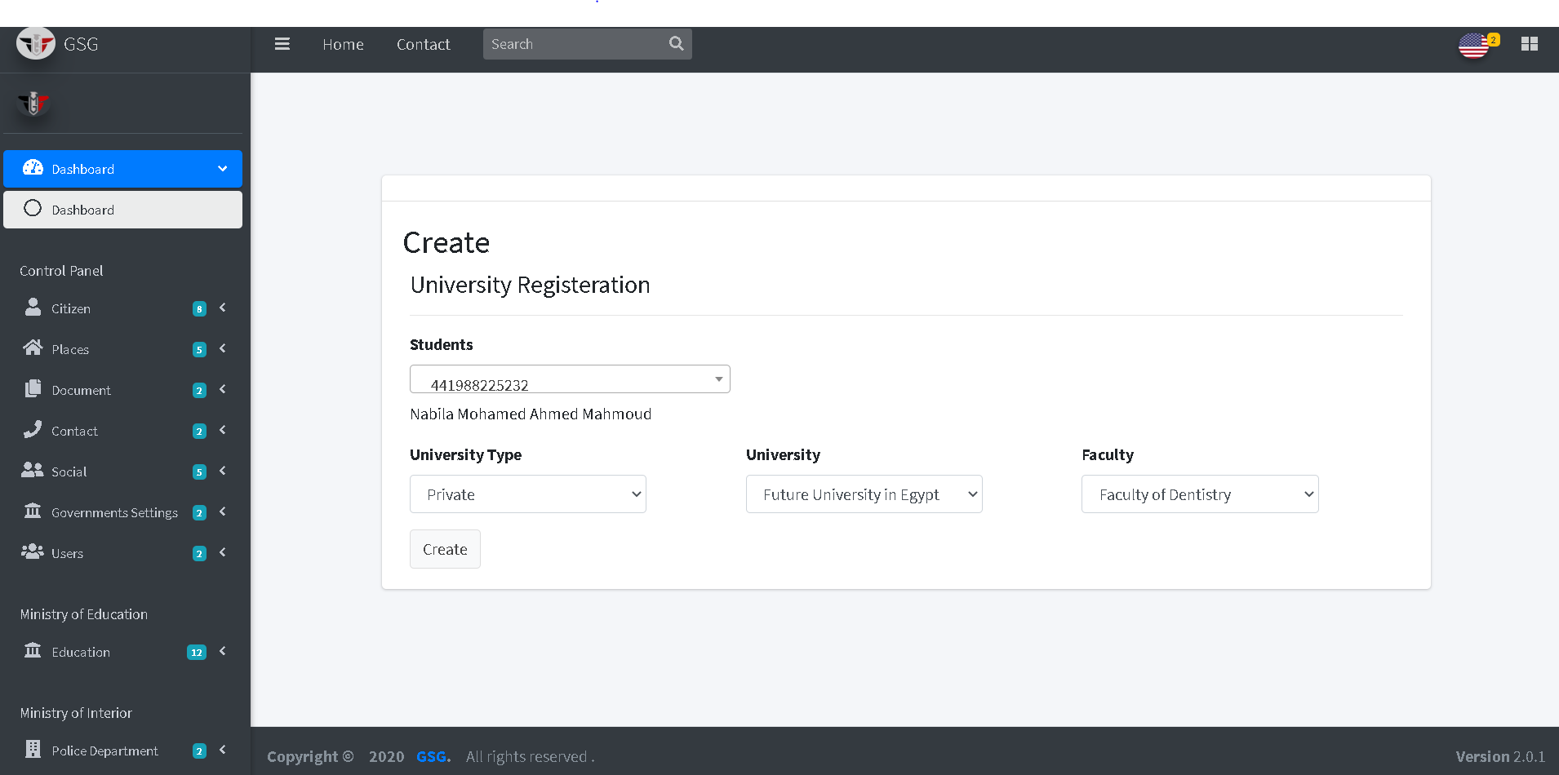

Then the system will go to the index page and display all student by selecting a faculty, university and its address, so the user can find student in that school he searched.

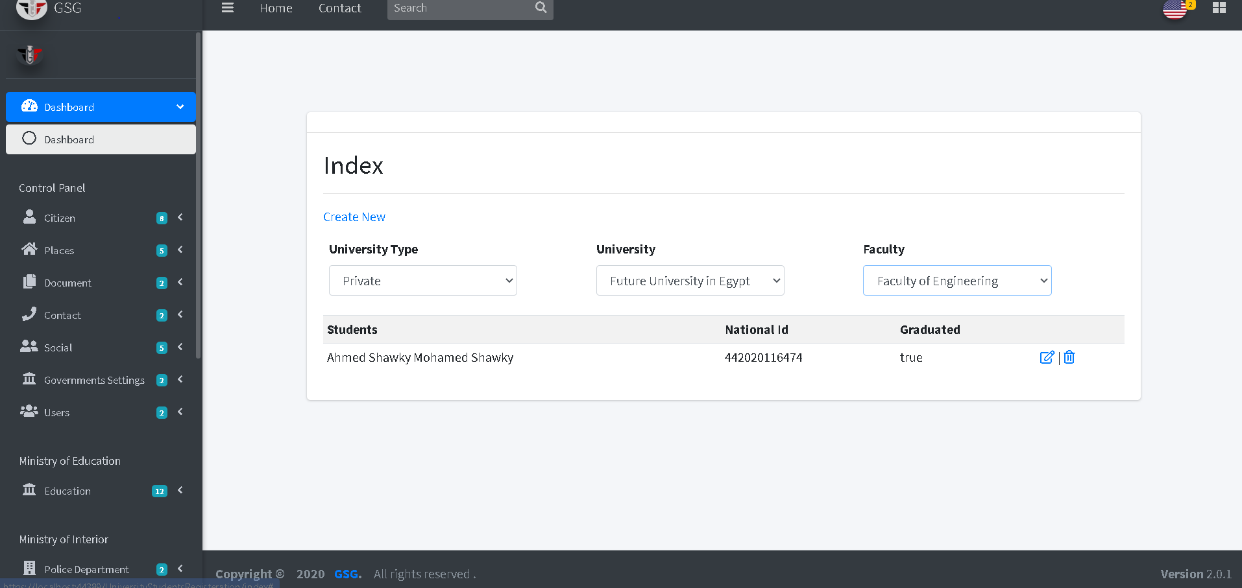

Then the user can edit or delete by click on “edit icon” or “trash icon”, the system will go to edit page and user can edit on the fields then click on “edit button”

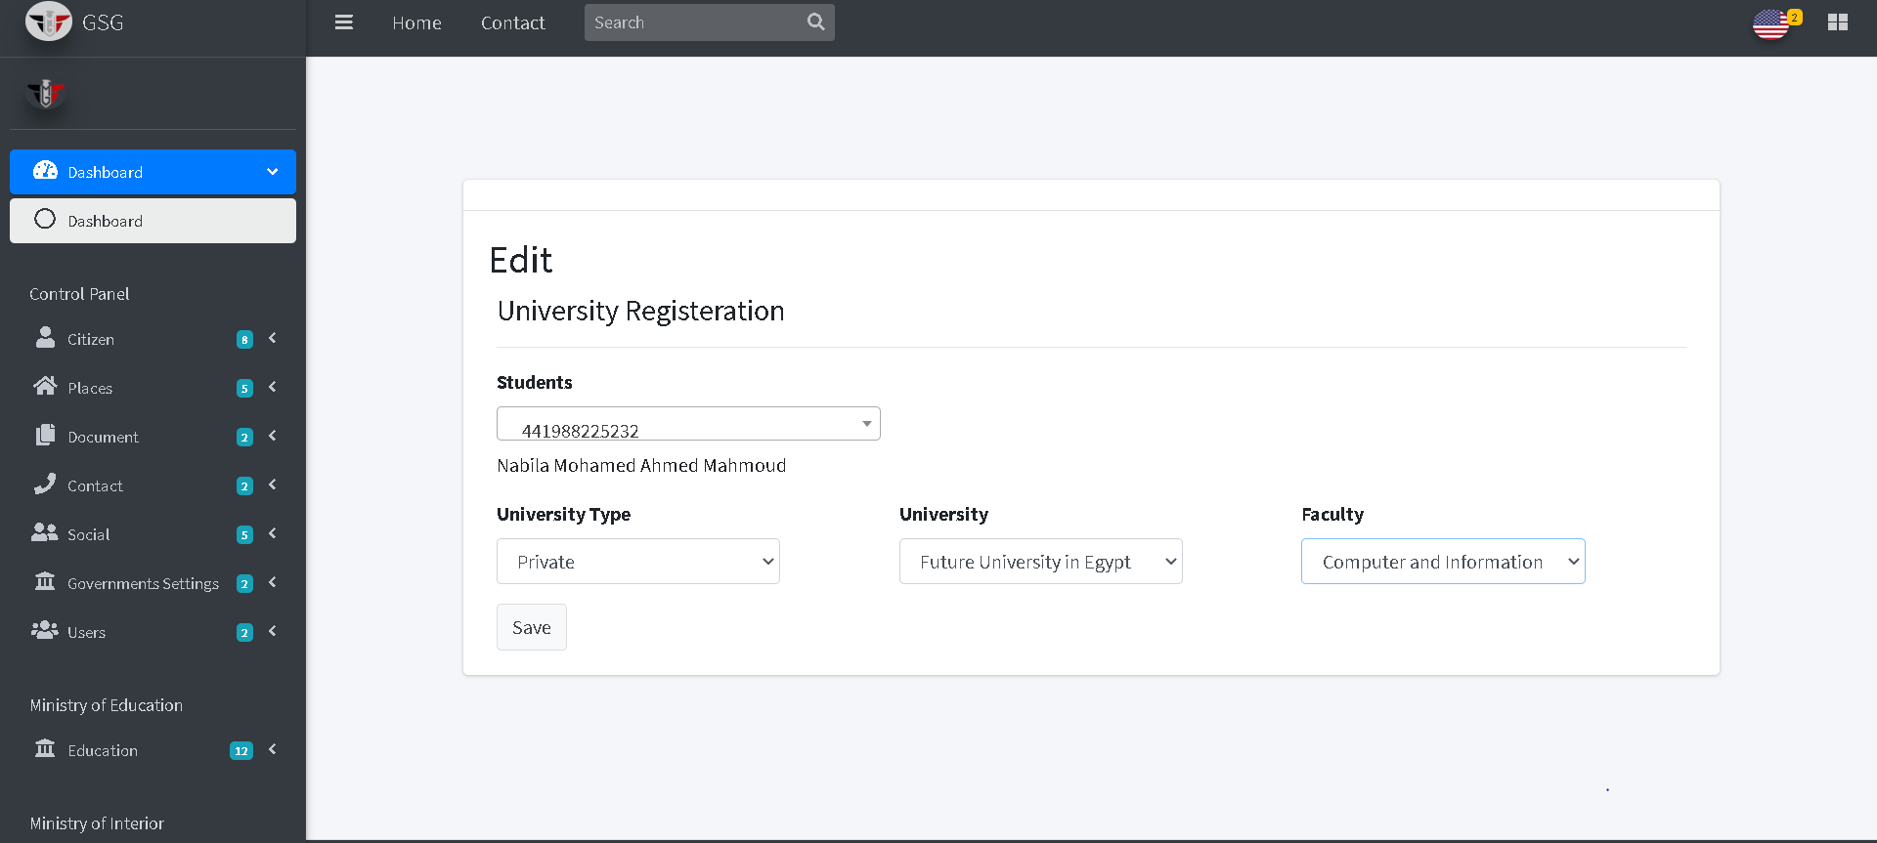

If the user click on the “educated abroad card” the system will redirect to create page that can the user add the student who educated abroad.



The user must select the national id of student and upload a document that prove the student is educated abroad then click on “create button”

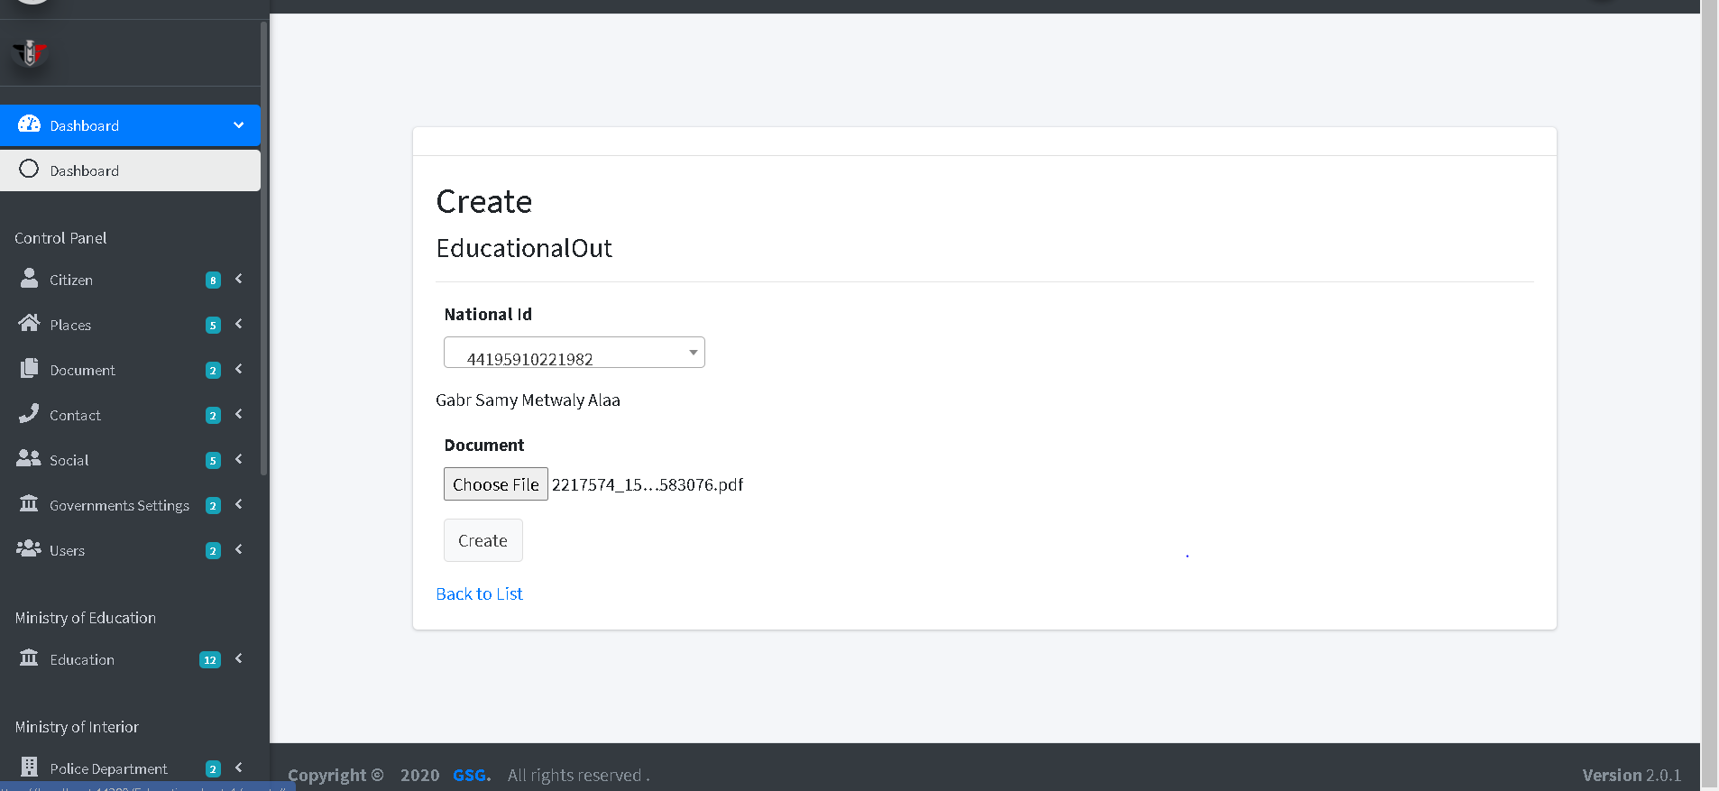

Then the system will redirect to the index page to display all student that educated abroad

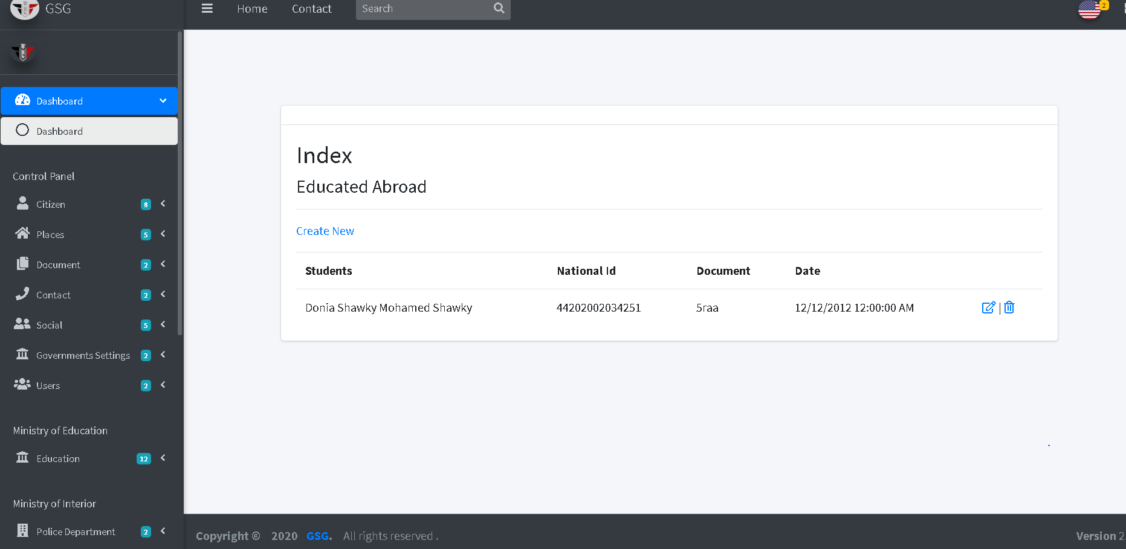

Then the user can edit or delete by click on “edit icon” or “trash icon”, the system will go to edit page and user can edit on the fields then click on “edit button”

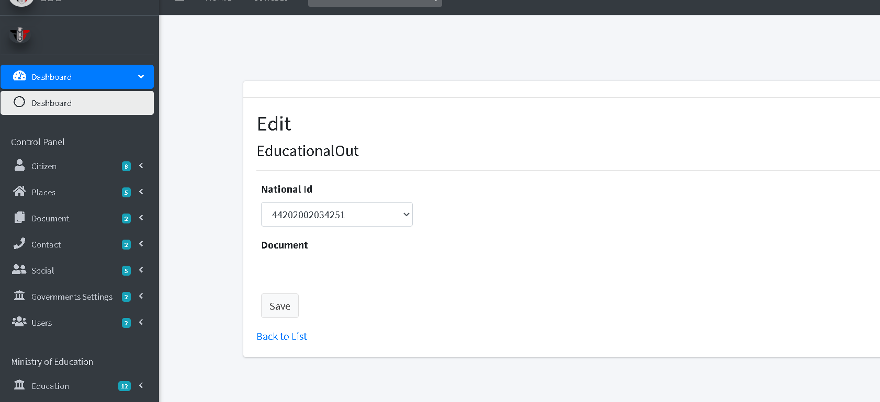

**Add graduated student in university**

The user should select the grade and filter student by university type, address and faculty then he can choose more than one student that have the same selected grade and click on “create button”.

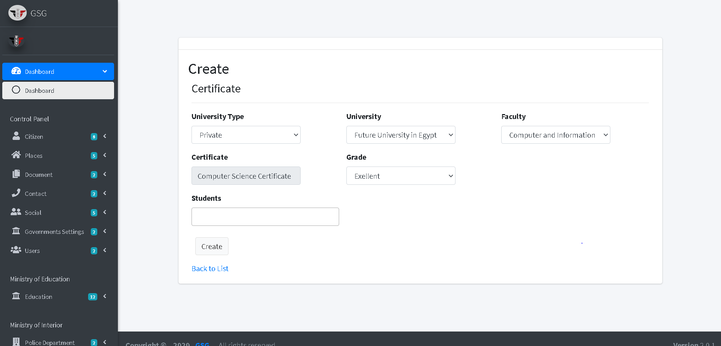

Then the system will go to index page and the user can filter the graduated student by date, faculty or specialization of the selected faculty

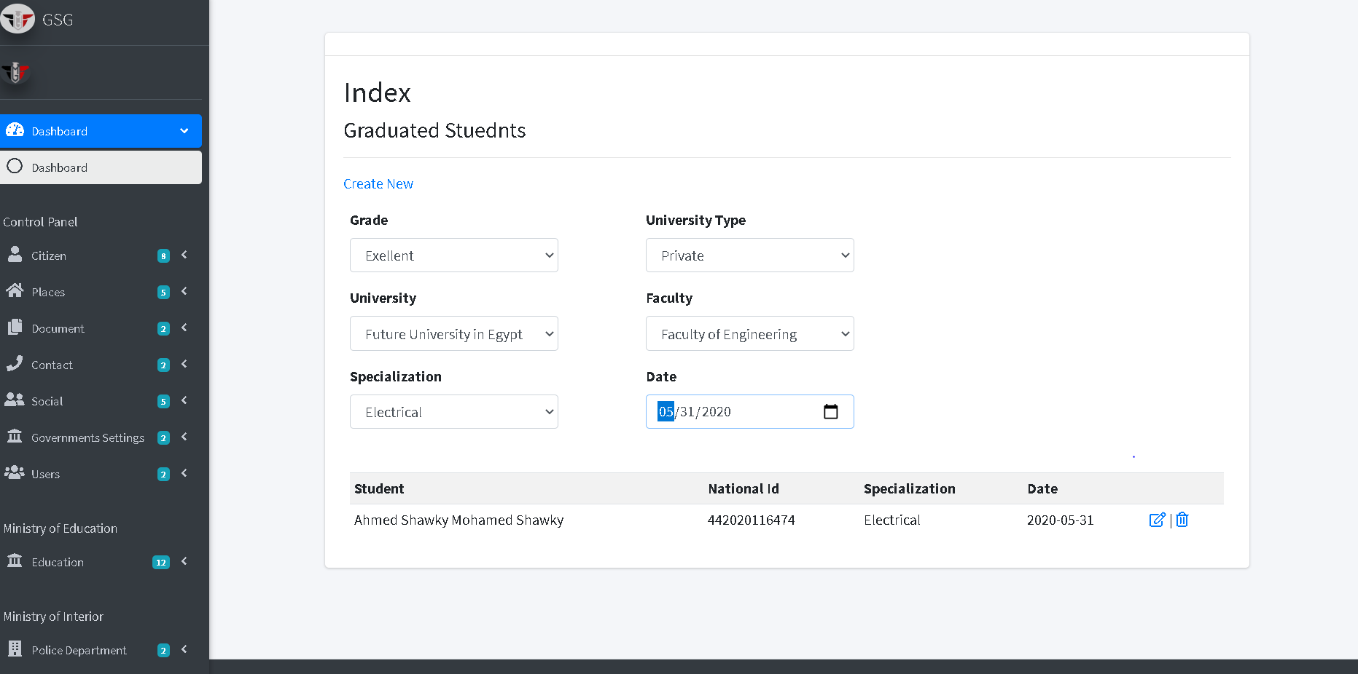

Then the user can edit or delete by click on “edit icon” or “trash icon”, the system will go to edit page and user can edit on the fields then click on “edit button”

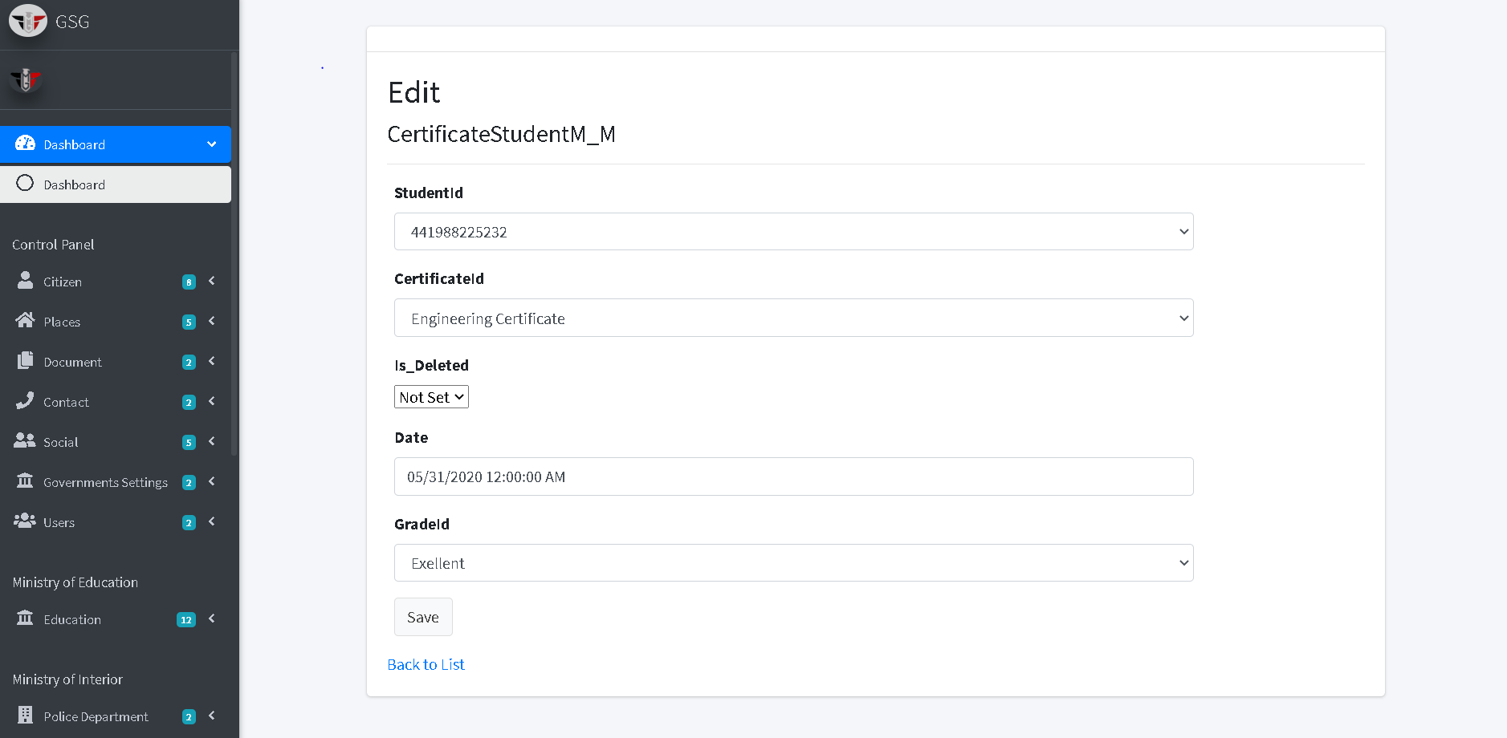

Or will go to delete page and user can confirm deletion by clicking on “delete button” then the system will redirect to index page.

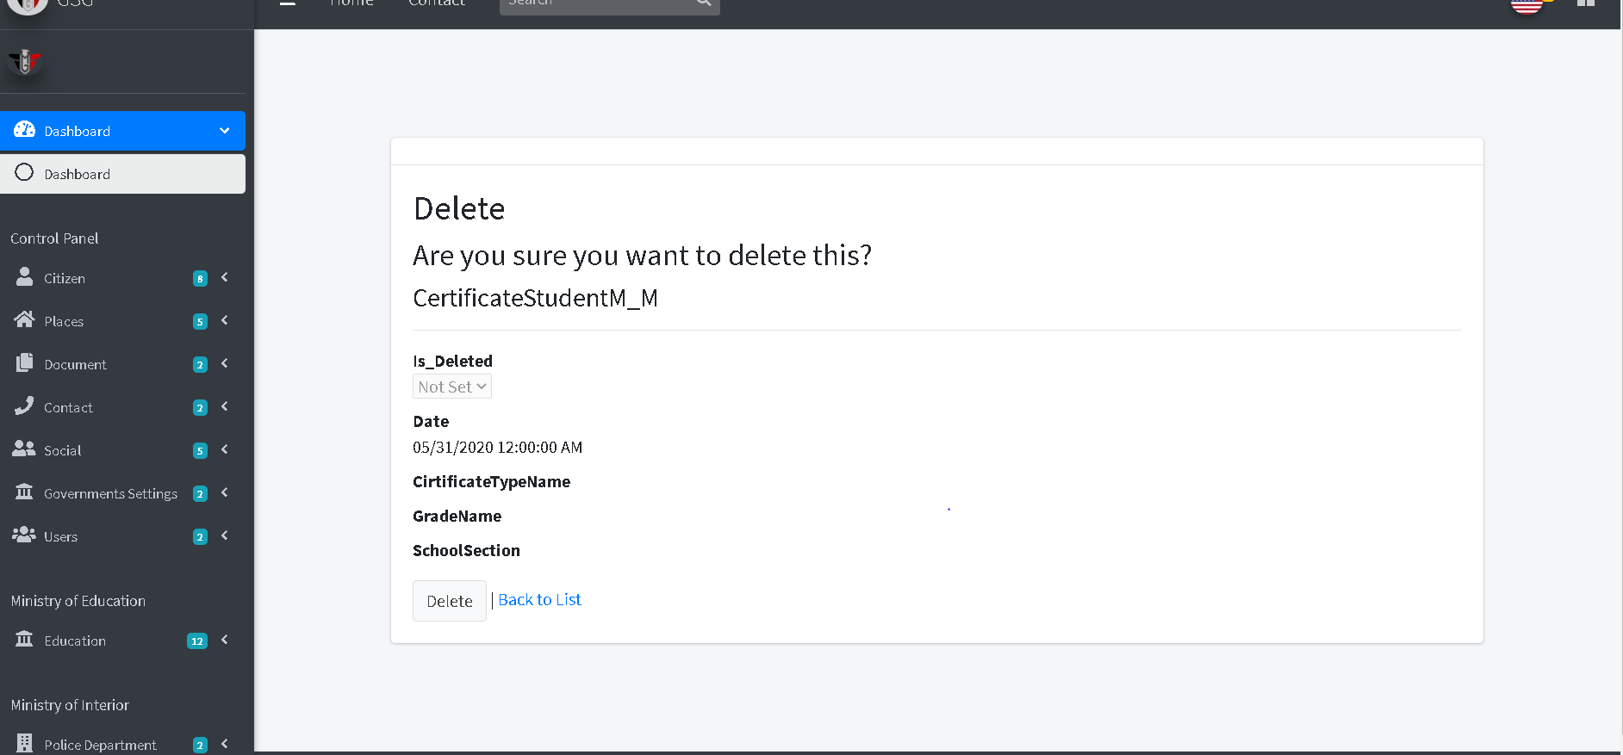

**Create a coordination for faculties**

The user should fill the required fields, specify the size of student and the grade of the selected faculty

Then click on ”create button”

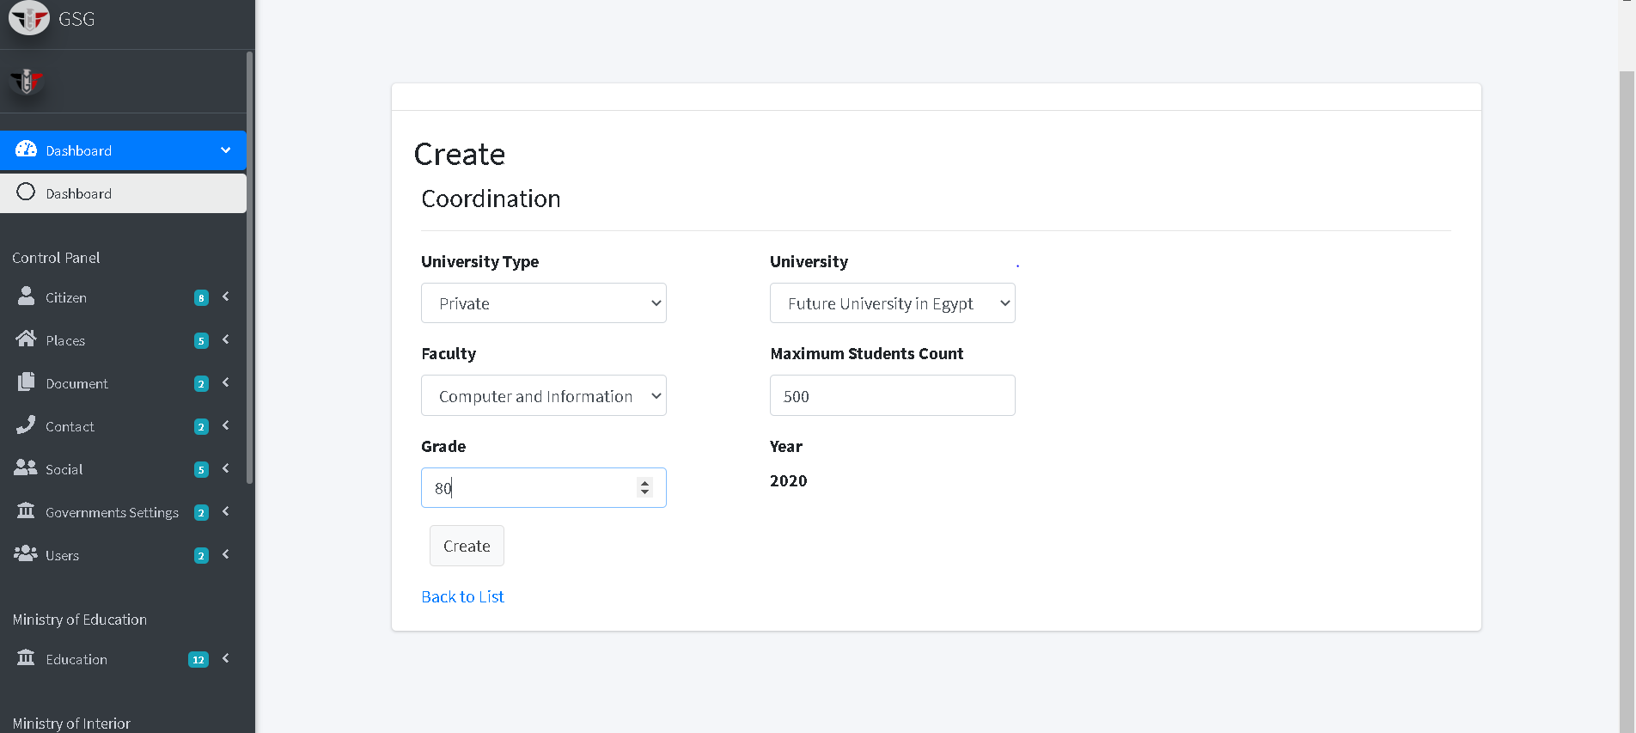

Then the system will go to index page and the user can filter coordination by university type, university and faculty

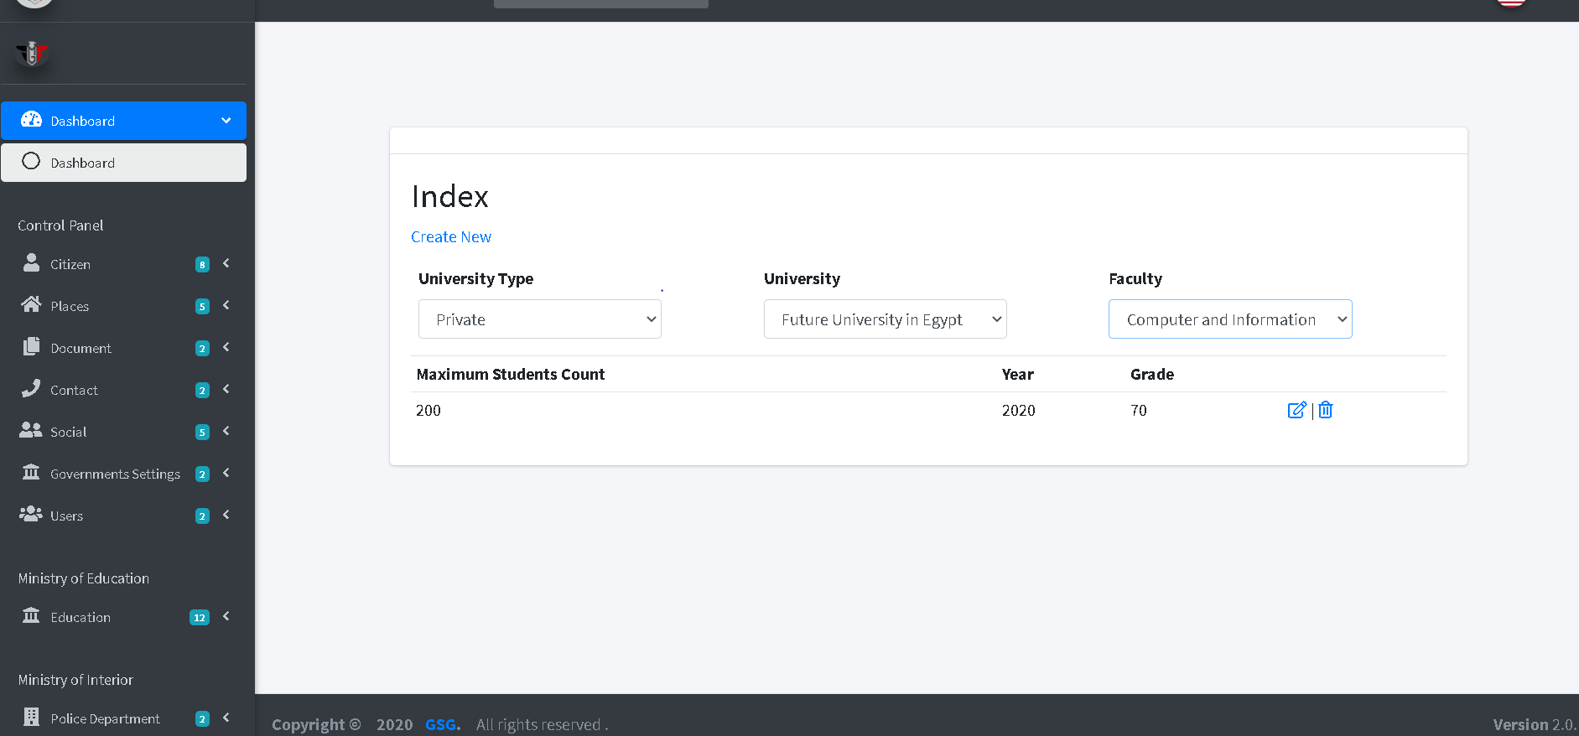

Then the user can edit or delete by click on “edit icon” or “trash icon”, the system will go to edit page and user can edit on the fields then click on “edit button”

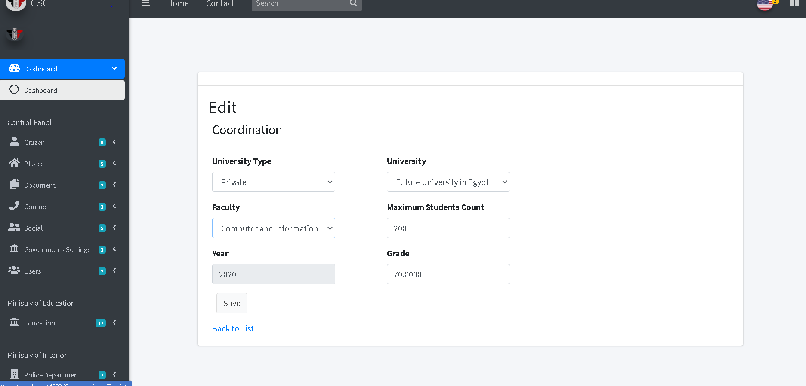

Or will go to delete page and user can confirm deletion by clicking on “delete button” then the system will redirect to index page.

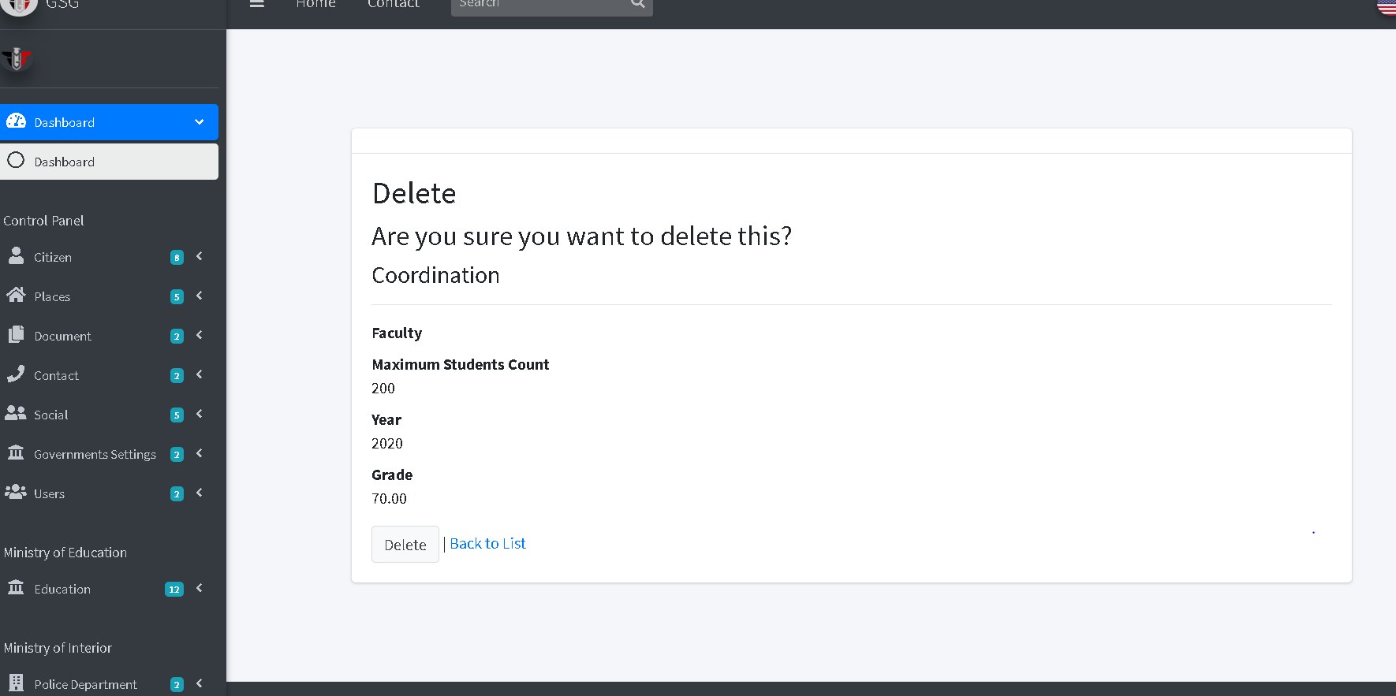

**Add Certification**

The user should fill the required fields then click on “create button”

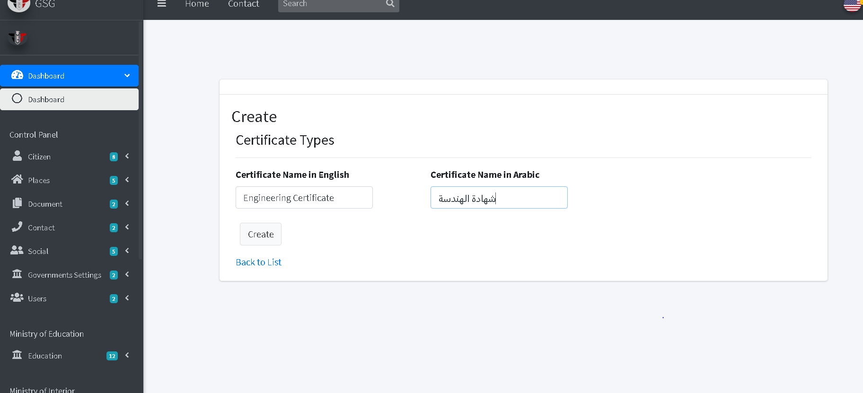

Then the system will redirect to the index page and display all certificates

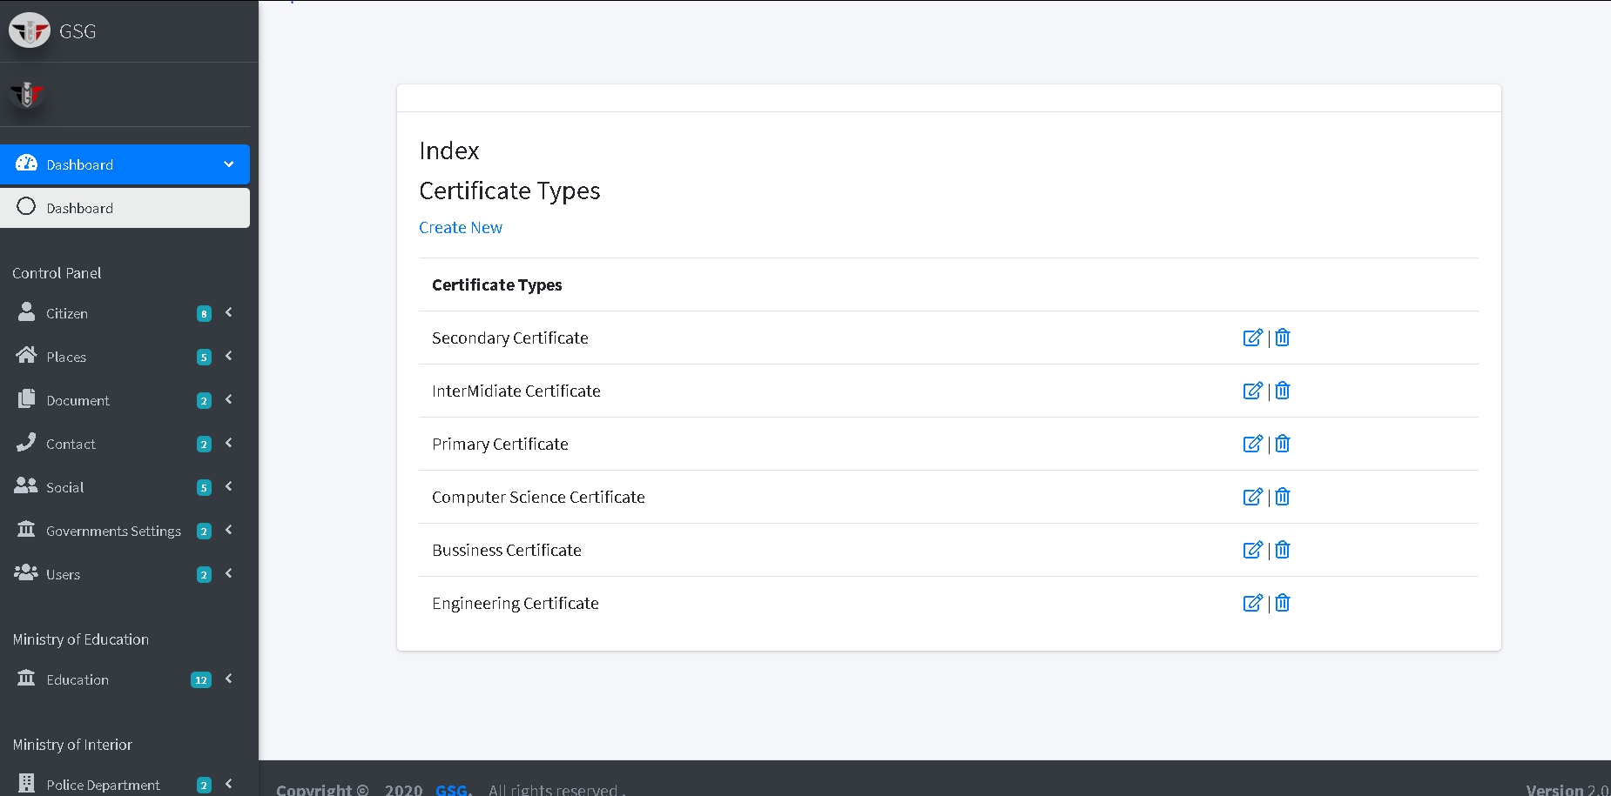

Then the user can edit or delete by click on “edit icon” or “trash icon”, the system will go to edit page and user can edit on the fields then click on “edit button”

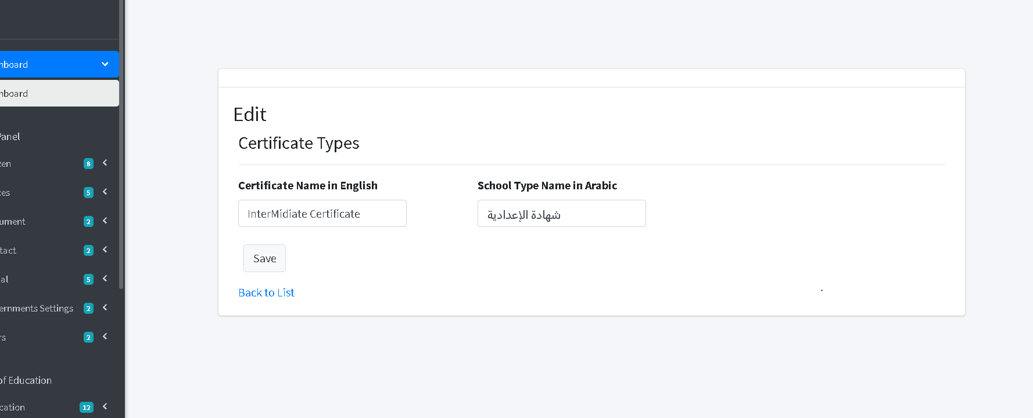

Or will go to delete page and user can confirm deletion by clicking on “delete button” then the system will redirect to index page.

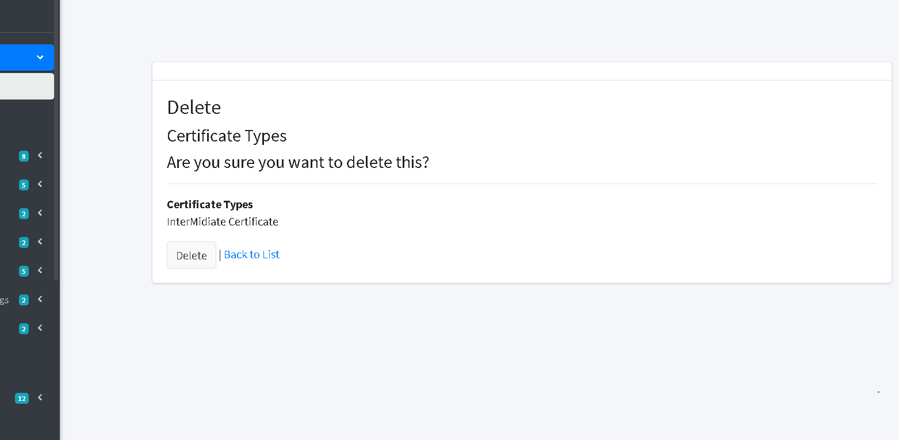

**Add grades**

The user should fill the required fields then click on “create button”

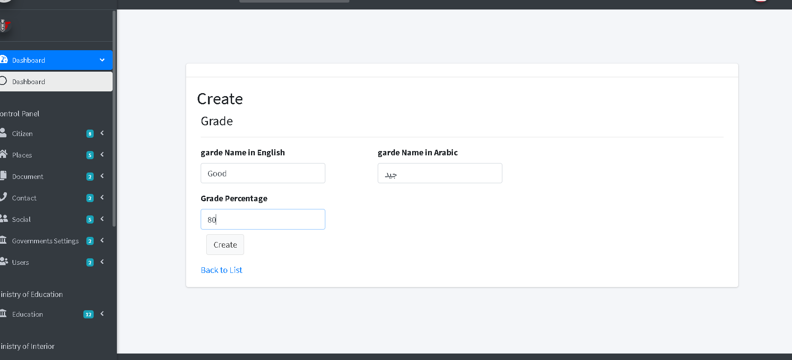

Then the system will redirect to the index page and display all grades

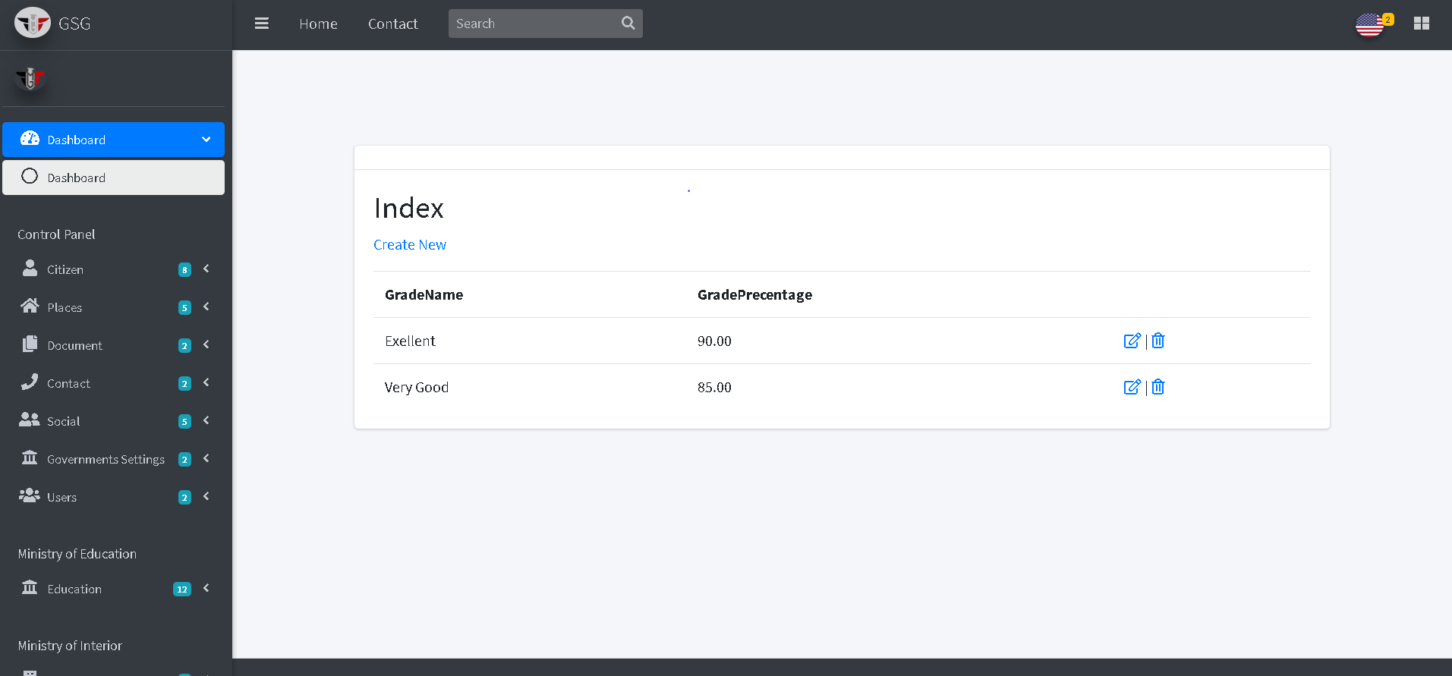

Then the user can edit or delete by click on “edit icon” or “trash icon”, the system will go to edit page and user can edit on the fields then click on “edit button”

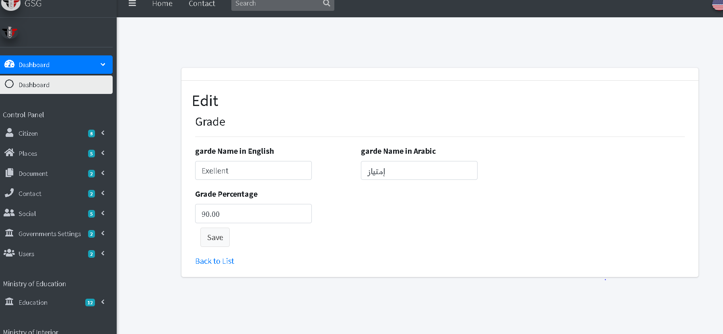

Or will go to delete page and user can confirm deletion by clicking on “delete button” then the system will redirect to index page.

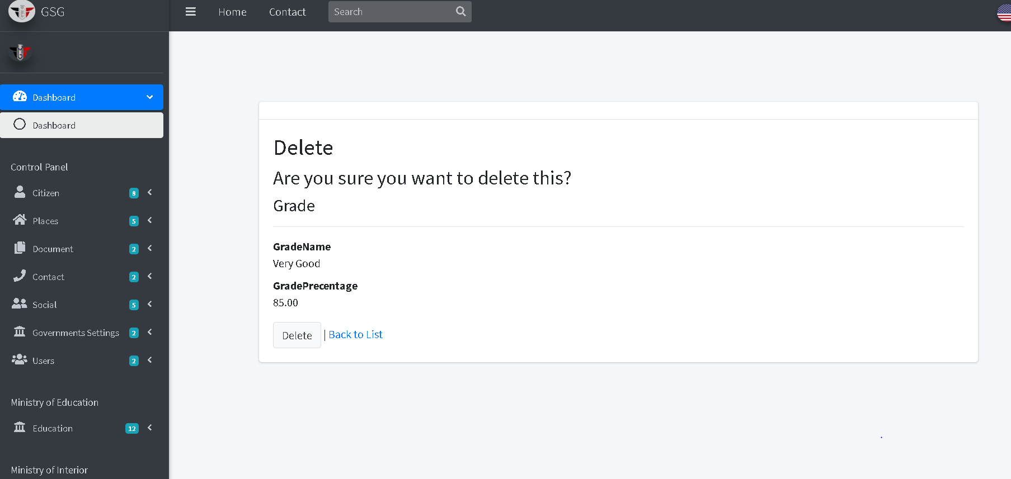

**Add Live Status**

The user should fill the required fields then click on “create button”

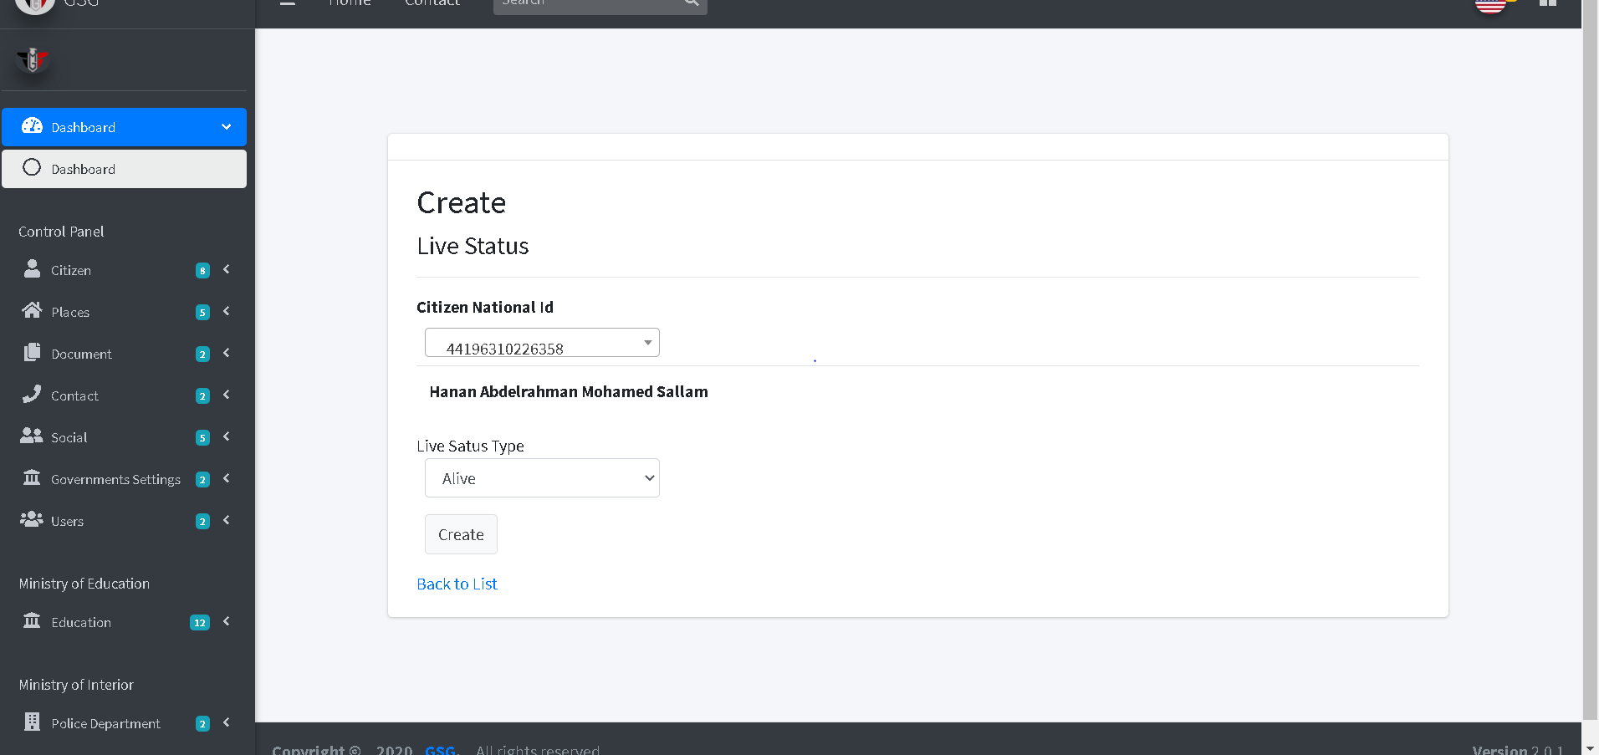

Then the system will redirect to the index page and display all Live status by selecting national id of citizen

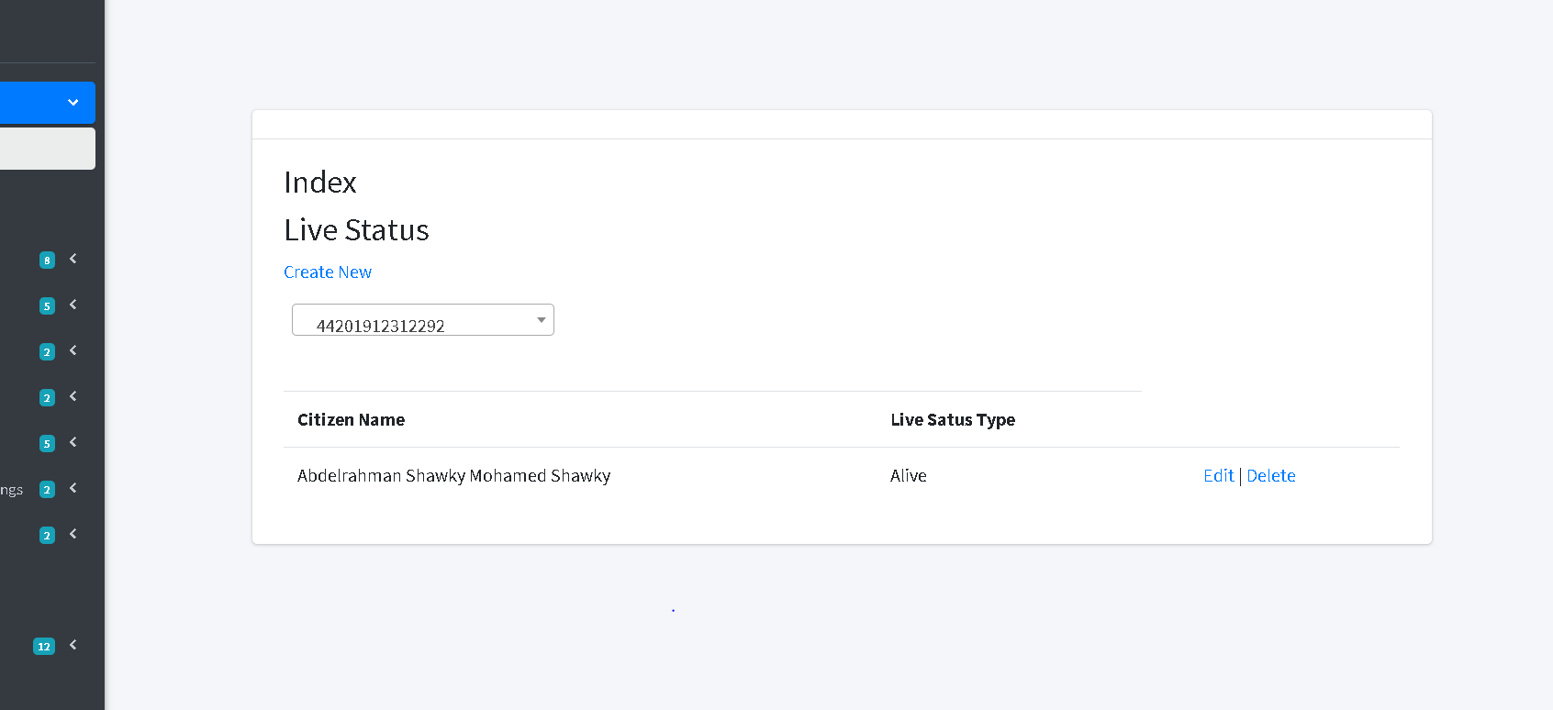

Then the user can edit or delete by click on “edit icon” or “trash icon”, the system will go to edit page and user can edit on the fields then click on “edit button”

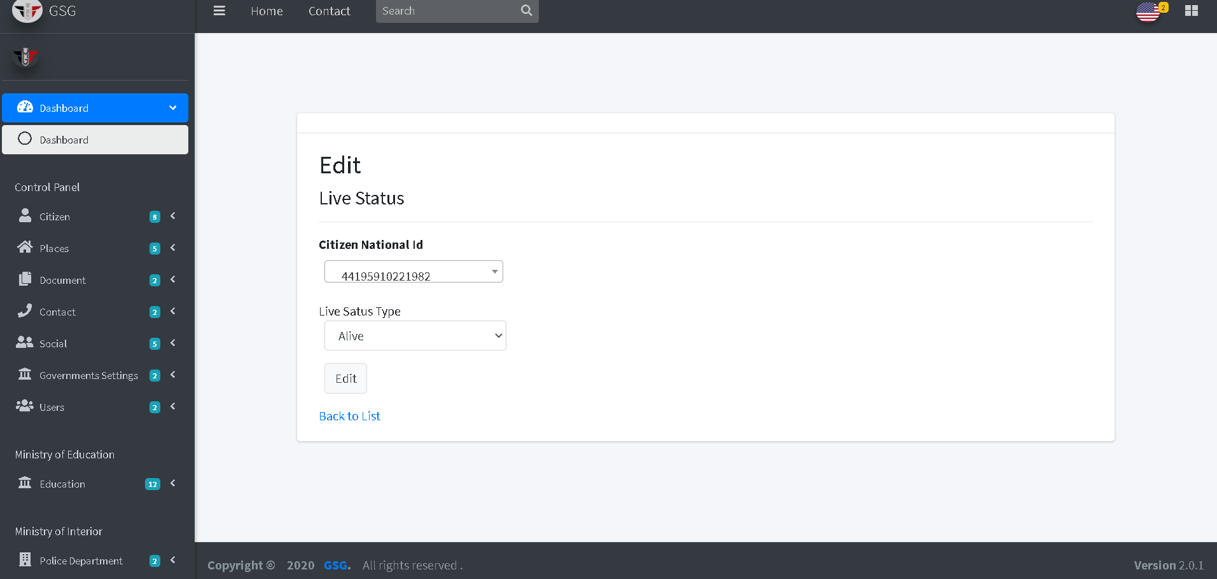

Or will go to delete page and user can confirm deletion by clicking on “delete button” then the system will redirect to index page.

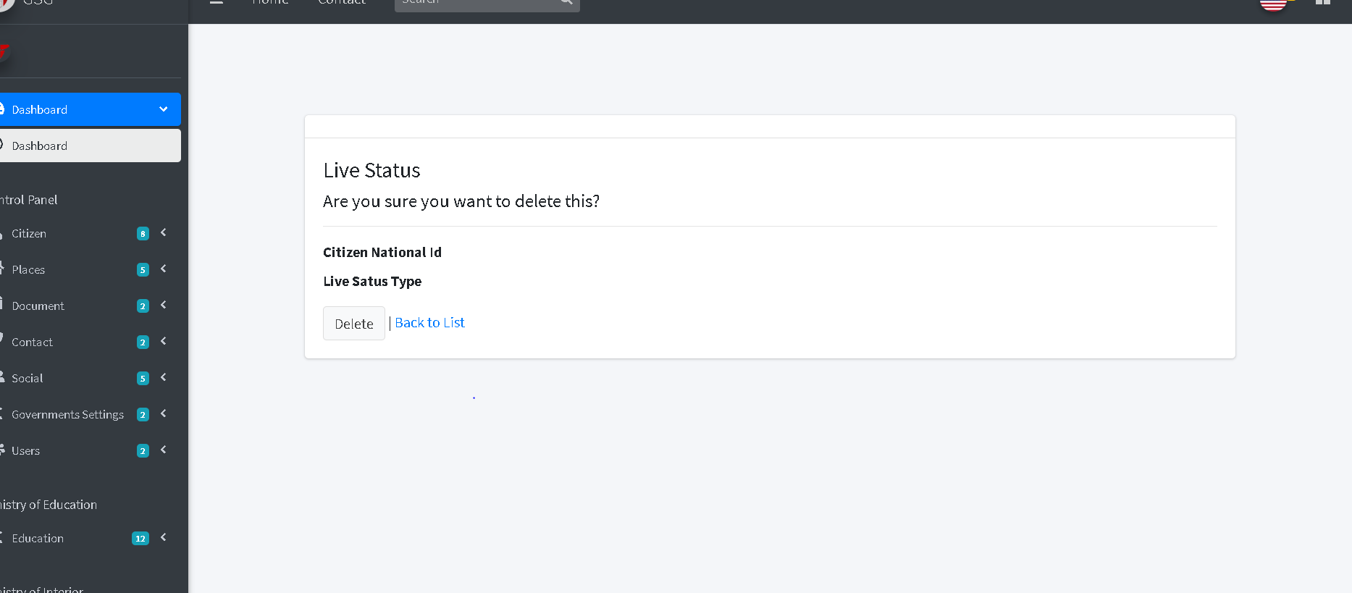

**Add live status type**

The user should fill the required fields then click on “create button”

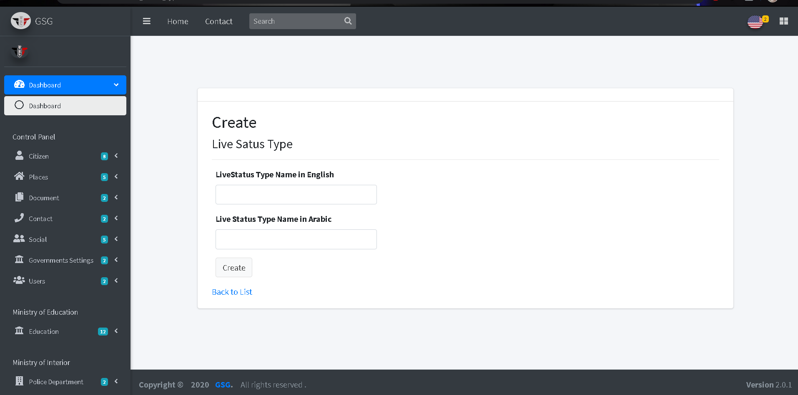

Then the system will redirect to the index page and display all Live status types

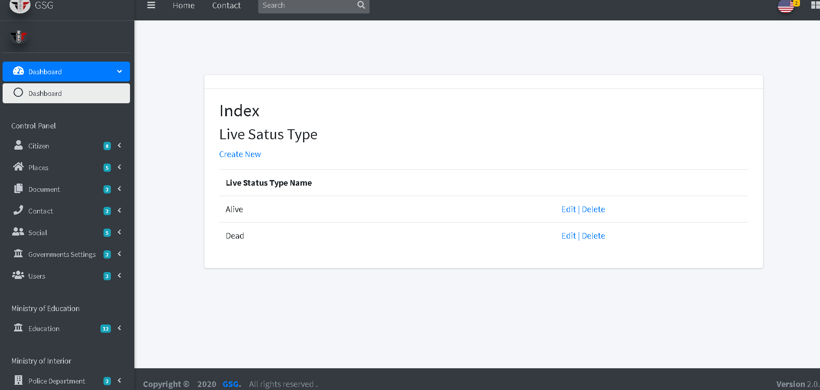

Then the user can edit or delete by click on “edit icon” or “trash icon”, the system will go to edit page and user can edit on the fields then click on “edit button”

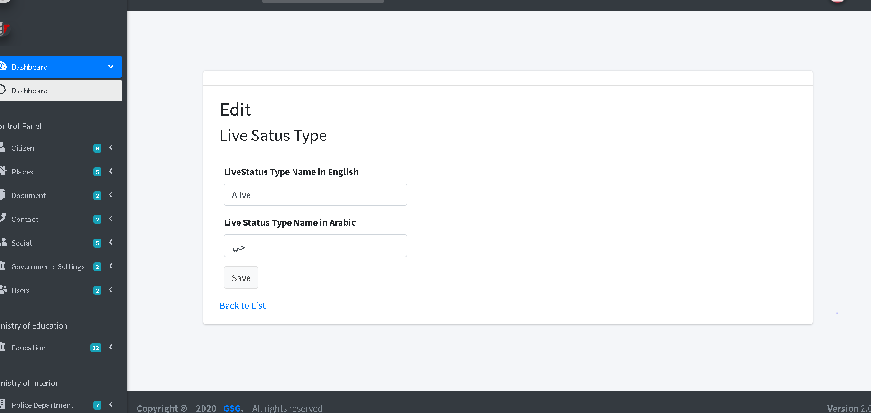

Or will go to delete page and user can confirm deletion by clicking on “delete button” then the system will redirect to index page.

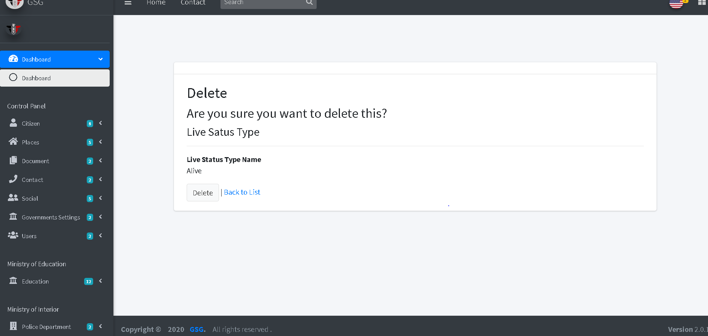

**Add vaccination type**

The user should fill the required fields then click on “create button”

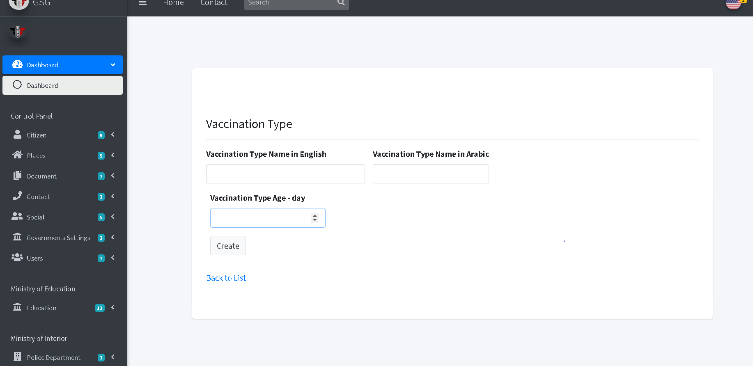

Then the system will redirect to the index page and display all vaccination types

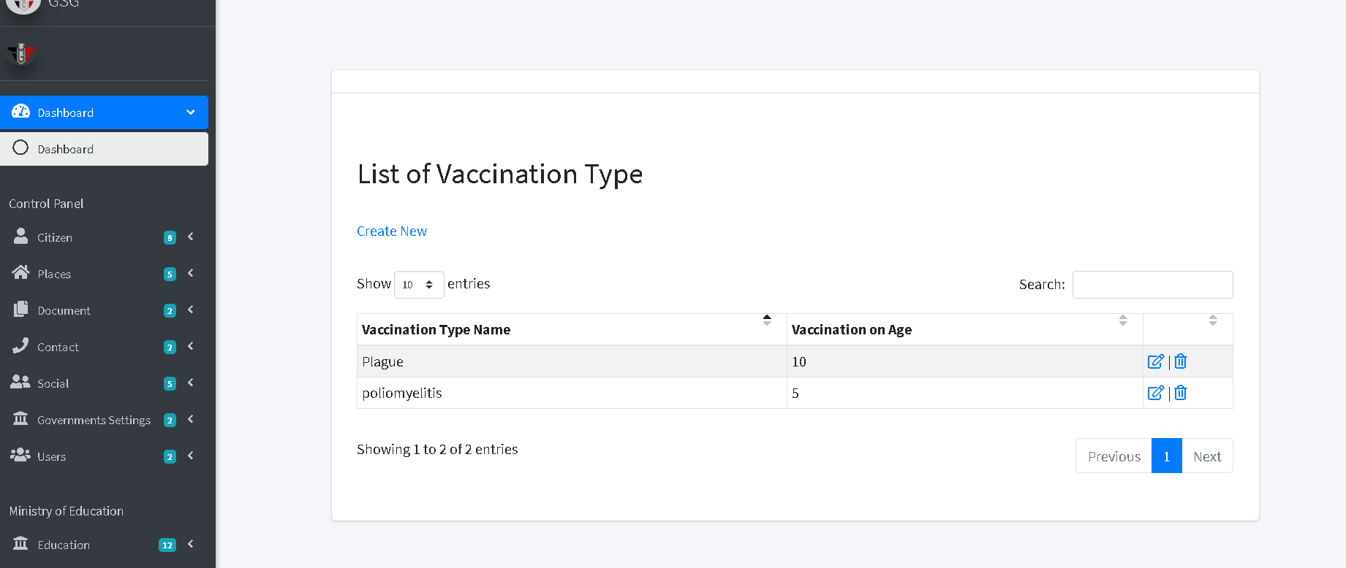

Then the user can edit or delete by click on “edit icon” or “trash icon”, the system will go to edit page and user can edit on the fields then click on “edit button”

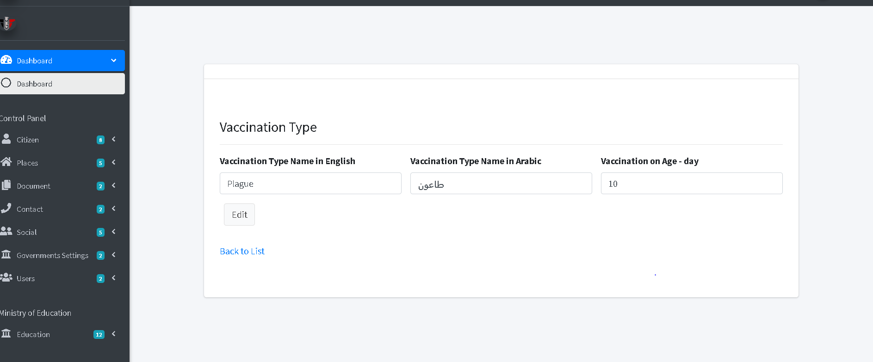

Or will go to delete page and user can confirm deletion by clicking on “delete button” then the system will redirect to index page.

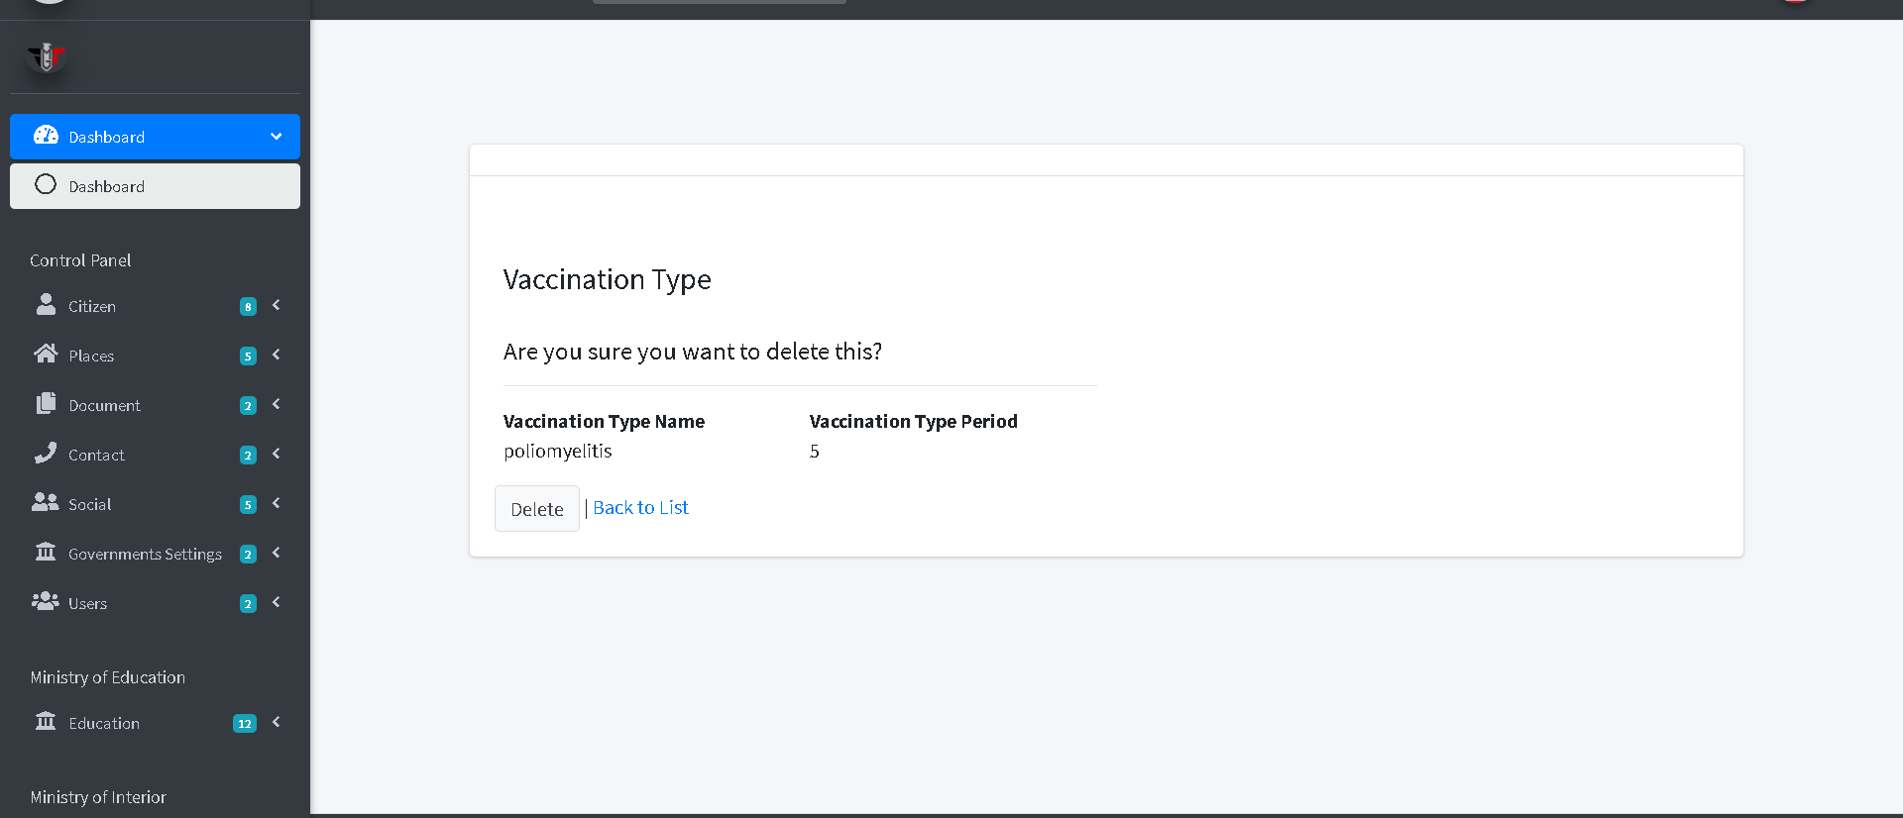

**Add vaccination schedule**

The user will go through two step to make a schedule.

Step 1: the user should filter the vaccination he want to put a schedule to it by health care type, address and select the health care then click on “next button”

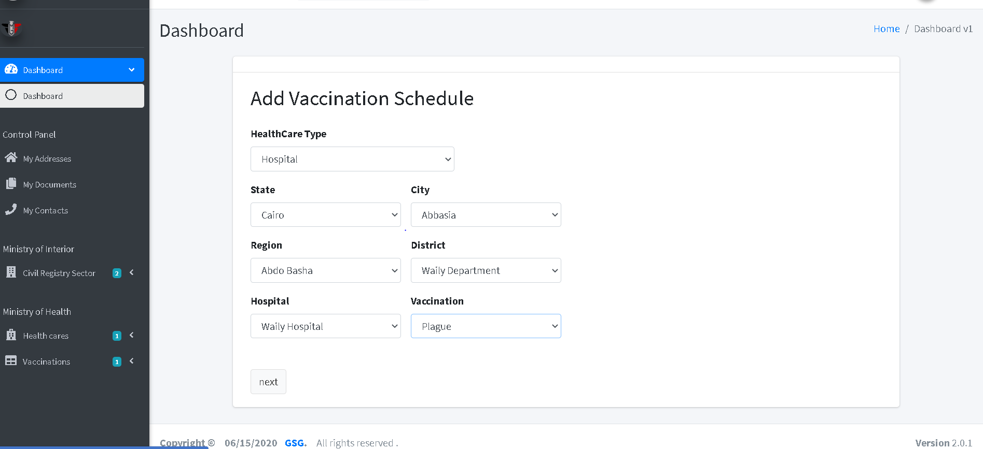

Step 2: now the user must fill the date, checkup start, checkup end and maximum number of children then click on “Create button”

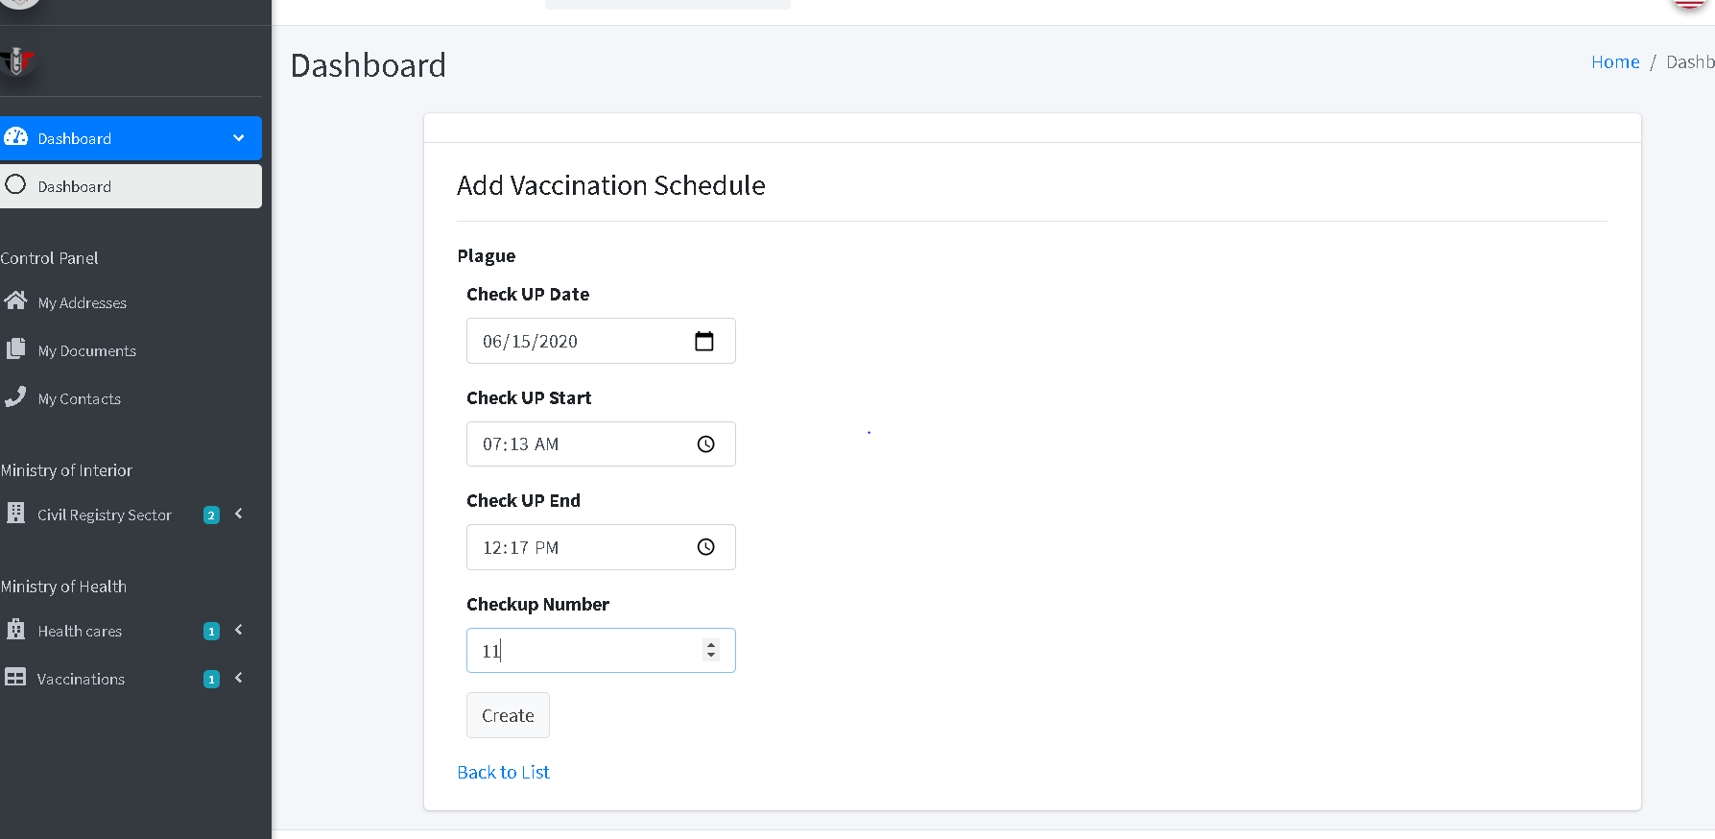

Then the system will redirect to the index page and display all vaccination schedules

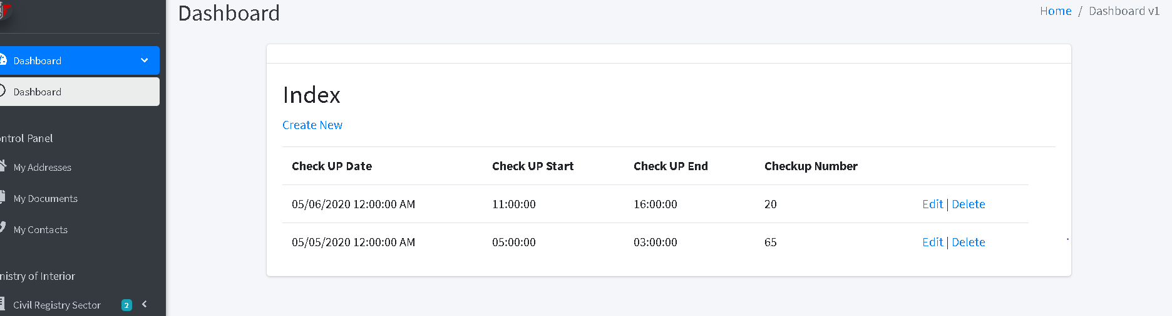 Then the user can edit or delete by click on “edit icon” or “trash icon”, the system will go to edit page and user can edit on the fields then click on “edit button”

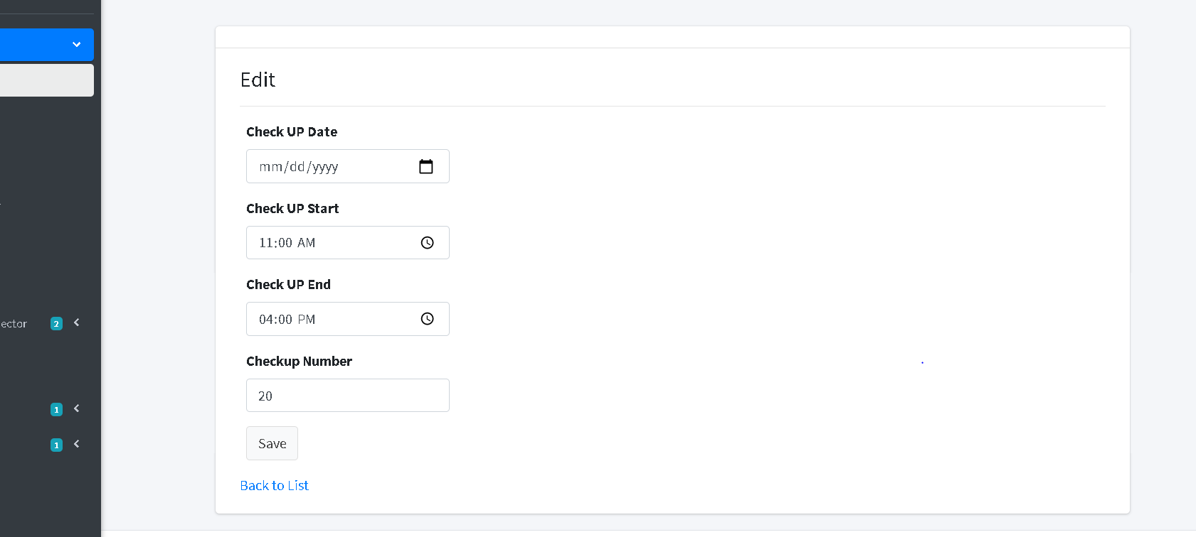

Or will go to delete page and user can confirm deletion by clicking on “delete button” then the system will redirect to index page.

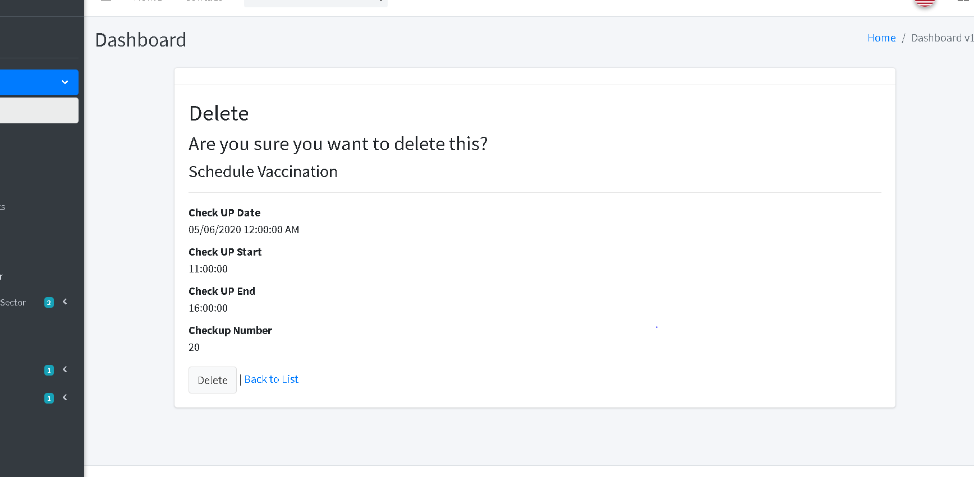

**Add health care type**

The user should fill the required fields then click on “create button”

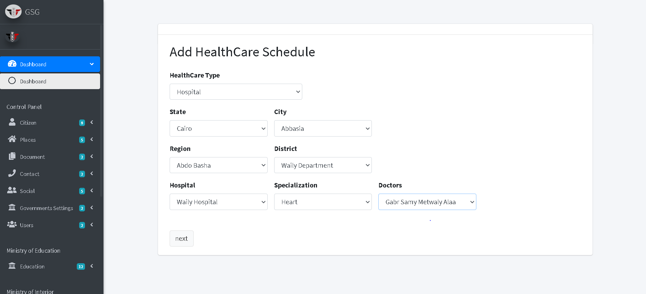

Then the system will redirect to the index page and display all health care types

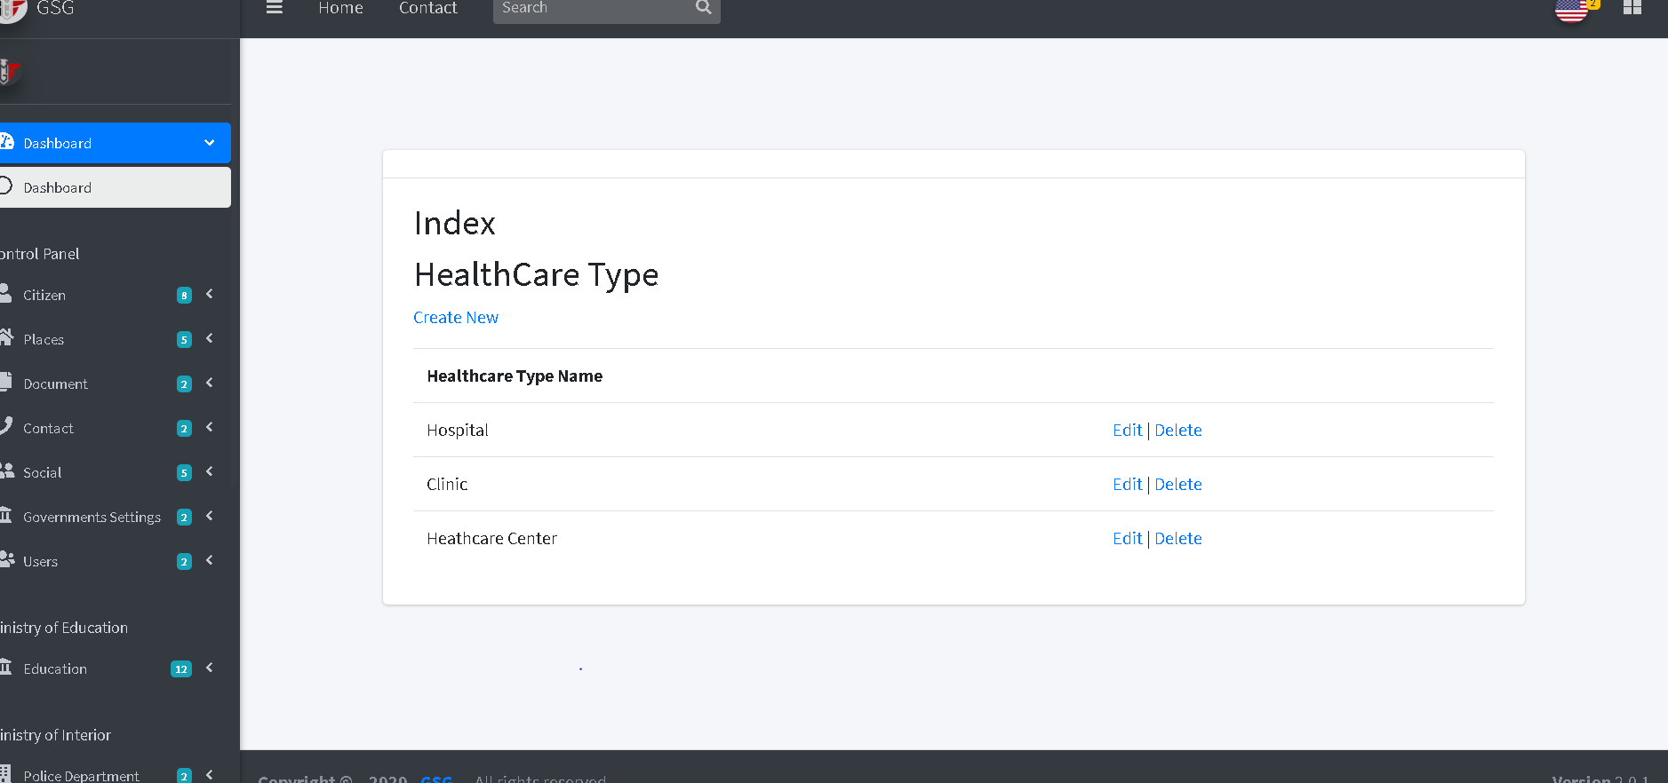

Then the user can edit or delete by click on “edit icon” or “trash icon”, the system will go to edit page and user can edit on the fields then click on “edit button”

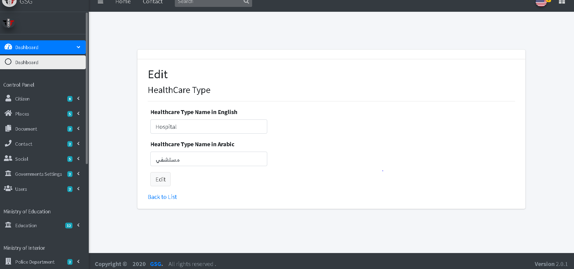

Or will go to delete page and user can confirm deletion by clicking on “delete button” then the system will redirect to index page.

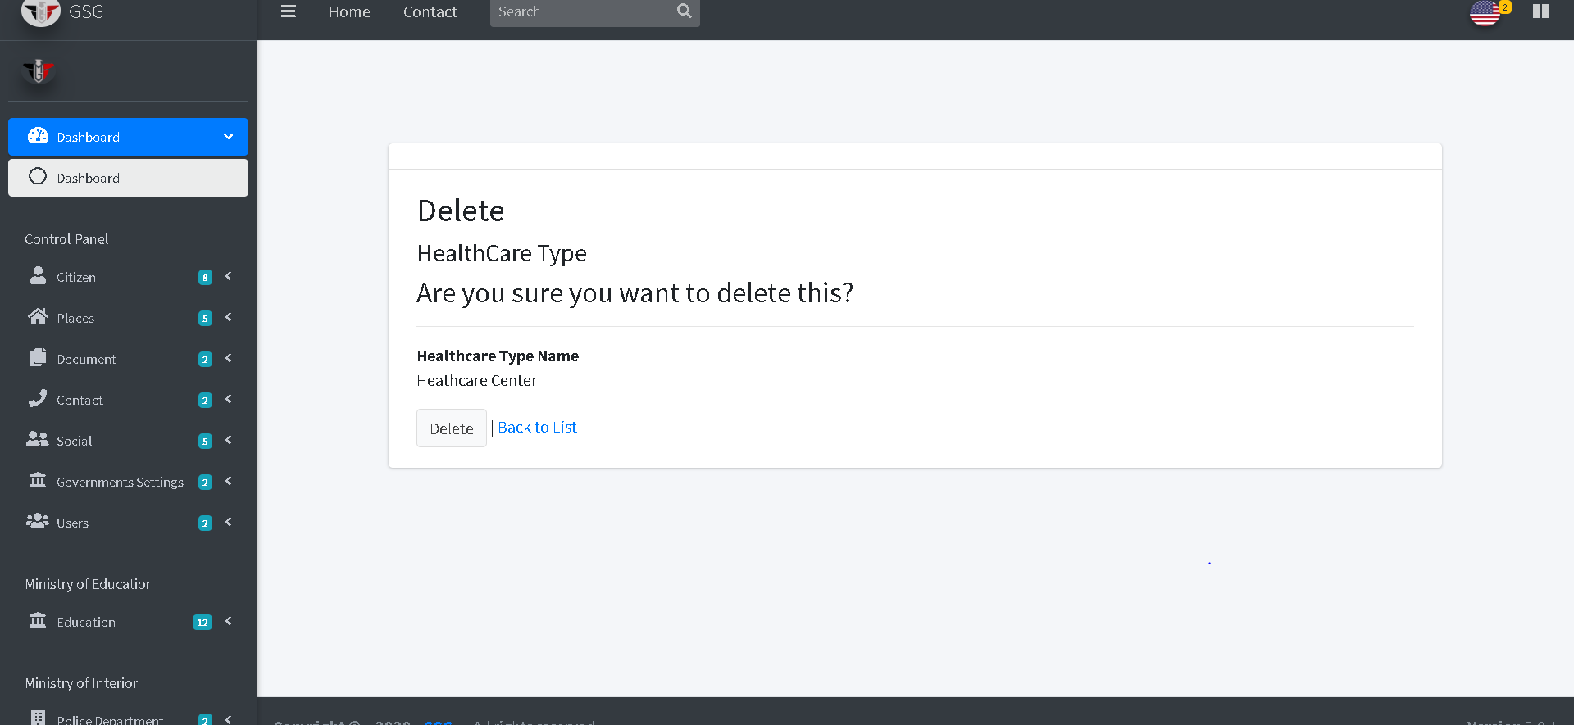

**Add Doctor Schedule**

The user will go through two step to make a schedule.

Step 1: the user should filter the Doctors he want to put a schedule to him/her by health care type, address and select the specialization of the selected health care then click on “next button”

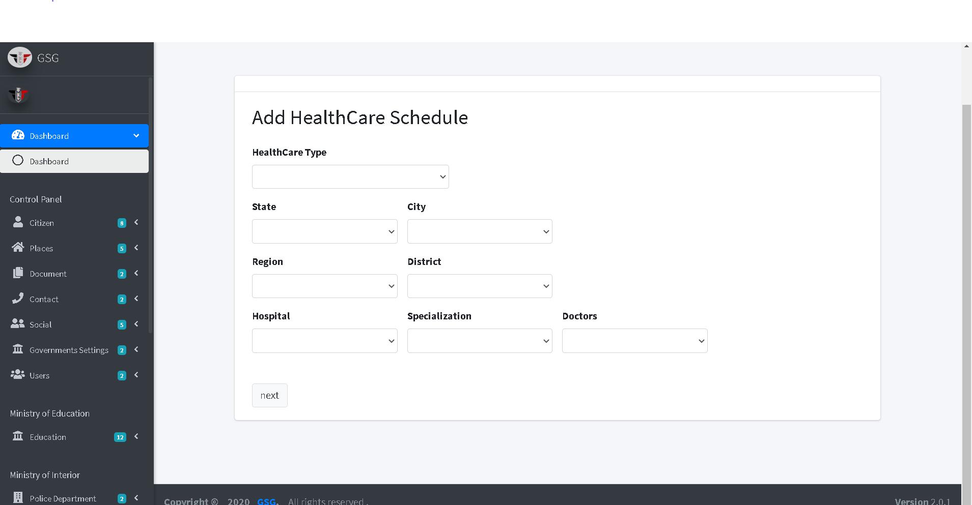

Step 2: now the user must fill the date, checkup start, checkup end and maximum number of children then click on “Create button”

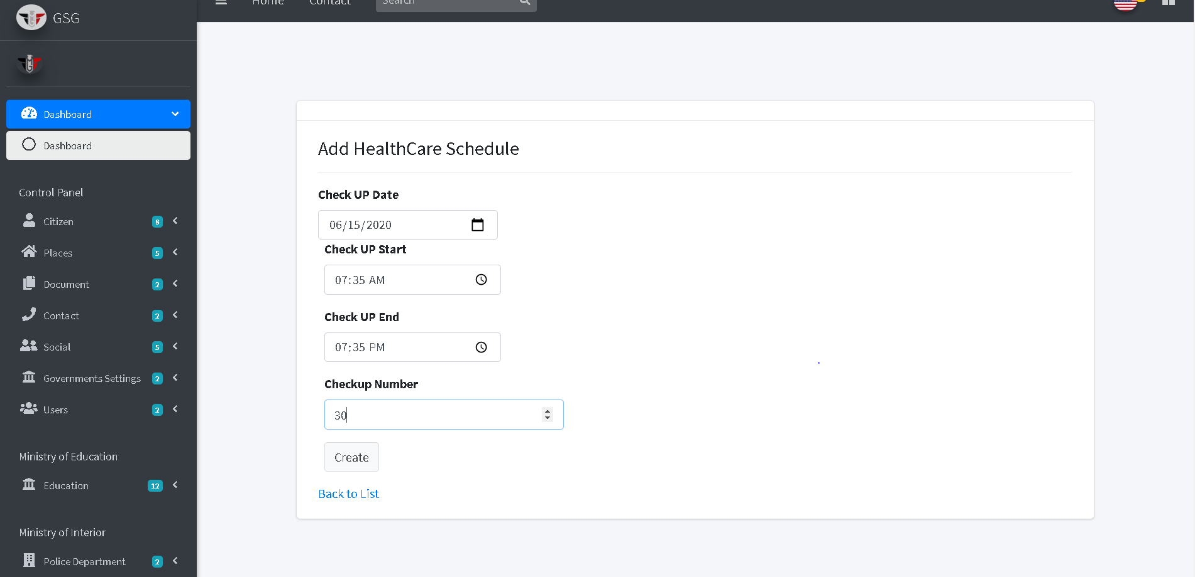

Then the system will redirect to the index page and display all doctor schedules

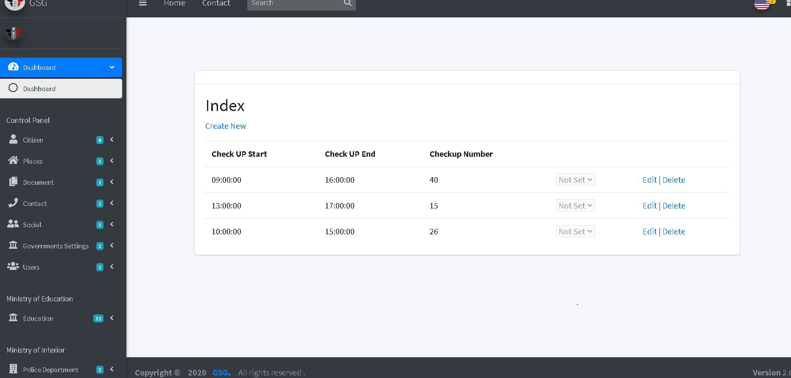

Then the user can edit or delete by click on “edit icon” or “trash icon”, the system will go to edit page and user can edit on the fields then click on “edit button”

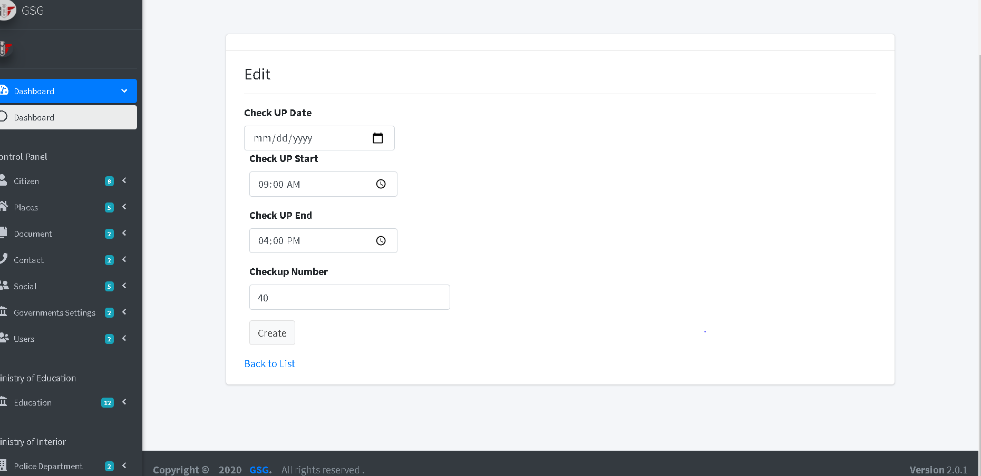

Or will go to delete page and user can confirm deletion by clicking on “delete button” then the system will redirect to index page.

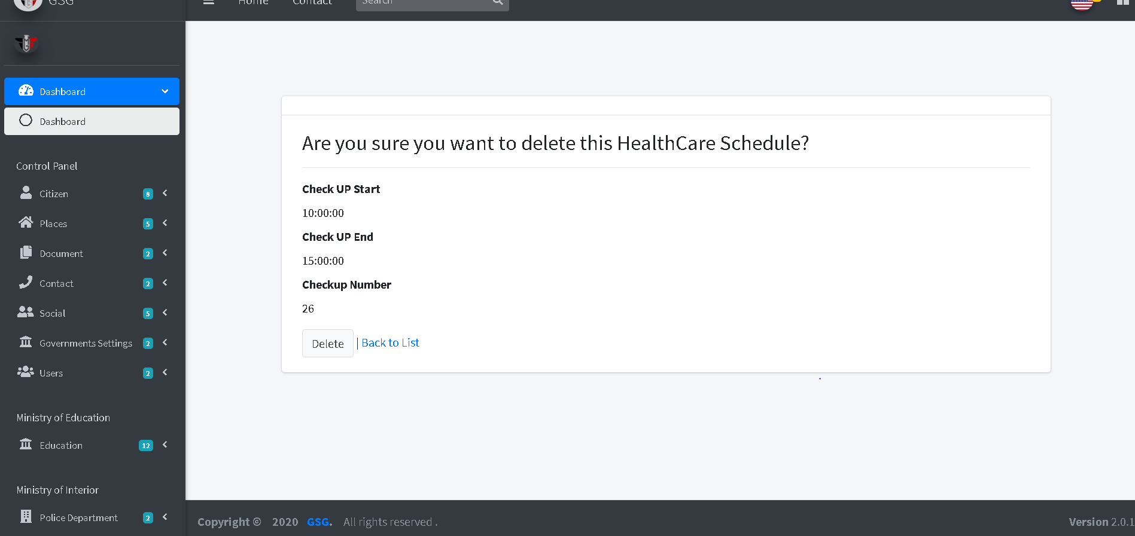

**Add Specialization**

The user should fill the required fields then click on “create button”

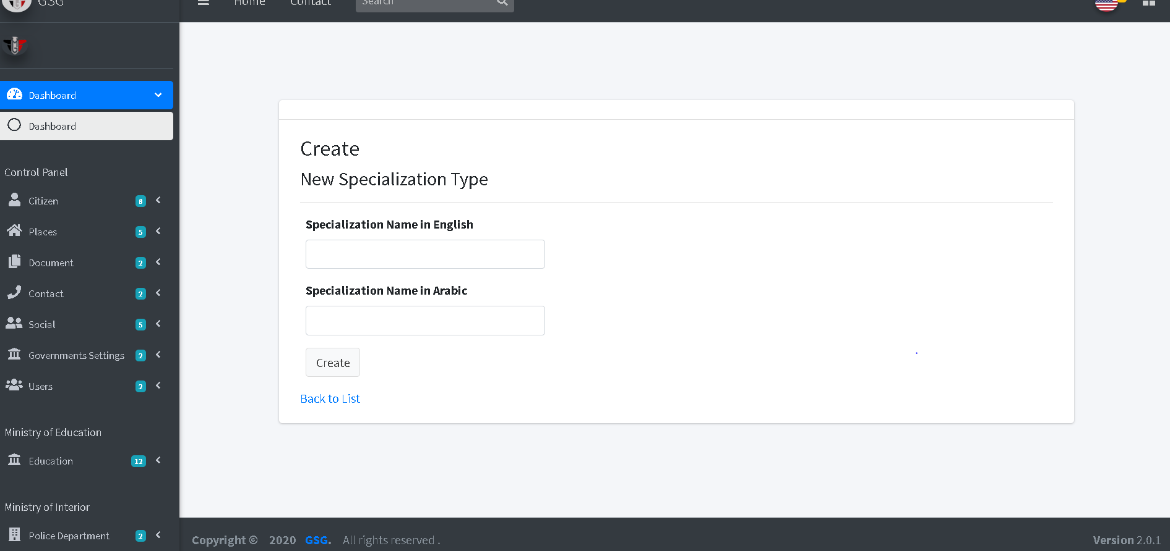

Then the system will redirect to the index page and display all Specialization

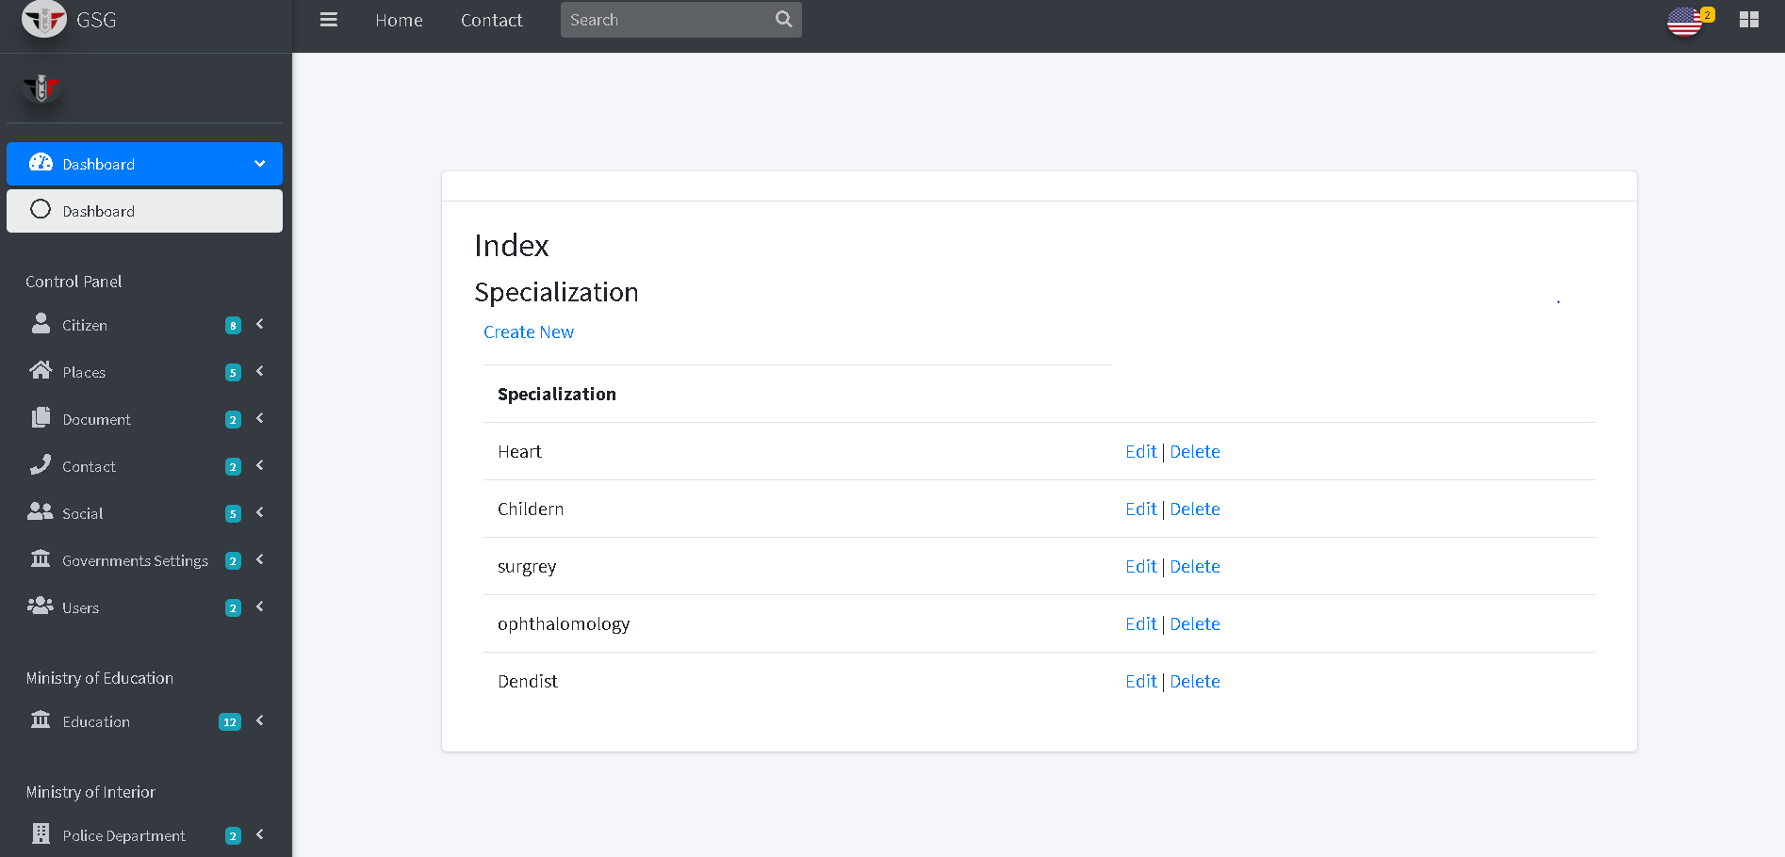

Then the user can edit or delete by click on “edit icon” or “trash icon”, the system will go to edit page and user can edit on the fields then click on “edit button”

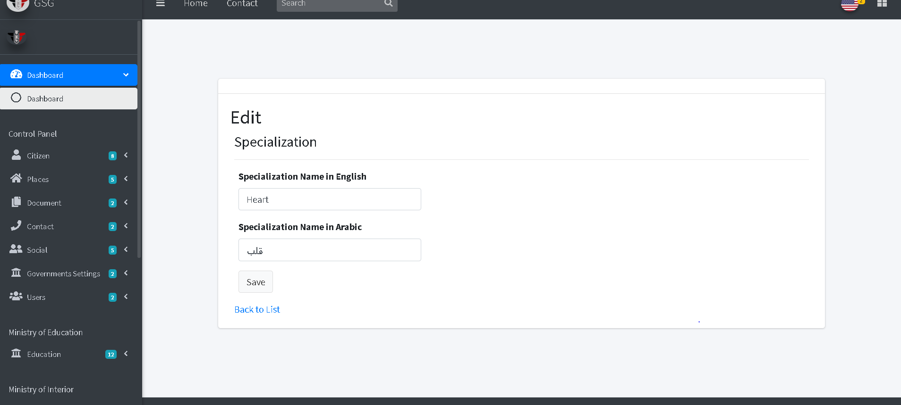

Or will go to delete page and user can confirm deletion by clicking on “delete button” then the system will redirect to index page.

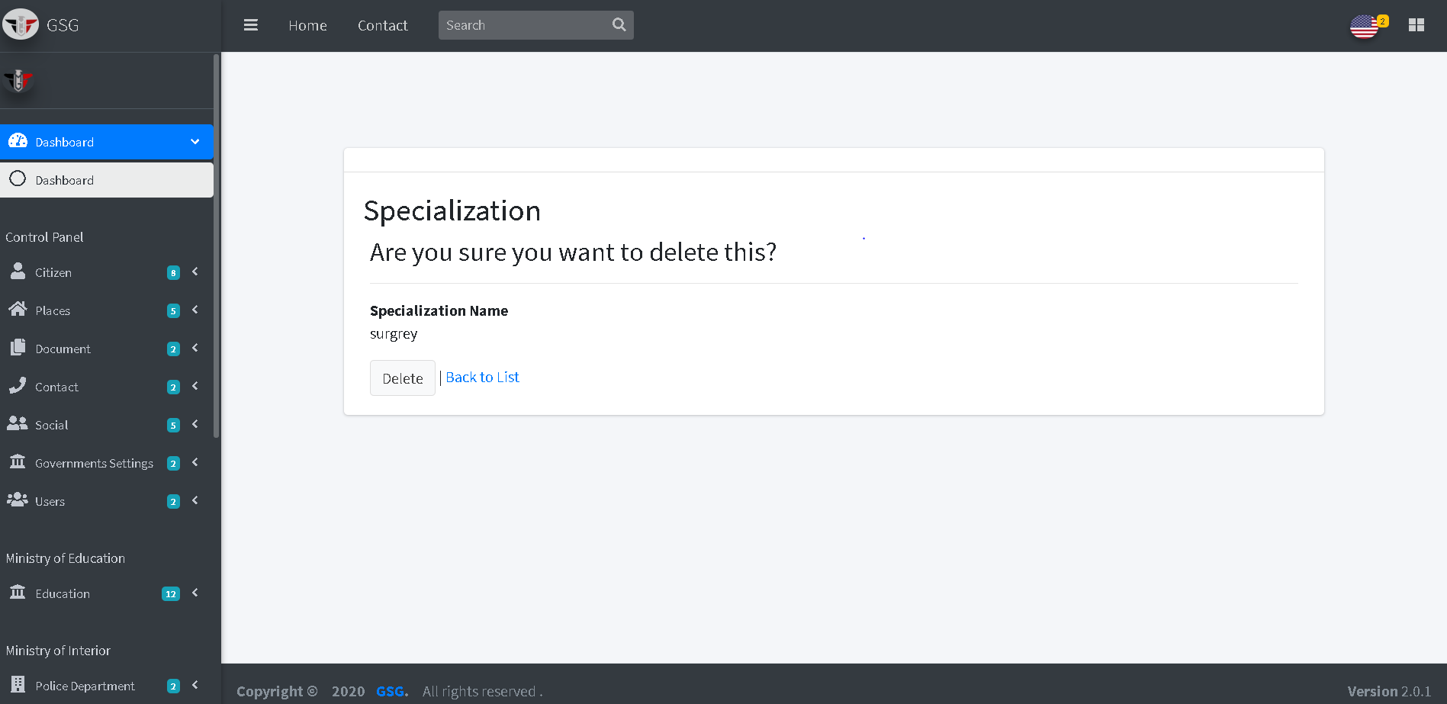

**Add doctors**

The user must choose doctor national id and select the health care that he work with then click on “create button”

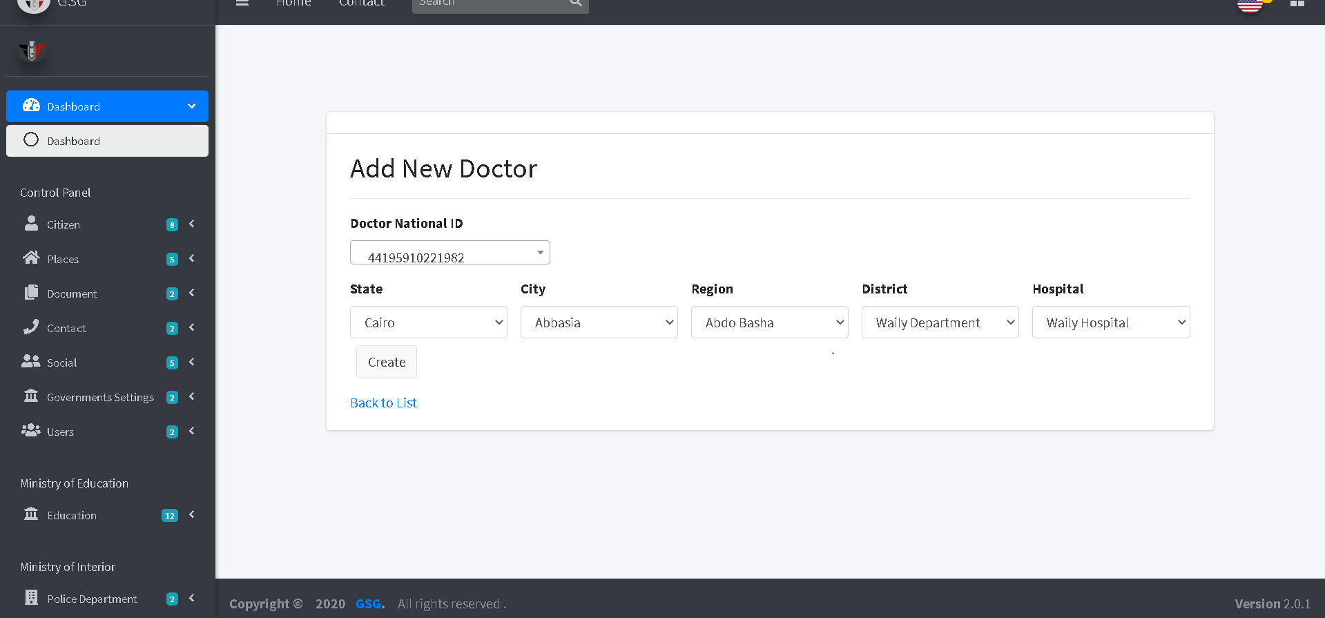

The system will redirect to the index page and display all doctors and their information

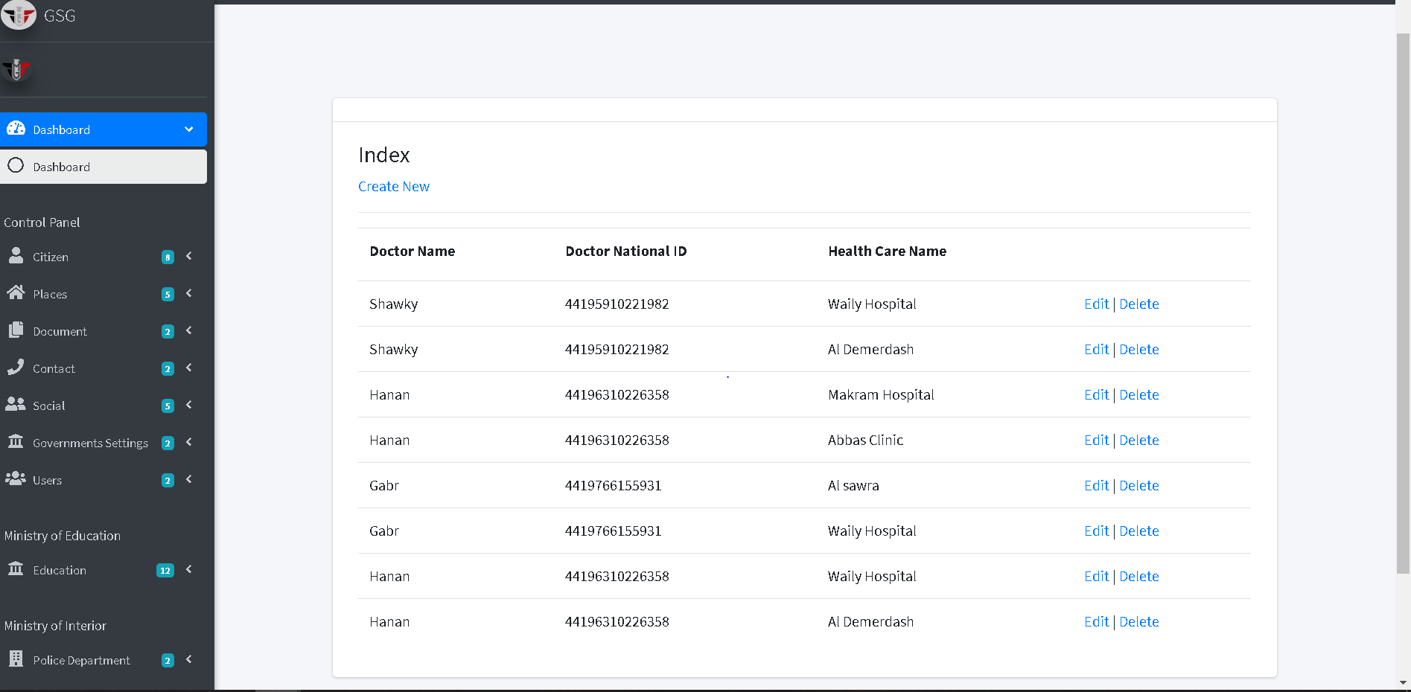

Then the user can edit or delete by click on “edit icon” or “trash icon”, the system will go to edit page and user can edit on the fields then click on “edit button”

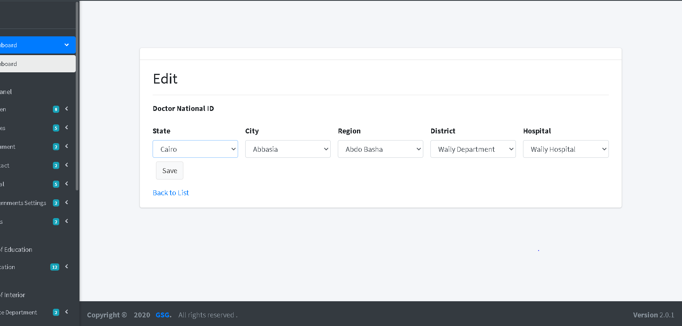

**Add health Cares**

The user should enter the health care name and filter the place of this health care then specify specializations and if it has any vaccination types then click on “create button”

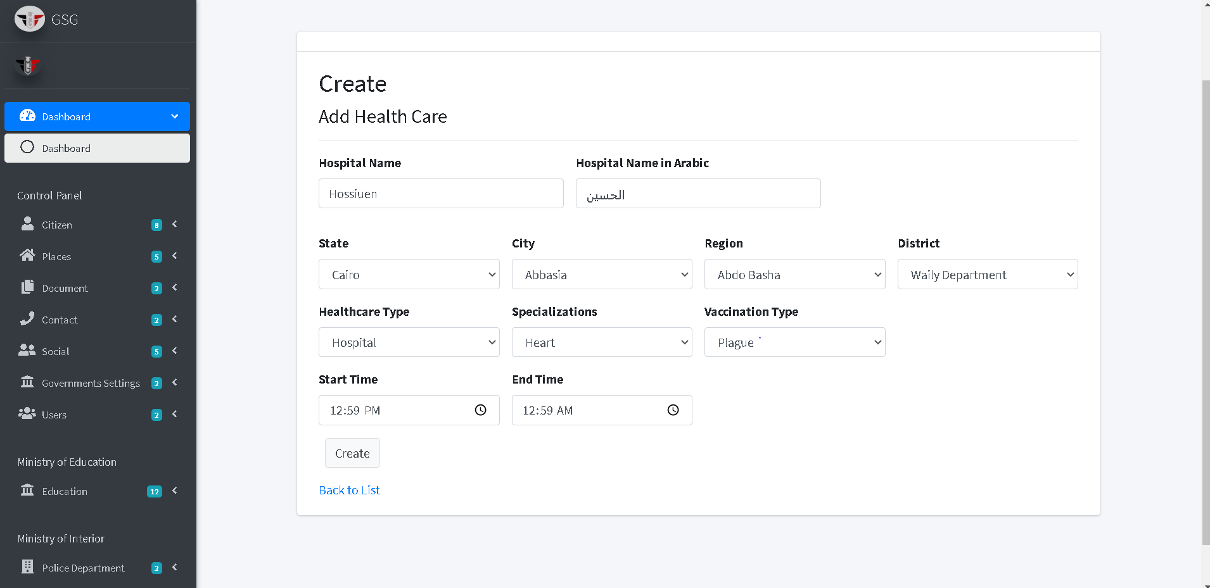

Then the system will redirect to the index page and display all health cares and its information

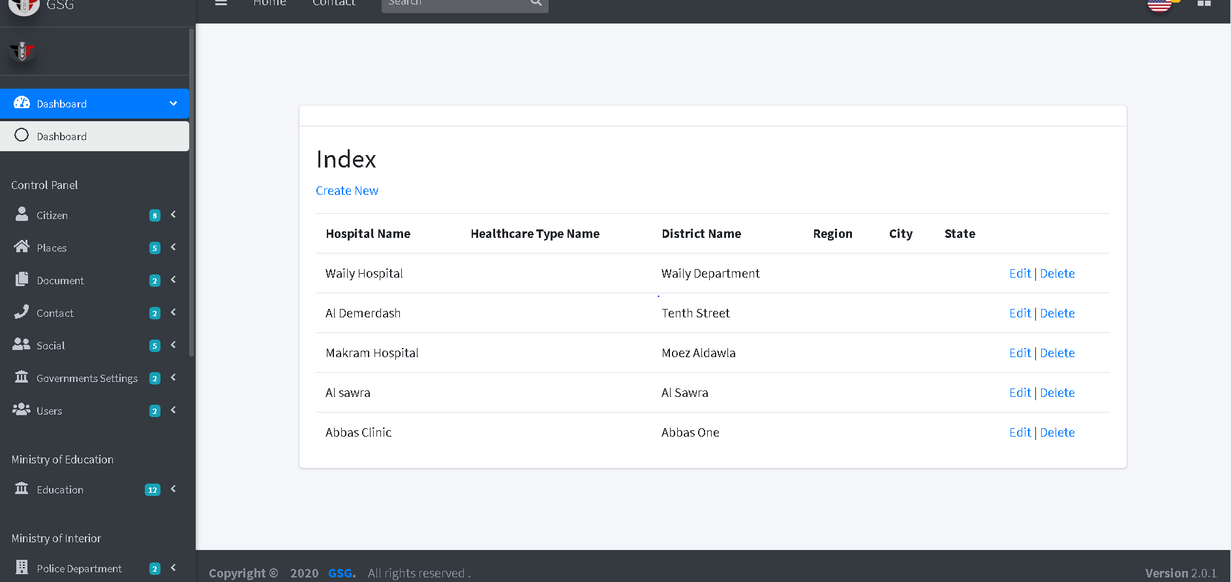

Then the user can edit or delete by click on “edit icon” or “trash icon”, the system will go to edit page and user can edit on the fields then click on “edit button”

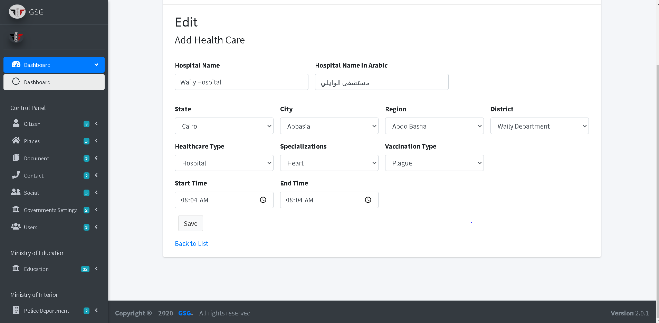

Or will go to delete page and user can confirm deletion by clicking on “delete button” then the system will redirect to index page.

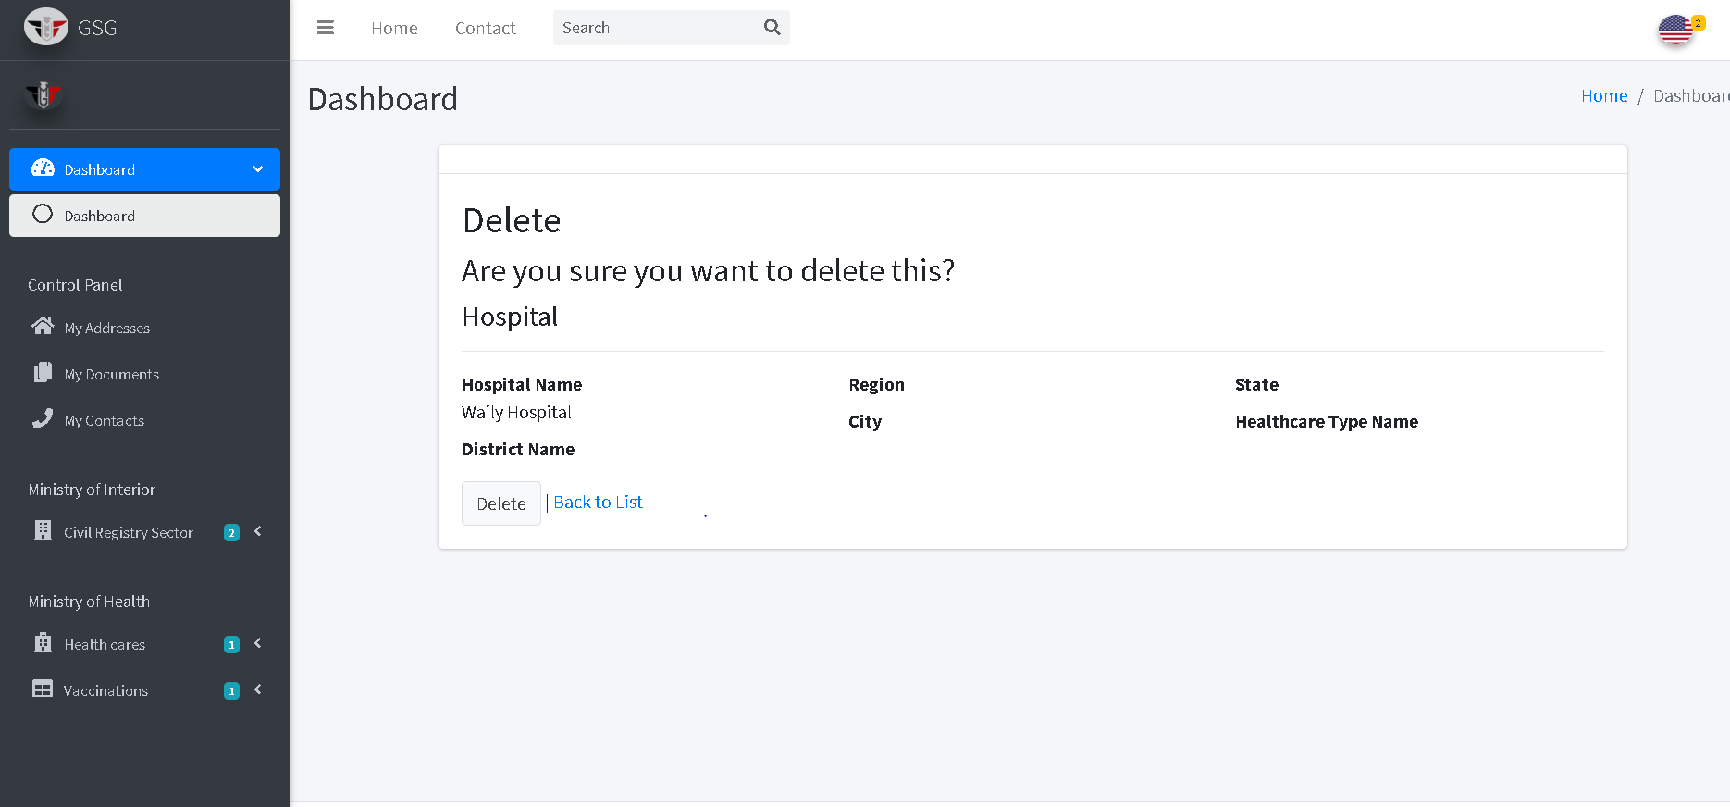

# 

# References

1. <https://docs.microsoft.com/en-us/>
2. <https://jquery.com/>
3. <https://jqueryvalidation.org/>
4. <https://jqueryui.com/>
5. <https://mdbootstrap.com/>
6. <https://getbootstrap.com/docs/4.5/getting-started/introduction/>
7. <https://docs.microsoft.com/en-us/sql/sql-server/?view=sql-server-ver15>
8. <https://getbootstrap.com/>
9. <https://plugins.krajee.com/file-input>
10. <https://sweetalert2.github.io/>
11. <https://select2.org/>
12. <http://www.jquery-steps.com/>
13. <https://datatables.net/>
14. <https://fontawesome.com/>
15. https://icons8.com/
16. https://stackoverflow.com/
17. <https://www.w3schools.com/>
18. <https://codepen.io/>
19. <https://larsjung.de/jquery-qrcode/>
20. <https://online.visual-paradigm.com/drive/>
21. <https://github.com/coderifous/jquery-localize>
22. <https://docs.microsoft.com/en-us/azure/devops/repos/git/gitquickstart?view=azure-devops&tabs=visual-studio>
23. <https://docs.microsoft.com/en-us/aspnet/identity/overview/getting-started/adding-aspnet-identity-to-an-empty-or-existing-web-forms-project>